Studfall
Nursery
Phonics
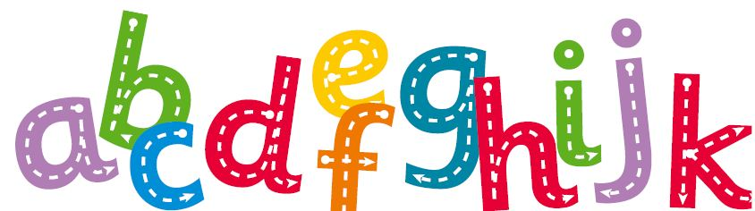

Your child is beginning an exciting journey with phonics, which will ultimately enable them to become a reader and writer.
In the first phase of phonics, we concentrate on developing speaking and listening skills, phonological awareness (identifying sound patterns in spoken words) and oral blending and segmenting skills. Their language skills are developed through carefully organised activities and a broad and rich language curriculum with speaking and listening at its centre. Your child will begin to make links with their language and the physical and practical experiences in an environment rich in print and abundant in opportunities to engage with books.
In Phase One (the phonics phase for Nursery) most of the activities are adult-led. These include daily speaking and listening activities that are matched to their developing abilities and interests. The Nursery environment and provision is planned to support the children’s language learning. As opportunities arise throughout the day’s activities, as well as in planned adult-led group sessions, the children are encouraged to explore the sounds in words.
Phase One is separated into seven aspects:
Environmental Sounds, Instrumental Sounds, Body Percussion, Rhythm & Rhyme, Alliteration, Voice Sounds and Oral Segmenting & Blending.
Activities will be planned for each aspect such as the following:

Environmental Sounds
Listening walks: encouraging the children to listen carefully to the sounds around them. Talking about all the different sounds they can hear.
Songs and stories: involving the children in songs and stories through props, role-play and making sounds as accompaniment.

Instrumental Sounds
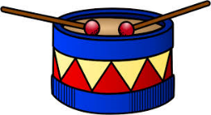
Musical Instruments: games involving exploring instruments e.g. guess what instrument is playing, copying a musical pattern, making loud and quiet sounds, making musical accompaniments to stories or matching sounds to animals.


Body Percussion
Action songs
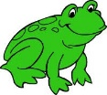

Rhythm & Rhyme
Rhyming books and games: including ‘rhyming soup’ (making ‘soup’ with objects that rhyme e.g. dog, frog)

Alliteration
Alliteration games: I spy games, ‘digging for treasure’ (matching objects with the same initial sounds) in sand, foam, mud etc.

Making a sound bag/ table: making a collection of objects with names beginning with the same.

Voice Sounds
Exploring mouth movements: such as blowing, sucking or wiggling their tongues.
Making sounds with their mouths e.g wheeee, boing, moooo, baaaaa

Oral segmenting & Blending
Clapping sounds: sounding out words and clapping each phoneme e.g. c-a-t.
Oral blending games; e.g. touch your t-oe-s, put your hands on your h-i-p-s.



How you can help at home
- Read and share books with your child.
- Go to the local library and let them to look at and choose their own books.
- Encourage your child to use language by asking them questions about their experiences.
- Play listening games e.g. hide a soft toy and guide your child to find it by making a louder noise as they get closer.
- Play games like ‘I spy’ which will help your child tune into initial sounds of words.
- Sing songs such as ‘Old Macdonald had a farm’ encouraging your child to join in with the animal noises.
- Make musical instruments e.g. using a plastic bottle and rice.
- When outdoors encourage your child to use their bodies to make sounds e.g stamping their feet.
- Encourage your child to make noises as they play e,g. calling ‘wheee’ as they go down a slide.

