
Relationships and Sex Education Policy

September 21

Version | 1.2 Final
Document author | EDPT-AC
Classification | Internal
Created | Jun 2020
Review | 30.06.21



Contents

1. | Values and Ethos
2. | Aims
3. | Statutory Requirements
4. | Definition
5. | Curriculum Design
6. | Delivery of RSE
7. | Roles and Responsibilities
8. | Parents’ right to withdraw
9. | Safeguarding
10. | Training
11. | Monitoring Arrangements
12. | Assessment

Appendices

Appendix 1: EYFS Curriculum Map
Appendix 2: PSHE Association Programmes of Study KS1 to KS5
By the end of primary school pupils should know
Appendix 4: Parent Form: withdrawal from sex education within RSE
Appendix 5: Roadmap to RSE
Appendix 6: Right to Withdrawal - DfE Summary

1. Values and Ethos

- We believe relationships and sex education is important for Studfall Infant Academy because it will help our children to value positive relationships and have the confidence and strength of character to identify and lead a healthy lifestyle.

- We view the partnership of home and school as vital in providing the context of open discussion, honesty and support.

The intended outcomes of the programmes of study are that pupils will:

- Know and understand, how as individuals our bodies change as we get older.
- Understand they have the right to be safe.

- Understand they have a responsibility to be a responsible, valued member of Studfall Infant Academy.
- Develop the skills needed to lead a healthy lifestyle.

- Develop the attributes of positive relationships.

2. Aims

The aims of Relationships and Sex Education (RSE) are to:

- Provide a framework in which sensitive discussions can take place;

- Prepare pupils for puberty, and give them an understanding of sexual development and the importance of health and hygiene;

- Help pupils develop feelings of self-respect, confidence and empathy;

- Create a positive culture around issues of sexuality and relationships;

- Teach pupils the correct vocabulary to describe themselves and their bodies;

- Support the academy ethos of nurturing a caring community.

3. Statutory Requirements & Legislation

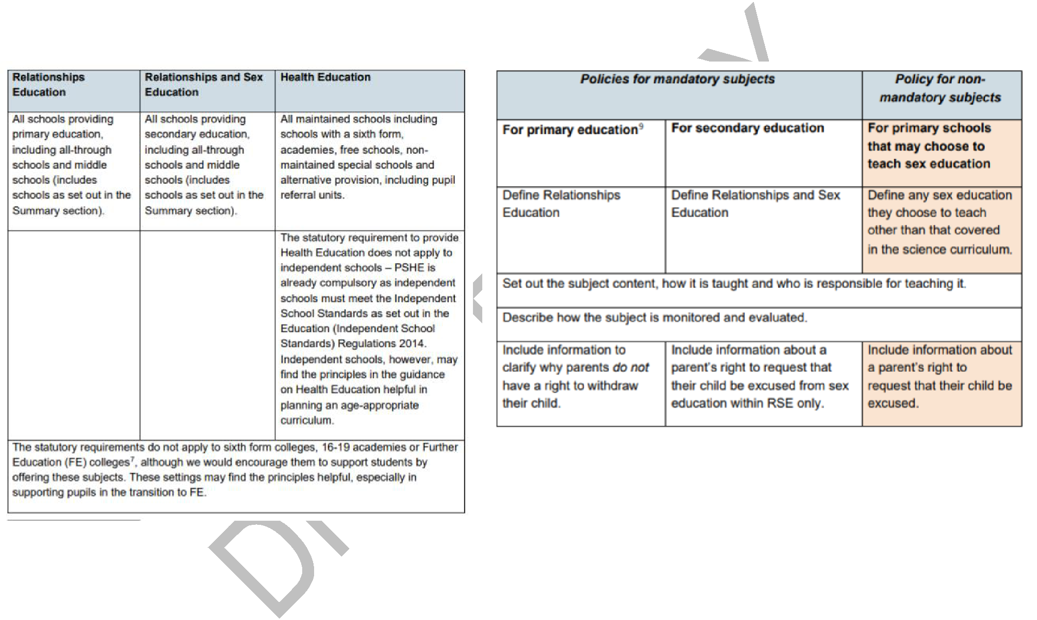
Studfall Infant Academy follows the revised Department for Education statutory guidance that states from September 2020 all primary and secondary schools must deliver relationships education. In implementation of the RSE curriculum the requirements and scope from the DfE are:

Documents that inform the school's RSE policy include:

  - Education Act (1996)

  - Learning and Skills Act (2000)

  - Education and Inspections Act (2006)

  - Equality Act (2010)

  - Locally Agreed RE Syllabus in line with SACRE Guidelines

  - Supplementary Guidance SRE for the 21st Century

- Keeping Children Safe in Education – Statutory safeguarding guidance

*As an academy we must provide relationships education to all pupils as per section 34 of the Children and Social work act 2017.

4. Definition

RSE teaches children and young people how to be safe and healthy. It teaches them how to manage their academic, personal and social lives in a positive way. RSE involves a combination of sharing information, exploring issues and values. RSE is not about the promotion of sexual activity or lifestyles.

Relationships Education: the focus is on teaching the fundamental building blocks and characteristics of positive relationships, with particular reference to friendships, family relationships, and relationships with other children and with adults. These areas of learning are taught within the context of family life taking care to ensure that there is no stigmatisation of children based on their home circumstances (families can include single parent families, LGBT parents, families headed by grandparents, adoptive parents, foster parents/carers amongst other structures) along with reflecting sensitively that some children may have a different structure of support around them (for example: looked after children or young carers). See Appendix 2 for content mapping from the PSHE Association.

Health Education: the focus is on teaching the characteristics of good physical health and mental wellbeing. Teachers should be clear that mental wellbeing is a normal part of daily life, in the same way as physical health. See Appendix 2 for content mapping from the PSHE Association.

Sex Education: the focus is on teaching children the facts about puberty (preparing boys and girls for the changes that adolescence brings) and reproduction (how a baby is conceived and born). Parents have the right to withdraw a pupil from sex education lessons up to three months before the 16th birthday of the pupil when the child can choose to opt in.

5. Curriculum Design

The curriculum for RSE is set out in line with this policy. Parents will be kept informed as per DfE expectations.

Our RSE curriculum takes into account the age, needs and feelings of pupils. If pupils ask questions outside the scope of this policy, teachers will respond in an appropriate manner so they are fully informed and don’t seek answers online inappropriately.

The RSE programme is an integral part of whole school PSHE provision and will cover: Health and Well Being, Relationships and Living in the Wider World.

It:

  - is inclusive of equality and diversity and enables all pupils to engage with it providing pupils with knowledge and awareness from a broad spectrum of society as a whole.

  - will meet the needs, or be adapted for, those children with protected characteristics through teaching which respects and acknowledges all pupils.

  - supports the demographic of the locality with staff and leaders being acutely aware of common issues and needs of our pupils.

  - fosters gender equality and LGBT + equality by respecting the views and feelings of all and promoting an understanding of equality through openness and respect.

  - will be planned and delivered through both direct teaching time each week and also across the curriculum with the core values being modelled and embedded through daily routines. The curriculum acknowledges the range of ages and takes into account content when considering the age of the pupils it will be shared with.

  - will be taught through a range of teaching methods and interactive activities.

  - Will ensure that learning about relationships and sex education will link to/complement learning in science and SMSC.

At Studfall Infant Academy, RSE is taught as an integral part of our PSHE curriculum.

Studfall Academy PSHE & Citizenship – Long Term Plan – KS1
UNITS
Year group | Term 1 | Term 2 | Term 3 | Term 4 | Term 5 | Term 6
1 | Relationships: TEAM | Relationships: Be Yourself | Health & Well-being: It’s my body | Living in the wider world: Money Matters | Living in the wider world: Britain | Health & Well-being: Aiming High
2 | Health & Well-being:  Think Positive | Health & Well-being: Safety First | Relationships: VIPs | Living in the wider world: Respecting Rights | Living in the wider world: One World | Relationships: Growing up

- Twinkl units are used as a basis for planning for KS1; Oak National Academy resources are linked where appropriate and other schemes are accessed, e.g Jigsaw, where relevant.

Oak National Academy programme, for EYFS and KS1.
Key stage | Unit title | Length of unit
EYFS | New beginnings | 5 lessons
KS1 | *Me, you and us! | 6 lessons
Key stage | Unit title | Length of unit
EYFS | Staying safe | 5 lessons
KS1 | *Forever friends  Happy Families | 4 lessons  4 lessons
Key stage | Unit title | Length of unit
EYFS | Food glorious food | 7 lessons
KS1 | *I know my rights! | 6 lessons

Key stage | Unit title | Length of unit
EYFS | Circle of love  Circle of trust | 3 lessons  3 lessons
KS1 | *Stop the spread  *It’s OK not to be OK | 4 lessons  5 lessons
Key stage | Unit title | Length of unit
EYFS | Squeaky clean | 6 lessons
KS1 | *Healthy isn’t a goal; it’s a lifestyle | 5 lessons

Key stage | Unit title | Length of unit
EYFS | Circle of life  Same and different | 4 lessons  7 lessons
KS1 | *Stop, think, stay safe! | 5 lessons

- Delivery of RSE
RSE is explicitly taught within the PSHE curriculum, with biological aspects of RSE taught within the Science and P.E curriculum, and other aspects in R.E lessons. At least 1 hour of taught PSHE per week is timetabled. RSE will also be included within assemblies, circle time, story time and addressed during special celebrations and themes over the school year.

7. Roles and Responsibilities

The Trust

The Trust has a set of activities that will monitor the quality and effectiveness of the RSE policy and curriculum at Studfall Infant Academy. The Curriculum Assurance Board will be key to the monitoring of this policy and will develop additional support or guidance to academies if required.

Studfall Infant Academy

The Principal is responsible for ensuring that RSE is taught consistently across Studfall Infant Academy, and for managing requests to withdraw pupils from non-statutory/non-science components of Sex Education. The Principal is responsible for ensuring policy and practice are adhered to and that all information is made accessible to all parents and carers.

- The nominated person for PSHE is responsible for development of the curriculum and monitoring of the curriculum across Studfall Infant Academy.

- It will be taught by teachers in each year group.

- Teachers will receive RSE training as appropriate.

The Principal should also ensure that there has been consultation with Studfall Infant Academy community and parents/carers on the policy and curriculum for RSE in line with the guidance from the DfE. Studfall Infant Academy should ensure this also published on the website.

Staff

Staff are responsible for:

Delivering RSE in a sensitive way

Modelling positive attitudes to RSE

Monitoring progress

Responding to the needs of individual pupils

Responding appropriately to pupils whose parents wish them to be withdrawn from the non-statutory/non-science components of Sex Education

Staff do not have the right to opt out of teaching RSE. Staff who have concerns about teaching RSE are encouraged to discuss this with the Principal. All class teachers are responsible for teaching RSE. The trust would expect the Principal to honour appropriate requests for withdrawal (request form can be found in Appendix 4) and meet with parents to discuss these in line with the DfE guidance as summarised in Appendix 6.

Pupils

Pupils are expected to engage fully in RSE and, when discussing issues related to RSE, treat others with respect and sensitivity.

8. Safeguarding

  - Teachers should be aware of the academy confidentiality policy.

  - Teachers are aware that effective RSE, which brings an understanding of what is and what is not appropriate in a relationship, can lead to a disclosure of a child protection issue.

  - Teachers will consult with the designated safeguarding leads who will follow academy policy for safeguarding.

  - Visitors/external agencies which support the delivery of RSE will be required to adhere to academy safeguarding policies, confidentiality and the RSE policy.

- Parents’ right to withdraw

Parents do not have the right to withdraw their children from relationships education.

Parents have the right to withdraw their children from the non-statutory/non-science components of sex education within RSE. See Appendix 6 for DfE guidance on this issue.

Studfall Infant Academy will be clear in our curriculum mapping which aspects are ‘Relationships Education’ and which are ‘Health Education’ to support parents in decisions over withdrawal.

Requests for withdrawal should be put in writing using the form found in Appendix 4 of this policy and addressed to the Principal.

Alternative work will be given to pupils who are withdrawn from sex education.

10. Training

Staff are to be trained on the delivery of RSE.

The Principal may also invite visitors from outside the school, such as school nurses or sexual health professionals, to provide support and training to staff teaching RSE where this is appropriate and age related.

11. Monitoring Arrangements

The delivery of RSE is monitored in Studfall Infant Academy through:
- Lesson observations, learning walks, planning scrutiny and book monitoring;
- Pupils’ development and progress in RSE is monitored by class teachers as part of our internal assessment systems.

The implementation of this policy is monitored by the Trust through:

- Assurance activities to ensure statutory arrangements are in place in Studfall Infant Academy.

- Assurance activities to ensure policies are being implemented and the RSE curriculum is of sufficient quality.

- This policy will be reviewed by the Curriculum Assurance Board annually and the Board will lead the development of any amendments to the policy.

12. Assessment

There are many reasons why it is important that learning in RS education is assessed, including:

- Pupils need opportunities to reflect on their learning and its implications for their lives.

- Teachers need to know that learning has taken place, and be able to demonstrate progress and identify future learning needs.

- Assessment increases pupils’ motivation and improves learning, as their raised awareness of their progress illustrates the value of this learning.

- Assessment allows the leadership team, parents, governors and school inspectors to see RS education’s impact on pupils and whole school outcomes, such as Ofsted judgements on personal development, safeguarding, spiritual, moral, social and cultural (SMSC) development and the promotion of fundamental British values.

- Without assessment, all a school can do is describe its RSE provision, not show it’s impact.

- The DfE also states in the statutory guidance for Relationships, Sex and Health education that “schools should have the same high expectations of the quality of pupils’ work in these subjects as for other curriculum areas” — therefore assessment for and of learning should be central to any RS education provision.

At Greenwood Academies Trust:

Assessment in RSE will take the approach where adults will allow time for pupils to reflect and ask questions to qualify their thinking. These discussions will support teachers into how follow up lessons will be planned in order to meet the needs of the children.

- Pupils will have opportunities to review and reflect on their learning through; discussion, written work and artwork.

- Pupil voice will be influential in adapting and amending planned learning activities by adults providing time for pupils to discuss and share their thoughts and feelings and adults responding to pupil needs through follow up work either whole class, small group or 1:1.

- Parents will be informed of pupil understanding via parent consultations and written reports.

13. References and Sources

The following have been referenced during the development of this policy:

- The PSHE Association for the POS and Overview Documents

- Lincolnshire LA

- Beacon Primary Academy (Policy into Practice) in line with policy development across the East Coast Cluster

- Department for Education guidance for Relationships Education, Relationships and Sex Education (RSE) and Health Education

- Equalities Act 2010

- Keeping Children Safe in Education

- Early Years Foundation Stage – Early Learning Goals and Development Matters

Appendix 1: Curriculum Map for Early Years
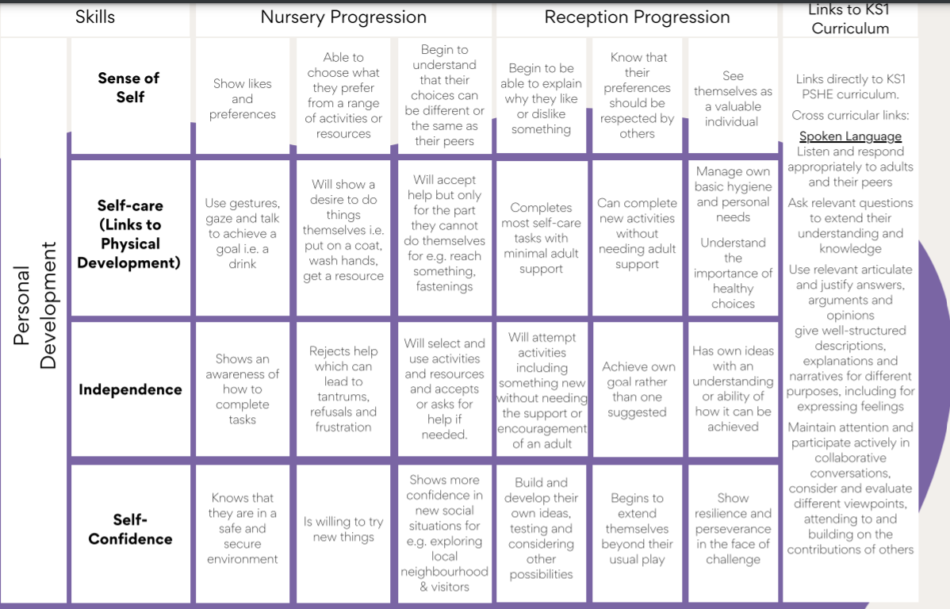

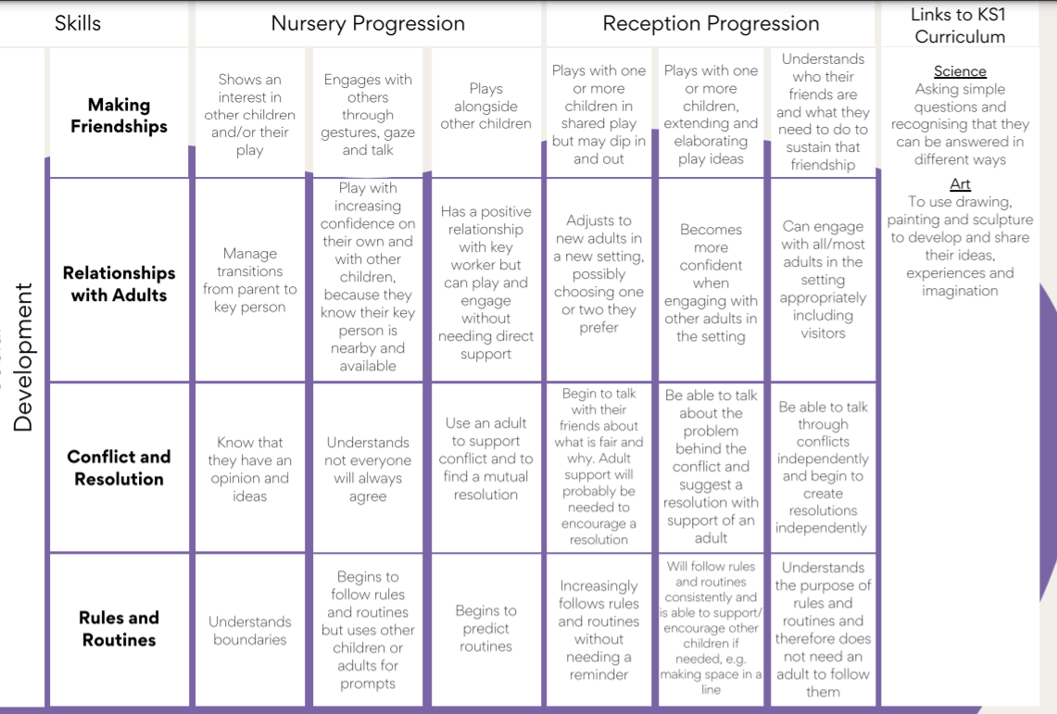

The development of positive relationships is a key strand that runs through every area of learning in the early years. These skills link into the 3 Early Learning Goals that reference personal and social education. There is a specific learning intention about families. This contributes to the early learning goal: showing sensitivity to others needs and feelings.

Learning Intention

To recognise that all families are different
Learning Outcomes

Identify different members of the families

Understand how members of a family can help each other
Resources
Picture books and pictures of children’s own families

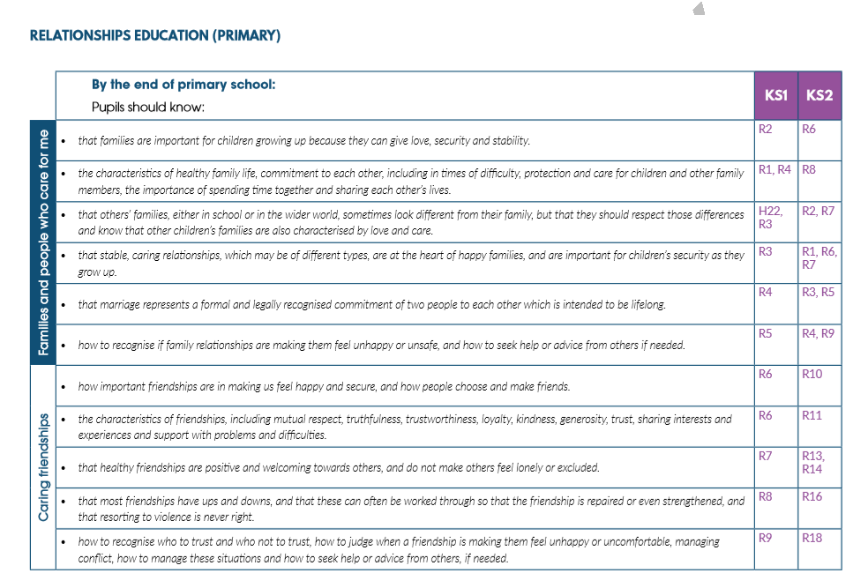
Appendix 2: Primary Expectations – from the PSHE Assoc
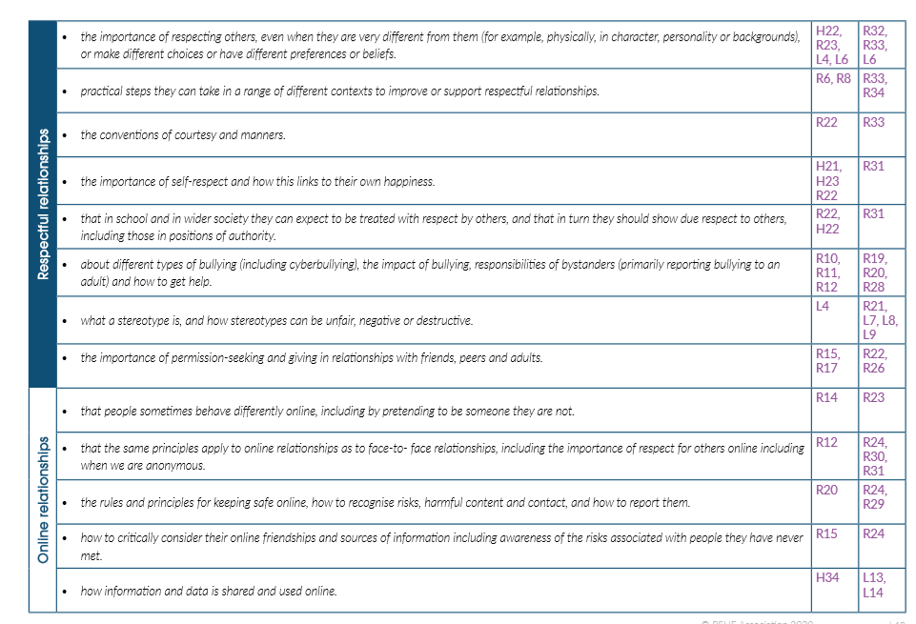
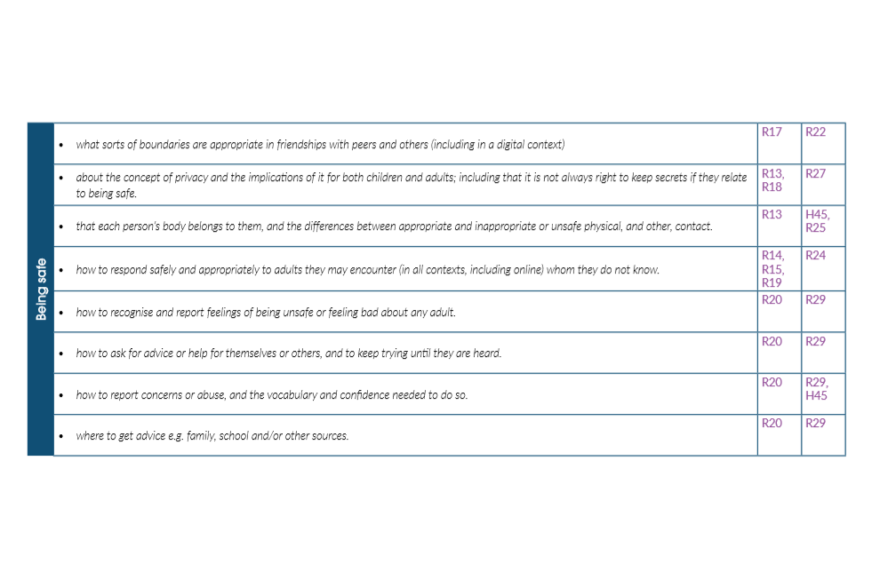

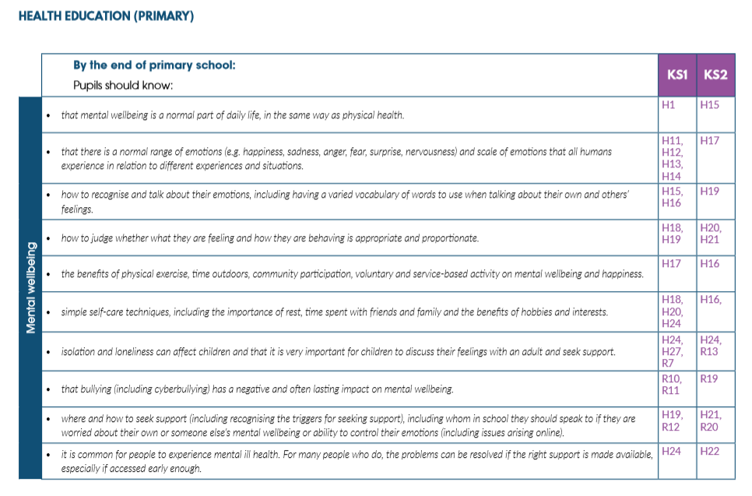

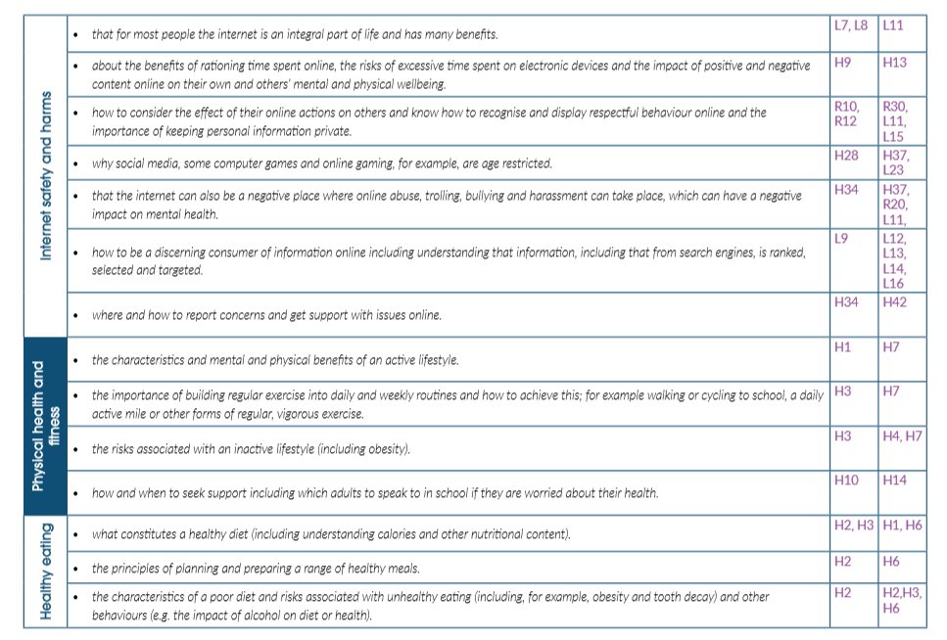

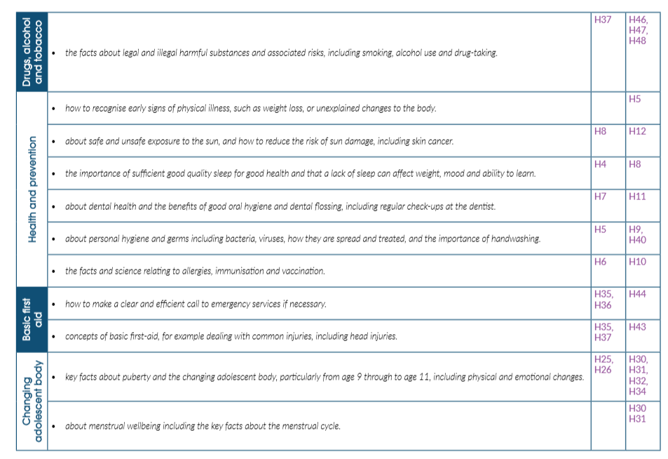

Appendix 4: Parent Form

 | TO BE COMPLETED BY PARENTS
 | Studfall Infant Academy |  | Withdrawal from Relationships & Sex Education
 | Name of child |  |  | Class
 | Name of parent |  |  | Date
 | Reason for withdrawing from sex education

Any other information you would like the school to consider

Parent signature

Agreed actions from discussion with parents

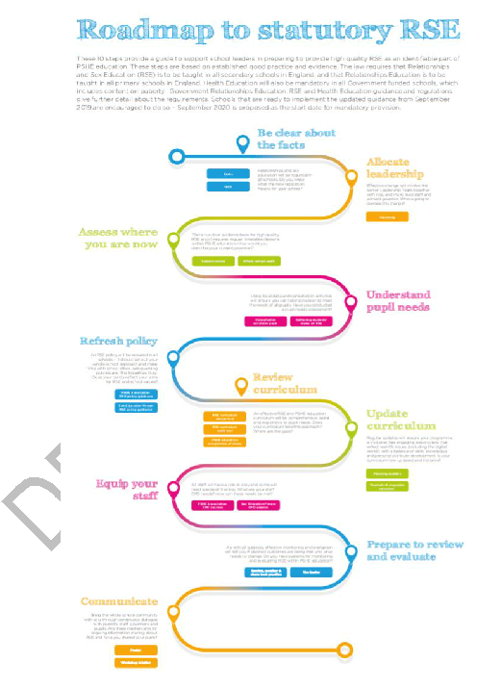
Internet link - https://pshe-association.org.uk/system/files/RSE%20roadmap%20FINAL.pdf


