Curriculum:
Intent, Implementation & Impact
Statement

Written: Dec 2020
Review Date: Sept 2022

Authors
Kim Kirchin and Louise McGeachie
Principals

&

Andrew Clarke Senior Education Adviser

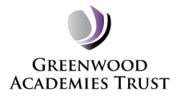

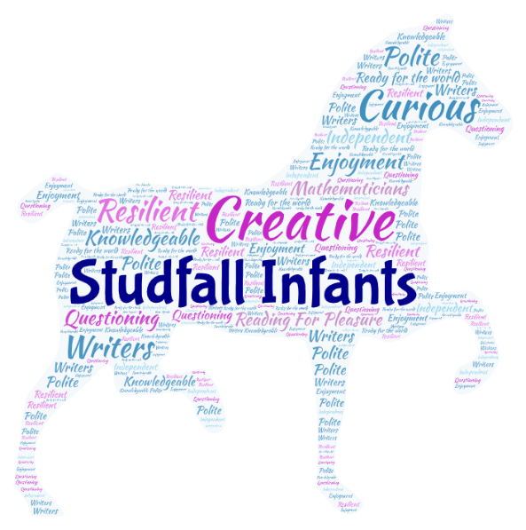

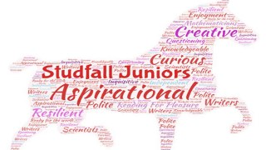
Intent – Greenwood Academies Trust

GAT Primary Curriculum

Central to the curricula in our academies are the fundamental principles that a curriculum should be:

- of quality
- contextualised to reflect the community of the academy
- developing core transferable knowledge and skills
- securing progress in the core areas of reading, writing and mathematics
- broad and balanced
- meeting the expectations set out in the National Curriculum (2014)
- exciting and engaging

We made the decision as a Trust not to centralise our approach to a curriculum or the schemes of work that are used to deliver that curriculum across our Primary academies.

As we work across a diverse number of regions our academies have the autonomy to craft and shape a curriculum that meets the requirements of the National Curriculum 2014 and the context of the community it serves. We ensure that it is fit for purpose through our quality assurance processes and annual academy performance review.

We encourage our academies, their leaders and teachers to be innovative and forward thinking in their approach to planning a purposeful curriculum. In order to achieve this we expect our academies to continually review the effectiveness of their curriculum.

Intent – Studfall Infant and Junior Academies

At both academies our core values are –
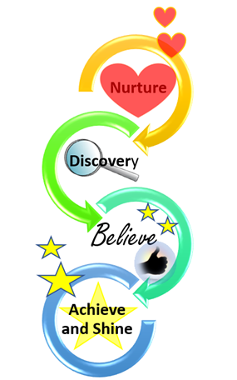

This was developed from whole school input on Nov 20. These are the focus of our curriculum and motivate the – why aspect of what we do – what we want for our children as they grow and develop though all stages in our academies .

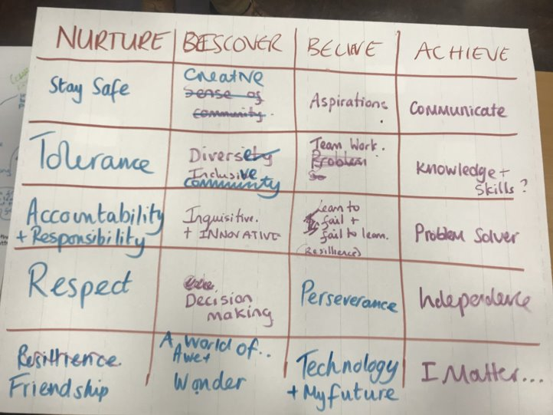

Academy Expectations
- Staff have high expectations of themselves and all children.
- Teachers are expected to impart knowledge accurately and with enthusiasm which generates high levels of commitment from children.
- We expect children to make rapid and sustained progress in lessons.
- We expect teachers to support in developing independence.
- We expect teachers to systematically children check understanding, intervening in a timely manner when needed.
- We expect children to be challenged.
- We expect teachers to regularly provide high quality marking and constructive feedback to children.

We are in the process of looking at how we arrange our classes and teaching groups. We are moving to set ability groups only for maths and for the rest of the time – the vast majority of children to be taught in class groups. This will enable us to get even greater connections in the curriculum and continue to raise expectations for all.

Following some training from Chris Quigly ( June 2019) we have looked at core skills that should be delivered on a daily or regular basis – for example – telling the time , calendar information , times tables etc. These skills are blended into the plans and daily routines of classes so the information is regularly developed and re called – to ensure a deep understanding
Implementation

Effective Teaching
At the Studfall Academies we all have high expectations of progress which apply equally to children working above, at, or below age-related expectations, including those who have been identified as having special educational needs. There is an expectation of participation, fulfilment and success; and teaching and learning is characterised by ambitious objectives, challenging personal targets, rapid intervention to keep pupils on trajectory and rigorous assessment to check and maintain pupil progress. There are clear plans to support those who are struggling to maintain trajectory. The teacher’s priority is to support children so that they can keep up with the pace of learning and make good rates of progress.

Teachers will be reflective and thoughtful practitioners and use assessment to inform planning. (Formative and summative). Teachers will use AfL to adapt their teaching as the lesson progresses, using a variety of whole class engagement strategies (such as individual whiteboard work (for short responses), say together, talking partners) wherever appropriate.

Differentiation is clear and progressive. It is designed to challenge the more able and support or enable access for the less able- it “levels the playing field” and ensures that there is not a group that always finds the work easy and always a group that struggles. We enable children in each lesson to challenge themselves and get the support they need – based on what they know – rather than set groups, tables etc.

1. Quality first teaching
- Highly focused lesson design with sharp objectives;
- High demands of child engagement with their learning;
- High levels of interaction for all children;
- Appropriate use of teacher questioning, modelling and explaining;
- Emphasis on learning through dialogue;
- An expectation that children will develop resilience and accept responsibility for their own learning and work independently;
- Use of appropriate resources and children having access to these.
- Regular use of specific encouragement and praise to motivate children.

2. Target setting
- Individual children’s progress tracked;
- Strengths and weaknesses identified supporting planning and intervention
- Data collected on a regular basis and shared with staff and children;
- Children have regular opportunities to discuss their progress. Teachers actively involve children in setting and reviewing their progress towards their targets;
- Teaching, interventions and revision programmes are adjusted in the light of progress children make;
- Parents and carers regularly are regularly updated on their child’s progress;
- Processes run across the whole academy to ensure consistency and are regularly evaluated by SLT to ensure that the needs of all children are being met.

3. Focussed assessment
- Rigorous assessment and tracking of children’s performance takes place to inform classroom practice allowing children to make good progress and close attainment gaps;
- Day to day, Periodic and Transitional assessments used effectively;
- Assessment for Learning (AfL) evident across the academy – learning objectives, learning outcomes, success criteria, self and peer evaluation

4. Intervention
- Individuals and groups who are not making sufficient progress are identified;
- Provision for intervention is mapped according to need;
- Detailed plans are put into place;
- Learners are enabled to perform beyond the norms expected for their year group where appropriate;
- Interventions are evaluated and relevant adjustments are made;
- Year Teams and SLT regularly meet to discuss current and future interventions engaging in dialogue around the impact of interventions, potential barriers and further actions required.

5. Learning environment
- Organisation of the classroom/learning environment adapted to the children’s learning needs;
- The use of learning resources and ICT developed to allow children to work independently and successfully;
- Make effective use of other spaces – ‘outdoor classroom’, ICT suite, hall space;
- Working walls – to be used to display current learning- for children and staff to refer to ;
- Displays to be a mixture of celebration of children’s work, supportive resources and information.
- Key foci for the school to be evident in its areas between classes – with a focus on learning.

6. Curriculum organisation
- The curriculum is designed to cater for the needs and interests of a full range of learners including:
- Learners with learning difficulties, including those with speech, language and communication needs and EHC plans
- More able children
- Learners who are learning English as an additional language
- Boys and girls
- Children who are in care
- Learners with social, emotional and behavioural difficulties
- Flexibility is built into the curriculum organisation and delivery to ensure greater coherence from the children’s perspectives and local areas of importance.
- Following some whole school training from Chris Quigly ( June 2019) we have looked at core skills that should be delivered on a daily or regular basis – for example – telling the time , calendar information , times tables etc. These skills are blended into the plans and daily routines of classes so the information is regularly developed and recalled – to ensure a deep understanding.

7. Extended curriculum
- The academy offers a full range of ‘extra-curricular’ activities and clubs which enhance and extend the basic curriculum;
- We ensure access for all;
- Parents and carers, as well as the wider community, are involved in extended provision;
- Access to other services is provided or arranged, including health and social services.

8. Supporting children’s wider needs
- The academy maintains close communication with parents and carers;
- We develop and maintain multi agency links to support vulnerable children;
- Have learning mentors at both academies to support the well-being of children and families.

Effective Learning
We acknowledge that people learn in different ways and we recognise the need to develop pedagogies which enable all children to learn in ways which suit them.

We offer ways for children to learn in different ways including:
- investigation and problem solving;
- open ended tasks;
- reasoning;
- research and finding out, with independent access to a range of resources;
- group work, paired work and independent work;
- effective questioning;
- presentation and drama;
- use of ICT;
- visitors and educational visits;
- creative activities, designing and making;
- use of multimedia, visual or aural stimulus;
- participation in physical or athletic activity;
- homework;
- extra-curricular clubs and activities.

Following training on Bloom’s Revised Taxonomy and research carried out by our maths leaders we have introduced a whole school approach to enable children to develop their thinking skills.

The characters are:
Captain Conjecture – this is where a child is challenged to say what they will think will happen in a range of contexts.
Convince Me Vince – this is when a child is asked to give reasons for their ideas- perhaps looking at patterns or using concrete resources to show why this is the case.
Generate Jess – using existing knowledge to create a new problem or idea. This may be a new design in a DT project, develop a word problem for a situation.

The characters have pictures to represent them. These can be used in teaching sessions to reinforce and develop concepts. The characters are developmental in the order of Blooms Taxonomy – conjecture, convince then generate. However they may be used out of sequence if it helps to develop children’s learning and a character is better suited to a particular lesson.
We do not expect all lessons to include the use of these characters but it should be undertaken on a regular basis.
Evidence of the use of the characters will be seen through the use of them in planning, in children’s work and through marking for progress. Posters for all of the characters should be displayed in classrooms. Stickers for all of the characters are available and should be used in books to identify where the skills have been used and to encourage deeper thinking via marking for progress.

Our Curriculum

EYFS Curriculum
In Nursery we work to the Development Matters. This framework Prime Areas: CL, PSED & PD, and Specific Areas: Literacy, Maths, UW & EAD.

In Reception, we follow the Early Years Statutory Framework as set out in the EYFS Handbook 2018 for the Early Years Foundation Stage – we are early adopters of the new EYFS framework.

A vital aspect in the development of essential knowledge and skills is the use of continuous provision. This means that children are using and developing certain skills throughout the year on a daily/weekly basis.

Continuous Provision practice and principles begin in Early Years Foundation Stage and support children to develop key life skills such as independence; innovation; creativity, enquiry; analysis and problem solving.

English
Our English lessons develop pupils’ spoken language, reading, writing and grammar and vocabulary. Where possible, English is taught in a cross-curricular way, blending with other areas of the curriculum. We also use a text based approach in some aspects – to deliver high quality texts and foster the connection between reading and writing. We teach our pupils to speak clearly, to convey their ideas fluently and confidently and to ask questions. Their vocabulary is developed systematically. Our pupils are encouraged to read for pleasure and to read widely.

We use a range of strategies for teaching phonics – grounded in the Letters and Sounds programme and enhanced with Read Write Inc – which we also use an in intervention and for pupils with SEND where appropriate. Phonic awareness helps the development of reading by segmenting and blending sounds. The children will be heard reading individually and in groups. The guided reading sessions cover both fiction and non-fiction books. Guided reading also develops the children’s comprehension skills. Parents are given clear expectations about reading at home.

We develop writing skills so that our pupils have the stamina and ability to write at the age expected standard. To support children in moving towards independent writing we provide a wide range of activities including use of film and imagery, modelled, shared and guided writing, peer editing and discussion. We provide opportunities for writing for purpose and we encourage pupils to see themselves as authors.

Handwriting sessions are incorporated into the English lessons – where we use the Kinetic Letters Programme across both academies. A range of extra activities are used to promote literacy within the school including an annual focus week, visiting theatre groups, trips to the theatre and author visits.

National Curriculum English Programmes of Study:
https://www.gov.uk/government/publications/national-curriculum-in-england-english-programmes-of-study/national-curriculum-in-england-english-programmes-of-study

Mathematics
At the Studfall Academies we embrace a problem solving, needs based curriculum. Over a period of years we have looked at the CPA approach to maths – concrete, pictorial and abstract approach to teaching mathematics. This is reflected in our calculations policy. Our teachers will ensure that mathematical skills are taught every day. They also use cross curricular opportunities to develop pupils’ mathematical fluency. A range of resources are used to help with planning – including the White Rose Hub. Our pupils understand the importance of mathematics, are encouraged to be confident in numeracy and to apply the skills that they learn to simple problem solving. The activities cover a wide range of mathematical knowledge, many with an emphasis on practical work. We also focus on developing children’s mental maths skills at age appropriate levels. We build on skills and understanding in a step by step and progressive way and continue to develop place value, the four number operations and the understanding of fractional parts. We have a maths Super Hero day at Key Stage 2 – which has brought great parental involvement.

National Curriculum Mathematics Programmes of Study:
https://www.gov.uk/government/publications/national-curriculum-in-england-mathematics-programmes-of-study

Science
Science may be taught as a separate lesson but will be linked to our Topic work where appropriate. We will encourage our pupils to be curious about natural phenomena and to be excited by the process of understanding the world around them. Key scientific terminology will be introduced each lesson and knowledge will be built upon throughout the school. Pupils will be encouraged to work scientifically and will able to carry out simple tests and experiments using equipment and to gather and record data. Whilst at the Studfall Academies, children will learn about plants, animals including humans, materials, seasonal change, habitats, rocks, light, forces, states of matter, sound, electricity, earth and space and evolution and inheritance.

Visits by specialists such as The Weird Fish Lady and The Planetarium alongside close links with local secondary schools and the University of Northampton will enhance the delivery of our science curriculum. We will also have dedicated science week in which children take part in a variety of activities and workshops.

National Curriculum Science Programmes of Study:

https://www.gov.uk/government/publications/national-curriculum-in-england-science-programmes-of-study/national-curriculum-in-england-science-programmes-of-study#key-stage-1

Art and Design
Art has a very important place in our curriculum. We see art as a vehicle for creativity and individual expression and it provides opportunities for collaborative work. It is an important form of cultural expression and, therefore, has significance and meaning for all our children. Our teaching provides an understanding of all the diverse art forms so that the children experience drawing, painting, collage, textiles, 3D designs, printmaking and digital media.

Our design and technology lessons encourage the designing and making of products to solve real and relevant problems. Our pupils learn to select from and use a wide range of materials and components, including construction materials, textiles and ingredients, according to their characteristics.

National Curriculum Art Programmes of Study
https://www.gov.uk/government/publications/national-curriculum-in-england-art-and-design-programmes-of-study

Drama
Drama is used as a key tool in developing oral skills, vocabulary development, building confidence and self- esteem, and as an essential tool in developing imaginative, expressive, and persuasive spoken and written language. ‘Hot seating’, and ‘response in role’ drama techniques are used in literacy lessons aid the development of speaking and listening, reading and writing skills. Imaginative role play is fundamental to developing the whole child, not just in Early Years and KS1 education, but also as they children develop, and our curriculum provides opportunities to perform to wider audiences through assemblies and events around key festivals. There are increasing opportunities for our pupils to perform as they progress through the school – including our annual talent show at Key Stage 2 – Studfall Star for a Night.

Computing
We do have discreet timetable time for the development of ICT skills and we also encourage ICT to be used as atoll in the class room to enhance learning. Subject specific software, from one-off programmes to learning platforms, support teaching and learning across all years. The children develop their skills, starting in reception with mouse control, keyboard skills, saving and printing work. They draw pictures, write and use the internet to carry out research. They then progress to more complex skills such as data analysis and coding. Pupils will use technology safely and identify where to go for help and support when they have concerns. We have a strong focus on Internet Safety and children re visit this area on a regular basis and it forms part of our anti – bullying week.

National Curriculum Computing Programmes of Study:
https://www.gov.uk/government/publications/national-curriculum-in-england-computing-programmes-of-study

Modern Foreign Language
From Year 3 to Year 6 we teach French to all children. Our approach is to make learning a new language fun! Young pupils are very receptive to learning a new language; they like to mimic

pronunciation and they can easily pick up and duplicate new sounds. They feel a real sense of accomplishment when they learn to say something new. We use an interactive programme called Rigalo to teach this at Key Stage 2. In Key Stage 1 we do offer an extra-curricular class where a native French speaker teacher children basic skills.

National Curriculum Language Programmes of Study
https://www.gov.uk/government/publications/national-curriculum-in-england-languages-progammes-of-study

Music
We use an interactive programme called Charanga to deliver an effective music curriculum across both academies. In their music lessons pupils use their voices expressively and creatively by singing songs and speaking chants and rhymes. Assemblies may also provide an opportunity to practise singing. Pupils will also be taught to play a variety of instruments musically and encouraged to play together in ensemble groups. We encourage listening to a wide range of music with concentration and understanding. Music lessons may be linked to Topic work and music is used in a variety of lessons and activities to create, mood, atmosphere and to help thinking.

National Curriculum Music Programmes of Study:
https://www.gov.uk/government/publications/national-curriculum-in-england-music-programmes-of-study

Physical Education (PE)
Our PE sessions will be both indoor and outdoor for Reception and Key Stage 1. They focus on mastering basic movements including running, jumping, throwing and catching, as well as developing balance, agility and co-ordination. Pupils are encouraged to participate in team games and to develop simple tactics for being an effective team member. Key Stage 2 pupils will also complete lessons inside and outside and may also visit other facilities including the local swimming pool. Swimming is introduced to the timetable from Key Stage 2.

We ensure wider participation in the community by involvement in interschool sports tournaments, local authority and Trust based competitions.

PE Programmes of Study:
https://www.gov.uk/government/publications/national-curriculum-in-england-physical-education-programmes-of-study

PSHE
PSHE, or personal, social, health and education, is a planned programme of learning through which children and young people acquire the knowledge, understanding and skills they need to manage their lives. As part of a whole school approach, PSHE develops the qualities and attributes pupils need to thrive as individuals, family members and members of society. It prepares them to manage many of the most critical opportunities, challenges and responsibilities they will face growing up in such rapidly changing and challenging times. It also helps them to connect and apply the knowledge and understanding they learn in all subjects to practical, real-life situations while helping them to feel safe and secure enough to fulfil their academic potential. In our programmes we actively promote British values of democracy, the rule of law, individual liberty, and mutual respect and tolerance of those with different faiths and beliefs to prepare our pupils for life in modern day Britain. Our citizenship lessons enable our pupils to understand the British democratic process and how to effect peaceful changes in society.
All our year groups have PSHE time but we encourage a cross-curricular approach to the development of PSHE skills and understanding. Circle time can be used to listen to others and to be heard with the help of class friends. Pupils learn about similarities and differences between people and cultures. They participate in a variety of cultural events such as Diwali, Hanukkah, Shrove Tuesday and Shavuot. Planting and growing things are important aspects of our PSHE curriculum and we link this to an understanding of healthy eating.
National Curriculum PSHE programmes of Study https://www.gov.uk/government/publications/personal-social-health-and-economic-education-pshe
Religious Education
We follow the Agreed Syllabus for Religious Education (SACRE) produced by The Educational Framework for Religious Education in Northamptonshire. Religious Education (RE) is taught to all children except those who are taken out by their parents. Our teaching promotes the spiritual, moral, social and cultural development of our pupils. It reflects the fact that the religious traditions in Great Britain are in the main Christian whilst taking account of the teaching and practices of other principal religions represented in Great Britain. Our teaching enables pupils to acquire knowledge and understanding of religious beliefs, attitudes, practices and rituals. They will also develop their own beliefs and values. We will not convert or steer pupils towards a particular religious belief. They will also be aware that some people have no attachment to religious beliefs and follow secular philosophies. We have close connections with our local church - St Columba’s and our children have regular visits there.

Religious Education DfE Guidance
https://www.gov.uk/government/publications/religious-education-guidance-in-english-schools-non-statutory-guidance-2010

Topic
We use topics to deliver humanities subject skills and understanding. Our topic programme is carefully balanced and planned to be age appropriate across the years. Topic plans are produced to show how each is taught, the knowledge and skills covered and links to other parts of the curriculum. It is important to us that art, music, literacy and where appropriate numeracy and science are linked in topic teaching.
Following some training from Chris Quigly ( June 2019) we have looked at core skills that should be delivered on a daily or regular basis – for example – telling the time , calendar information , times tables etc. These skills are blended into the plans and daily routines of classes so the information is regularly developed and re called – to ensure a deep understanding. Our topics may have a history and geography base so that we teach location and place knowledge, weather and climate skills and knowledge and about significant historical events, people and places in our own locality. Topic time also provides further opportunities to learn about people and cultures. A timetable of trips to support pupils’ learning and to enhance the curriculum is published as part of our long term planning.

Humanities Programmes of Study:
https://www.gov.uk/government/publications/national-curriculum-in-england-geography-programmes-of-study

https://www.gov.uk/government/publications/national-curriculum-in-england-history-programmes-of-study

Enrichment
We are committed to the broadest educational offering, and that means looking beyond the National Curriculum. A very successful enrichment programme that draws upon a wide range of adult skills is offered through school trips, visiting specialists and themed days and weeks. The programme is planned throughout the year.

Trips and Visits
- We plan a series of trips throughout the year for each year group and these are communicated to parents at the start of the academic year.
- The trips are directly linked to our topic work for example an Africa topic may include a trip to Woburn Safari Park in order to allow children to see African animals in an environment replicating their true habitat.
- We organise residential trips for our Year 4, 5 and 6 pupils. Year 4 will spend two nights away in a small PGL centre, in Year 5 there is a geography based residential at Everdon on Northamptonshire and in Year 6 – pupils undertake a longer stay – based on leadership and team work at a large PGL centre.

Themed days and weeks
- We also have themed days and weeks throughout the year e.g. National Science Week, Careers Week and European Day of Languages to name a few.

The Role of the Academy Advisory Council (the AAC) & Trust Governance (the Trust Board)
Our local academy council are involved in supporting the academy in its delivery of its aims and values for the quality of teaching and learning. The monitoring of the consistent approach to Teaching and Learning at the Studfall Academies is undertaken by the Primary Education Team, in the main through a linked Senior Education Adviser.

The Role of Parents
We believe that parents have a crucial role in helping their child to learn. We do all that we can to inform parents about the progress of their child by:

- Sending home a termly newsletter outlining areas to be covered in the forthcoming topic.
- Holding regular Parent’s Evenings
- Inviting parents in to the academy to share in their child’s learning;
- Holding parent workshops where we explain assessment procedures and teaching and learning strategies;
- We report annually on children’s progress and areas to develop.
- In Key Stage 2 we have a Home – School book where staff provide information for parents on the activities in school, homework and general progress.

Impact

The main source of impact will always remain the quality and breadth of work seen in pupil’s books and the learning environment. As an academy we are striving to raise the expectation of learners and the quality of work they produce from a rounded and connected curriculum. We ensure there are always opportunities for application of leaning within and across subject disciplines.
We have termly pupil progress meetings to monitor the impact of the curriculum – ensuring consistency and evaluating where we are and what we can do to further develop.

The impact of our curriculum should also be measured by assessment procedures which allow us to measure outcomes against all schools nationally:
- EYFS % of pupils achieving a ‘Good level of development’ (GLD)
- Phonics Screening Test at the end of Year 1
- End of KS1 % of children working towards or at the expected standard and at Greater depth in reading, writing and maths
- End of KS2 % of children working towards or at the expected standard and at Greater depth in reading, writing and maths

But, will in fact be measured by how effectively it helps our pupils develop into well rounded individuals who embody our values and carry with them the knowledge, skills and attitudes which will make them lifelong learners and valuable future citizens.

