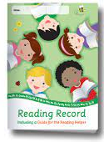
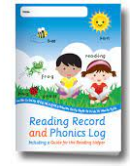
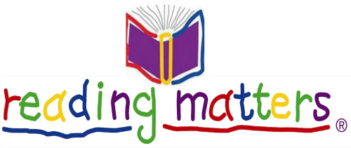

Dear Parents and Carers,

Thank-you for your support with your child’s reading at home- did you know that just ten minutes reading a day will have a big impact on your child’s literacy development and their likelihood to fall in love with reading!

With your child’s reading book is their Reading Record, this is for you to record the reading that your child does at home. Here are a few examples of the kind of comments are useful and informative that you could write to communicate this learning with your child’s class teacher.

• Understood the story well.
• Good discussion about events in the story.
• Retold the story in detail.
• Could talk about the story confidently.
• Answered questions about the content.
• Needs to read again to improve understanding.
• Used the pictures to assist understanding.
• Needed lots of help to understand the main events.
• Read all the words correctly
• Found some words difficult
• Tried hard to work out new words.
• Needs to practice again to reinforce the words.
• Read accurately and confidently.
• Was able to work out new words using picture clues.
• Read eagerly
• Enjoyed the story because ……
• Fantastic expression.
• Has learnt all about…………… and could explain in own words

I hope these suggestions are helpful to you when writing in your child’s reading record. It really is so important to listen to your child read – but we are also interested in books or reading material that you might be sharing with your child – for example - the books you may be reading at bedtime – do record these in the reading record as well – as it will help us to see what kinds of texts, they enjoy reading.

Thanks for all you are doing to encourage your child’s love of learning.

Miss Swan – Infant Academy Reading Leader

