Units of Study
Unit 1 | Colour
Unit 2 | Texture
Unit 3 | Tone
Unit 4 | Form & Space
Unit 5 | Line & Shape
Unit 6 | Pattern

National Curriculum 2014
Pupils should be taught six key themes of colour, pattern, texture, line, shape, form and space throughout each academic year. The scheme is designed flexibly so that these can either be:
- six half termly units married to the curriculum map
- or, six themes that are woven from elements of each strand across all the six half termly/three termly topic plans for each year group.

They are encouraged to explore art and design through a creative approach whilst at the same time developing skills in art, design and craft.
Throughout Key Stage 1 and 2 pupils should be taught about the work of famous Global and British artists and sculptors, craftsmen and designers, classical artists and architects through history – this is linked to the curriculum map for core and foundation national curriculum subjects.
EYFS | Year 1 | Year 2
Autumn 1  Mark making and Colour | Autumn 1  Texture and sculpture | Autumn 1  Texture and Drawing
Autumn 2  Tone | Autumn 2  Colour and painting | Autumn 2  Sculpture and 3D form and space
Spring 1  Textiles and Texture | Spring  Drawing and Tone | Spring 1  Design and Technology
Spring 2  Line and Shape | Spring 2  Printing and Line and Shape | Spring 2  Design and Technology
Summer 1  Form and Space & 3D Sculpture | Summer 1  Design and Technology | Summer 1  Pattern and Shape
Summer 2  Pattern and Sculpture | Summer 2  Form and Space- Sculpture | Summer 2  Colour and Printing

Year Groups | Suggested Global and British artists, sculptors, designers & architects to be studied across the units and key experiences linked to the curriculum map and academy schemes of work.
 | Painters & Sculptors | Designers & Architects
Reception | Kehinde Wylie  George Seurat  Justin Gaffery  Angie Lewin  Georgia O’Keefe  Richard Long  Beatrice Milhazes
Year 1 | Andy Goldsworthy  Jan Griffer  Lieve Vershuier  J.M.W Turner’s  William Morris  Niki de Saint Phalle | Christopher Wren
Year 2 | Paul Klee  Jean Metzinger  Esther Malangu  Andy Warhol  Roy Litchenstein

Reception
Unit of Study | Mark making and Colour | Tone | Textiles - Texture | Line and Shape | Form and Space – 3D sculpture | Pattern/ sculpture
Term | Autumn 1 | Autumn 2 | Spring 1 | Spring 2 | Summer 1 | Summer 2
Driver | Magical Me | Let’s Celebrate | The big wild world | Marvellous Minibeasts | Sensational Superheroes | Fantasy Worlds Wo
Overview | 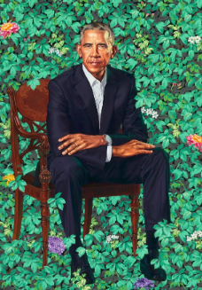 | 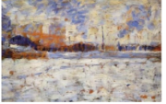 | 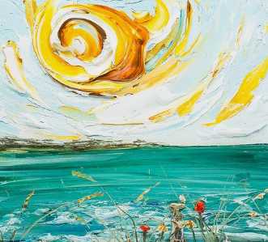 | 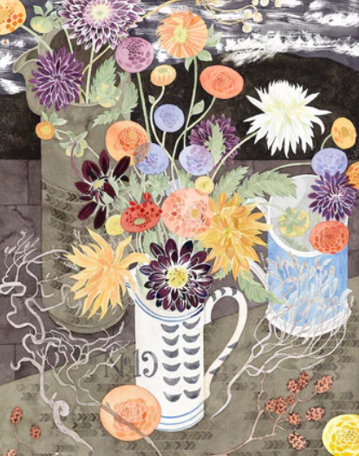 | 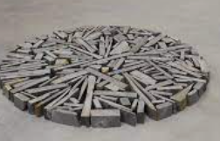 | 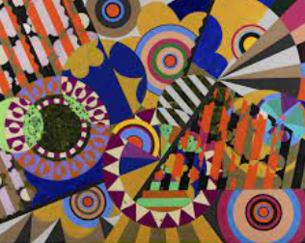  B
Key Experiences | Basic paint and routines, selecting & using tools & using materials.  Mixing paint thick/thin.  Recognising & naming primary colours and secondary colours.  Tools other than brushes.  Produce lines of different of Enjoy using graphic tools, fingers, hands and pencils.  Seasonal art: Autumn  Produce different thickness and tone using a pencil. | Tone: Recognising/ talking about light and dark places.  Recording dark and light.  Experimenting making dark and light pictures.  Colour  Explore colour and colour mixing. | Recognise pattern in their surroundings.  Alternate colour patterns.  Represent textures through paintings, drawings and malleable materials. | Make different kinds of lines, bumpy, spiky, zig-zag.  Make lines with a variety of materials and compare.  Recognise and name geometric shapes in the classroom and immediate environment. Sorting big and little shapes, | Experimenting with malleable materials.  Recognise simple geometric forms and join together.  Use a simple casting method.  Introduce a background & foreground. | Recognise pattern in their surroundings.  Alternate colour patterns.  Represent textures through paintings, drawings and malleable materials.  Experiment with 2D card shapes to create tessellation patterns.
Suggested Outcomes | Self-portraits during first week.  Create colourful ‘magical’ backgrounds using paint techniques such as bubble, splatter or straw. (Linked to topic Magical Me)  Digital – add photograph of child.  Drawing a family portrait linked to topic. | Splatter firework pictures. Day and night scene pictures. Colour mixing to make paint lighter or darker.  Winter themed pictures using pointillism techniques. | Colour mixing – looking at warm and colours.  Print pictures using a variety of objects.  Create a weaved basket. | Observational drawings of plants and vegetables.  Choose appropriate shapes to create a picture. | Design and create a 3D rocket or spaceship using junk modelling or clay.  Make a background then add objects.  Papier Mache planets | Making textured tessellations using clay to explore pattern inspired by Beatrice Mihazes artwork.  Design own cards with own patterns and designs.
Key Skills | Painting:  Use a range of tools including different size brushes and other objects e.g. sponge, fingers, twigs.  Recognise and name primary colours used.  Mix and match objects to different artefacts and objects.  Drawing  Collage:  Show experience: in fabric collage: layering fabric. | Drawing:  Produce lines of different thickness and tone using pencil.  Painting:  Look at and talk about what they have produced, describing simple techniques and media used. | Textiles:  Feel a variety of surfaces and describes.  Printing:  Enjoy taking rubbings: leaf, brick, coin. Simple pictures form objects.  Develop simple patterns by using objects. | Drawing:  Draw on different surfaces and coloured paper.  Start to produce different patterns and textures from observation’s, illustrations and imagination. | 3D and Sculpture: Enjoy using variety of malleable media such as class, papier Mache, salt dough. Impress and apply simple decoration.  Cut shapes using scissors and other modelling. | Drawing:  Draw on different surfaces and coloured paper.  Start to produce different patterns and textures from observation’s, illustrations and imagination.
Key Vocabulary | Hue, primary colours, secondary, splatter, draw, marks, line, bubble | Tone, light, dark, pattern, repeat, pointillism, dot, | Lumpy, bumpy, rough, smooth, stripped, zig zag, spiky | Line, shape, tone, cross-hatching, artist, dot, sketch, contour | Sculpt, 3D, 2D, form, model, shape, create | Mosaic, spirals, symmetry, colourful, inspires,
Suggested Artists/Sculptors/ Designers and Architects | Kehinde Wylie - portraits  Piet Mondrian - colour appropriate artists featuring colour backgrounds. | George Seurat  Ana Enshina – visual artist.  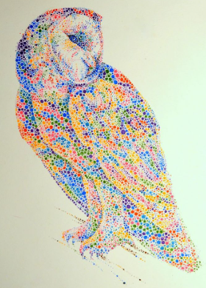 | Justin Gaffery – landscape paintings. | Angie Lewin – flowers.  Georgia O’Keeffe | Richard Long – sculpture and land art. | Beatrice Milhazes - pattern
Suggested Resources & Stimuli | Ready mixed paints/palettes  Brushes/natural materials  Rainbow pictures.  Pencils/crayons, charcoal  Book: ‘The Colour Monster’ by Anna Llenas | Splatter pictures  George Seurat – pointillism techniques  Book – ‘The Owl who was afraid of the Dark’ by Jill Murphy | Book ‘Handa’s Surprise’ by Eileen Brown.  Animal print pictures.  Collage materials using natural and man-made. | Use lines and shapes to sketch plants and flowers in the Reception garden or large field. | Press objects into media.  Experiment with malleable materials to create a sculpture inspired by Richard Long.  Construct a space ship using shapes in the outside area. | Compare and contrast different patterns in environment. Feel different surfaces and describe textures. Take photos on the Ipad and describe the patterns they see.

Year 1
Unit of Study | Texture and sculpture | Colour and painting | Drawing and Tone | Printing and line and shape. | Design and Technology | Form and Space - sculpture
Terms | Autumn 1 | Autumn 2 | Spring 1 | Spring 2 | Summer 1 | Summer 2
Driver | Teddy Bears | Frozen Planet | Great Fire of London | Growing | Explorers | Animals
Overview |  | 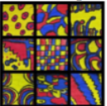 | 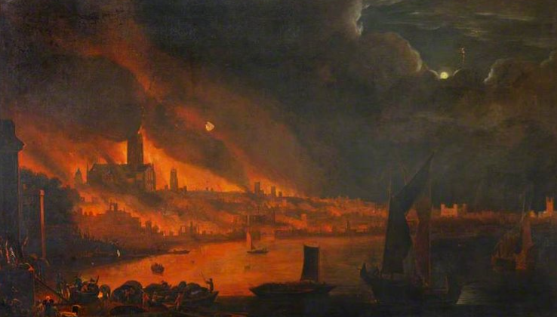 | 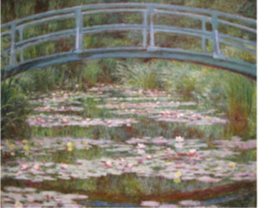 | Design and Technology | 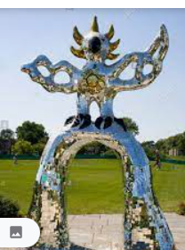
Key Experiences | Select natural materials from a selection of natural and manmade materials.  Make a simple collage for large classroom display.  Threading activities in Busy Bays, exploring ‘up and down/’in and out’ techique when threading wool/string in and out of holes | Basic paint outines, using tools & using materials. Collecting and sorting colours.  Mixing and matching colours.  Using tools other than brushes. | Experimenting with adding white/black to a colour.  Experimenting with dark and light.  Record the effect of dark and line on simple objects.  Research how artists use light. | Children explore print using a variety of 2D and 3D objects; Children explore colour when printing with a variety of man-made and natural materials;  Children use a variety of tools when exploring print (rollers, stamps, brushes etc) | Design and Technology | Recognise the difference between 2D and 3D forms and choose appropriate ‘found’ to represent ideas.  Experimenting with a variety of malleable materials;  Experiment with a variety of tools; Carve details into malleable materials
Suggested Outcomes | Children use a variety of natural and man-made materials when using a weaving technique to create a piece of art based on the artist Gunta Stolz | Once completed it could be put together to create a large scale collaborative artwork Or draw a large scale chalk mural on the outside playground. | Children create their own piece of artwork based on ‘The Burning of the Houses of Lords and Commons (1834) by J.M.W Turner. | Children use a printing technique to create a piece of floral artwork to go on the front of Mother’s Day cards | Design and Technology | Children create their own clay model of an animal of their choice
Key Skills | Textiles/Collage  Use a variety of techniques, e.g. weaving, finger knitting, fabric crayons, sewing and binca.  How to thread a needle, cut, glue and trim material.  Create images from imagination, experience or observation.  Use a wide variety of media, inc. photocopied material, fabric, plastic, tissue, magazines, crepe, paper etc | Painting  Use a variety of tools and techniques including the use of different brush sizes and types.  Mix and match colours to artefacts and objects.  Work on different scales.  Mix secondary colours and shades using different types of paint.  Create different textures e.g. use of sawdust | Drawing  Use a variety of tools, inc. pencils, rubbers, crayons, pastels, felt tips, charcoal, ballpoints, chalk and other dry media.  Use a sketchbook to gather and collect artwork.  Begin to explore the use of line, shape and colour | Printing  Make marks in print with a variety of objects, including natural and made objects.  Carry out different printing techniques e.g. monoprint, block, relief and resist printing.  Make rubbings.  Build a repeating pattern and recognise pattern in the environment | Design and Technology | 3D form  Manipulate clay in a variety of ways, e.g. rolling, kneading and shaping.  Explore sculpture with a range of malleable media, especially clay. Experiment with, construct and join recycled, natural and man-made materials. Explore shape and form.
Key Vocabulary | Decay, landscape, natural form, sculptor, sculpture, temporary, environment, nature. | Primary colours, secondary colours, red, yellow, blue, orange, green, purple, mixing, paint, tint, white, lighter, pale, shade, black, dark, darker, brush | Media, colours, red, yellow, orange,  white, light, lighter, black, dark, darker, tone, shade, pencils, crayons, pastels, chalk, foreground, background, line, thick, thin, curve, drawing, detail, landscape, building, bold, size, observe,  artist, mood, tone, painting,  fire, smoke, dull, mix, smudge. | Calligraphy, print, texture, imprint, impression, surface, pressure, image, | Design and Technology | Clay, roll, mould, carve, stretch, join, sculpt, 3D, pinch, model, flat, rough, smooth
Suggested Artists/Sculptors/ Designers and Architects | Andy Goldworthy: Working with nature.  Lisa Kokin – leaves.  Gunta Stolz – weaving |  | Jan Griffier  Lieve Verschuier  J.M.W Turner’s | William Morris |  | 3D Form  Niki de Saint Phalle: Animal sculptures – Firebird, fibreglass and steel 1983.  Explore shape and form using clay.
Suggested Resources & Stimuli | Science topic based on Autumn,  Make textured pictures/patterns using one or more textures.  Class collage linked to a particular theme. | Angus and the Colourful Day’ Alyssa Serfling | History topic based on The Great Fire of London.  The Great Fire of London painting by Jan Griffier 1 (1652 – 1718).  The Great Fire of London painting by Lieve Verschuier  The Burning of the Houses of Lords and Commons (1834) by J.M.W Turner. | Science topic ‘Growing’, drawing the structure of common plants and trees |  | Science topic: Animals  Animal workshop  Visit to Sacrewell farm

Year 2
Unit of Study | Texture and drawing | Sculpture and form and space |  |  | Pattern and shape | Colour - Printing
Terms | Autumn 1 | Autumn 2 | Spring 1 | Spring 2 | Summer 1 | Summer 2
Driver | Castles, Knights and Dragons | What’s On Our Doorstep? |  |  | Africa | Life in the 1950’s
Overview | 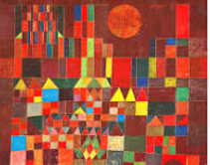 | 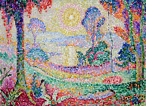 |  |  | 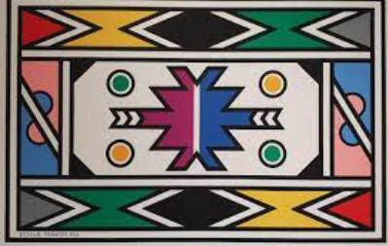 | 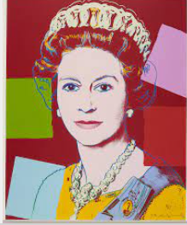
Key Experiences | Make rubbings. Add texture to paint  Represent texture whilst creating a castle scene.  Make textured surfaces.  To collect own resources from school grounds to create a textured picture. | Use rigid materials.  Introduce perspective and sketch a view from near and far at school or at home.  Make simple class or salt dough forms.  Use shapes to create more complex forms. |  |  | Use pattern to enhance shape.  Mirrored pattern.  Look at patterns in history.  Simple tessellation.  Pressing into clay or dough. | Mixing colour.  Mixing from a limited palette.  Painting techniques.  Use paint opaquely and transparently.  Primary and secondary colours.  Warm and cool colours.
Suggested Outcomes | To produce a sketch of a castle which will be used to make a castle scene.  To make a textured castle scene. Rub different materials such as wood, walls, stone, brick to explore different textures.  Painting patterns using one or more textures. | To plan a sculpture through drawing and any other preparatory work.  To create a clay tile house. |  |  | To create Kente cloth using repeating and tessellating patterns.  Weaving in the style of Kente and Esther Malgalu style. | To create pop art using pressing and printing.
Key Skills | Texture  Match and sort fabrics and threads by colour, texture, length, size and shape.  Change and modify threads and fabrics, knotting, fraying, fringing, pulling threads, twisting, plaiting.  Cut and shape fabric using scissors/snips.  Apply shapes with glue or by stitching. | 3D shape and form  Manipulate malleable materials in a variety of ways including rolling and kneading.  Explore sculpture with a range of malleable media.  Manipulate malleable materials for a purpose, e.g. pot, tile.  Understand the safety and basic care of materials and tools.  Form  Experiment with constructing and joining recycled, natural and manmade materials.  Use simple 2-d shapes to create a 3-d form.  Texture  Change the surface of a malleable material e.g. build a textured tile.  Draw |  |  | Texture  Create fabrics by weaving materials, e.g. grass through twigs, carrier bags on a bike wheel.  Drawing/shape  Observe and draw shapes from observations. Draw shapes in between objects. Invent new shapes. | Print  Print with a range of hard and soft materials, e.g. corks, pen barrels, sponge.  Make simple marks on rollers and printing palettes.  Make simple prints, e.g. mono printing.  Roll printing ink over found objects to create patterns e.g. plastic mesh, stencils.  Build repeating patterns and recognise pattern in the environment.  Create simple printing blocks with press print.  Design more repetitive patterns.  Colour  Experiment with overprinting motifs and colour.  Texture  Make rubbings to collect textures and patterns.  Create simple printing blocks with press print.  Design more repetitive patterns.  Colour  Experiment with overprinting motifs and colour.
Key Vocabulary | Texture, shape, twist, fray, modify | Mould, knead, roll, form, shape, manipulate, |  |  |  | Repetition, motif, collagraphy, print texture
Suggested Artists/Sculptors/ Designers and Architects | Paul Klee, Castle and Sun, oil on canvas 1928. | Jean Metzinger |  |  | Kente and Esther Malangu | Andy Warhol  Roy Litchenstein  Portraits from children’s families.
Suggested Resources & Stimuli | Make textured pictures, patterns using one or more textres. | To take a walk in the surrounding environments and look at houses and streets. |  |  | Tinga Tinga animal pictures.

