Anti-Bullying Policy

Statement

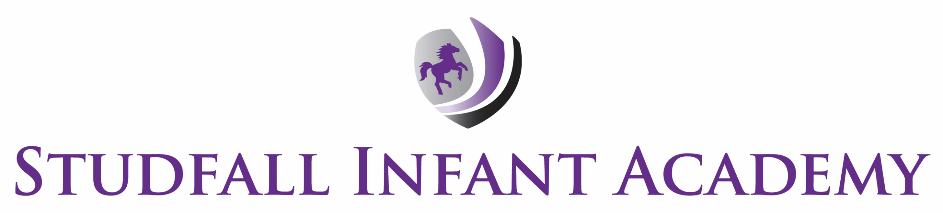

REVIEW PROCESS
Written | Oct 2023
Next Review | Oct 2024

The purpose and scope of this policy statement

The purpose of this policy statement is:
- to promote a happy and secure environment which prevents bullying from happening between children and young people who are a part of Studfall Infant Acacdemy.
- to take positive action to prevent bullying from occurring
- To create a whole school ethos in which pupils feel confident to raise their concerns about bullying both in and out of school.
- To work in partnership with parents to ensure that bullying is reported, dealt with thoroughly and stopped and that those involved receive the support they need
- To work with the children involved to overcome instances of bullying and ensure that the root causes are dealt with.

This policy statement applies to anyone working on behalf of Studfall academies including all staff, volunteers, agency staff and students.

What is bullying?
Bullying includes a range of abusive behaviour that is
- repeated
- intended to hurt someone either physically or emotionally.

The NSPCC definition of bullying is:
Bullying is when individuals or groups seek to harm, intimidate, or coerce someone who is perceived to be vulnerable (Oxford English Dictionary, 2021).
It can involve people of any age, and can happen anywhere – at home, school or using online platforms and technologies (cyberbullying). This means it can happen at any time.
Bullying can be a form of discrimination, particularly if it is based on a child’s disability, race,
religion or belief, gender identity or sexuality.

Learning to understand and manage conflict is an important part of growing up. Bullying is not simply a 'falling out'. Research shows that experiencing bullying can have a significant impact on a child's life well into adulthood.

Types of Bullying
According to the Anti-Bullying Alliance, bullying can be physical, verbal, or psychological. It can happen face-to-face or online.
Physical bullying refers to any behaviour that physically hurts another child, verbal bullying refers to the use of words to emotionally hurt another child. Psychological bulling can refer to other non-physical behaviours carried out with the intention of emotionally hurting the other child, such as leaving them out, or threatening them.
Bullying can also be related to:
- Disability
- Race
- Religion or belief
- Sex
- Sexual orientation
- Age
- Gender reassignment

We take incidents of bullying outside of school time, online or face-to-face, equally as seriously as incidents that take place in school that occur between pupils of Studfall Infant Academy

Signs and Symptoms
A child’s behaviour may change if they are being bullied. Adults should be aware of these signs in children. If noted by parents, these signs should be discussed with the Class Teacher as soon as possible. If noted by a member of school staff, they should be logged and discussed with the Class Teacher.
A child who is being bullied may:
- Be frightened of attending school and display real or imagined illness such as sickness, headache, or stomach pains.
- Be frightened of walking to or from school
- Become withdrawn, anxious, or lacking in confidence
- Begin to perform poorly in school work
- Become aggressive, disruptive, or unreasonable
- Have unexplained injuries
- Have unexplained damage to belongings
- Be frightened to use the internet or mobile phone

We will seek to prevent bullying by:
Ensuring all adults are familiar with Studfall Academies Behaviour Policy and Safeguarding policies and procedures
Ensure pupils are taught through PSHE, Assemblies, day to day interactions and the wider curriculum about how to behave and conduct themselves, using our core values of nurture , discover , believe and achieve and shine.
Ensuring the wider curriculum is representative of our diverse community and respects and recognises difference and diversity
Holding regular discussions with staff, children, and families about bullying and how to prevent it
Providing support and training for all staff and volunteers on dealing with all forms of bullying, including racist, sexist, homophobic, transphobic, and sexual bullying
Ensuring all incidents of bullying are fully recorded using CPOMs and this is monitored by members of the Leadership team
Regularly reviewing our preventative measures to ensure they are having a positive impact

Responding to bullying
We will make sure our response to incidents of bullying takes into account:
- the needs of the person being bullied
- the needs of the person displaying bullying behaviour
- needs of any bystanders
- our organisation as a whole.

We will review the plan we have developed to address any incidents of bullying at regular intervals, in order to ensure that the problem has been resolved in the long term.

Related policies and procedures
This policy statement should be read alongside our organisational policies and procedures including:
- GAT Behaviour and Exclusions
- Studfall Academies Behaviour Protocol
- GAT Safeguarding Policies and Procedures
- Studfall Academies Site Specific Safeguarding Arrangements
- GAT SEN and Disability Policy
- GAT Equalities, Diversity, and Inclusion Policies
- GAT E-safety Policy

