Pupil premium strategy statement 2025 - 2026
Studfall Infant Academy

This statement details our school’s use of pupil premium funding to help improve the attainment of our disadvantaged pupils.

It outlines our pupil premium strategy, how we intend to spend the funding in this academic year and the effect that last year’s spending of pupil premium had within our school.

School overview
Detail | Data
School name | Studfall Infant Academy
Number of pupils in school | 359
Proportion (%) of pupil premium eligible pupils | 25/26  Rec – 8/91 (8.79%)  Yr 1- 20/116 (17.2%)  Yr 2- 39/115 (33.9%)  67 children  24/25  Rec – 10/114 9%  This is initial figures for reception  Yr 1 – 35/116 30.1%  Yr 2 – 24/111 21.6%  69 children +  23/24  Rec – 25/114 20.2%  Yr 1 22/109 20.2%  Yr 2 26/115 22.6%  73 children
Academic year/years that our current pupil premium strategy plan covers (3-year plans are recommended) | 2025-2026
Date this statement was published | September 2025
Date on which it will be reviewed | September 2026
Statement authorised by | Kim Kirchin
Pupil premium lead | Karen Parris
Governor / Trustee lead | Charlotte Krzanicki
Funding overview
Detail | Amount
Pupil premium funding allocation this academic year | £111,013
Recovery premium funding allocation this academic year | £ 0
Pupil premium funding carried forward from previous years (enter £0 if not applicable) | £0
Total budget for this academic year  If your school is an academy in a trust that pools this funding, state the amount available to your school this academic year | N/A

Part A: Pupil premium strategy plan

Statement of intent
- We aim for our PP children to achieve their full potential on both academic and personal development. This includes having a rich and varied curriculum and a broad vocabulary.
- We use our skilled staff in school to support academic development and support emotional well-being and foster excellent attendance.
- We support family’s financial well-being and engagement with the school via a virtual allocation of funds to support school activities – such as trips and funding uniform and school photos
- The key principals of the strategy plan are to develop the key skills of numeracy and literacy for PP pupils to be in line with national expectations.
Nurture – we will ensure that all children’s basic needs are met
Believe – we will celebrate difference and strengths to help build aspirations and self-belief.
Discover – we will ensure that we will offer a wide curriculum which will allow the children to explore and discover and try new things.
Achieve and shine – we will ensure that each child has a feeling of success in a range of areas. We will enable them to find their strengths.

Challenges

This details the key challenges to achievement that we have identified among our disadvantaged pupils.
Challenge number | Detail of challenge
1 | Financial situation in Corby and local area deteriorating – we have dropped from D6 to D4
2 | Parental engagement to encourage academic engagement is sporadic.
3 | Lower attainment – with a diverse range of complex children and families and growing numbers of SEN children, particular children with EHCP’s in mainstream
4 | Low level of spoken language in some families
5 | Emotional well being of children and families at a lower level (impacted by pandemic too) – the attitude to learning/Independence

Intended outcomes
This explains the outcomes we are aiming for by the end of our current strategy plan, and how we will measure whether they have been achieved.
Intended outcome | Success criteria
Children’s levels of attainment and progress are good in all core areas of the curriculum | Children in all year groups will be achieving their targets and will be closer to national averages.
For children’s well being to be enhanced and for them to have positive attitudes to learning. | Children’s pupil’s voice evaluation with LM and MHST questionnaires to show progress in their well-being.
Speech and language levels will increase | Through the use of staff to deliver our SALT programmes – children’s speech development will increase – monitored with Speech therapists. This will also impact on achievement in literacy.
Whole School attendance to be in line with national expectations | Whole school attendance will be monitored and celebrated.  Last year school absence rates were 6.1% compared to 5.2% national.  Attendance will impact attainment.

Activity in this academic year
This details how we intend to spend our pupil premium (and recovery premium funding) this academic year to address the challenges listed above.

Teaching (for example, CPD, recruitment and retention)
Budgeted cost: £44,813.00
Activity | Evidence that supports this approach | Challenge number(s) addressed
To support use of ELS in Rec/Yr 1, including interventions in Yr 2 where children have not met yr 1 expectation. Support training for all staff, which will help with supporting families too.  Run a series of parent workshops in Rec and year 1 to introduce the scheme and provide home based resources to support parents and home learning  ELS subscription and resource renewal, including books.  5100 | Phonics approaches have been consistently found to be effective in supporting younger readers to master the basics of reading, with an average impact of an additional four months’ progress. Research suggests that phonics is particularly beneficial for younger learners (4–7-year-olds) as they begin to read.  This will help to further improve the quality of teaching in phonics | 2 & 3
Maintain and enhance high quality teaching and learning within school through whole school monitoring and development to improve quality first teaching.  5500 | By supporting teacher’s progression though pay scales and maintaining the high proportion of UPS teachers we have – we are able to effectively deploy quality teaching – including flexible teaching groups - this shown to have an impact on pupils attainment.  Leadership capacity within the academy – VP/SENDCO out of class. £ 29,913 to part fund this | 2,3,4 and 5
Enhance high quality teaching within the academy – through external training for staff to develop skills to support PP premium children  Implementation of emotional literacy support, linked to understanding of emotions/ emotion coaching  Further develop use of Zones of regulation strategies and resources to support this  £4300 | External and internal training opportunities sought to enhance staff development around meta cognition.  Metacognition and self-regulation approaches aim to help pupils think about their own learning more explicitly, often by teaching them specific strategies for planning, monitoring and evaluating their learning. Interventions are usually designed to give pupils a repertoire of strategies to choose from and the skills to select the most suitable strategy for a given learning task. Metacognition and self-regulation approaches have consistently high levels of impact, with pupils making an average of seven months’ additional progress. | 3, 4 and 5

Targeted academic support (for example, tutoring, one-to-one support structured interventions)
Budgeted cost: 50,450.00
Activity | Evidence that supports this approach | Challenge number(s) addressed
Small group catch up in year 2 for teaching of phonics – three tiered support with those near to target and those requiring ‘catch up’ programme (small group catch up – phonics)  4150 | Quality teacher input – from teachers that know the children and where to start from – EEF recommend and NTP funded.  Impacted on last year’s Year 2 phonics outcomes  This small group arrangement enables the teacher to focus exclusively on a small number of learners, usually in a separate classroom or working area. Intensive tuition in small groups is often provided to support lower attaining learners or those who are falling behind, but it can also be used as a more general strategy to ensure effective progress, or to teach challenging topics or skills. | 3
Reception and Year 1 interventions – additional reading, phonics, tailored programmes and fine motor.  ELS individual ‘Keep Up’ interventions daily with TA, approximately 60 mins per day, 1:1  Individual SALT programmes delivered x2 weekly 1:1  NELI – small group input  Individual reading Rec /Year 1/Year 2 1:1 with TA weekly in addition to class teacher read.  Staff training to implement assessment for children working pre NC in KS1. Develop use of INSIGHT to track progress  Extend training to class teachers through staff meetings and coaching systems  Individual focus on  LAC – 1:1 and small group support (phonics, numeracy, fine motor support, speaking and listening)  £34,000 | This small group arrangement enables the teacher to focus exclusively on a small number of learners, usually in a separate classroom or working area. Intensive tuition in small groups is often provided to support lower attaining learners or those who are falling behind, but it can also be used as a more general strategy to ensure effective progress, or to teach challenging topics or skills.  Target group addressing the higher number of children identified as SEN/PP  Rec – currently 2 SEN/PP  Year 1 – currently 6 SEN/PP, 2 of which have an EHCP  Year 2- 20 children PP/SEN support 8 of which have an EHCP and 1 SEMH | 2 & 3
TA interventions – structured and supported by teachers  SALT speech therapists - £3600  Purchase of speech and Language support  £5000 – TA | Regular planned interventions – using SALT programmes , reading and writing interventions . We also pay additionally for access to enhanced speech and language support. This is factored partially into the costs. | 3
Purchasing of books – through book Fayre – child’s choice and also texts to support learning.  700 | Reading comprehension strategies and engagement with reading have a very strong evidence base to help children to achieve to their potentials. | 1 & 3

Wider strategies (for example, related to attendance, behaviour, wellbeing)
Budgeted cost:15750.00
Activity | Evidence that supports this approach | Challenge number(s) addressed
Learning mentor bespoke support for children and families  £7000 | Behaviour support strategies – identified by EEF as effective. This will lead to decrease in problematic behaviour and have an impact on attainment. Pupils need to be emotionally ready to learn. | 5
Financial support for families – trips, uniform, food, emergency cost of living support etc – virtual £50 voucher  5000 | We have analysis from the local authority to show the drop in financial wellbeing for our community. This helps to alleviate some of the clear financial stress and enable children to access all aspects of school life. | 1
Support for attendance at school – breakfast club places , after school curriculum clubs  3500 | The evidence indicates that, on average, pupils make two additional months' progress per year from extended school time and in particular through the targeted use of before and after school programmes. There is some evidence that disadvantaged pupils benefit more, making closer to three months’ additional progress. There are also often wider benefits for low-income students, such as increased attendance at school, improved behaviour, and better relationships with peers. | 2 & 3
Additional lunch time and after school coach support – Gymnastics/social Interaction skills.  250 | Team work will build the necessary social skills needed to work collaboratively – which has been shown to enhance a child’s ability to learn. | 1 & 2

Total budgeted cost: £ 111,013

Part B: Review of outcomes in the previous academic year

Pupil premium strategy outcomes
This details the impact that our pupil premium activity had on pupils in the 2024 to 2025 academic year.
Children’s levels of attainment and progress are good in all core areas of the curriculum
Percentage of disadvantaged children achieving GLD Reception 2024-2025 (6 out of 19 children SEN support)
Disadvantaged | 47% Below | 16% Int | 37% Expected
Non disadvantaged | 29% Below | 9% Int | 62% Expected
Disadvantage less EHCP | 41% | 18% Int | 41% Expected
Non disadvantage  Less EHCP | 20% | 9% Int | 65% Expected

Key Stage One
Year 1 data for core subjects
11 pupils with SEN support and 8 children with EHCP
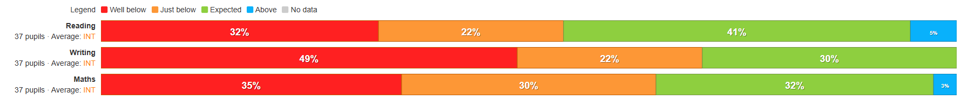
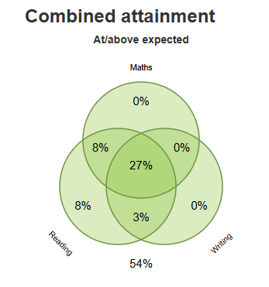

Year One Phonics
54% of children passed Phonic screener
77% Non disadvantaged
Less EHCP
66% of children passed
78% non disadvantaged
Big impact on disadvantaged group with number of EHCP plans. When removed from data, the gap between disadvantaged and non disadvantaged narrows significantly.

Year Two, 11 children with SEN support, 3 with EHCP plan
Core subject – non disadvantaged
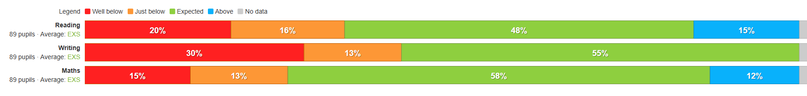
Core subjects - disadvantaged
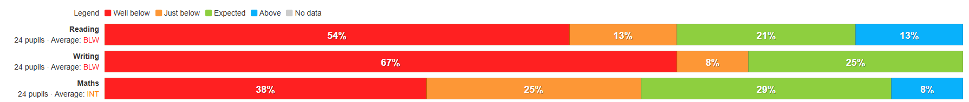
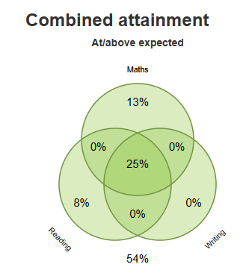

Year 2 phonics
63% disadvantaged children achieved passed phonics by the end of Year 2
87% - non disadvantaged achieved phonics pass
71% disadvantaged had passed (without EHCP)

For children’s well being to be enhanced and for them to have positive attitudes to learning.
Learning mentor – completed ELSA training
Continued support with Mental health team, including therapy for younger age groups, eg Happy heads, strengthening families, SSS, School nurse, drop in workshops for SEN and mental health awareness.
Close relationships with families, regular meetings with learning mentor/SENCO/Principal
Shared EHA’s with DSL’s
Children more aware of expectation – incentives/class dojo/token economy systems/individualised reward charts and incentive systems/alternative approach/nurture based curriculum.
All class teachers are responsible for reasonable adjustments, supported by the SENDCO

Speech and language levels will increase

Listening, attention and understanding

58% of reception children reached expected levels
80% non disadvantaged children reached expected levels

Speaking

63% of reception children reached expected levels
81% non disadvantaged children reached expected levels

Speech and Language
Continued input from SALT team, training in Gestalt language communicators, Intensive Interaction and communication booklets. Caseload reduced with SALT advice and resources shared.
SALT plans have been closed with new style system where parents and staff participate in evaluation and next steps/support moving forward.
SALT have conducted reviews/assessments in school, with TA and parents working together in a series of sessions.
Whole School attendance to be in line with national expectations

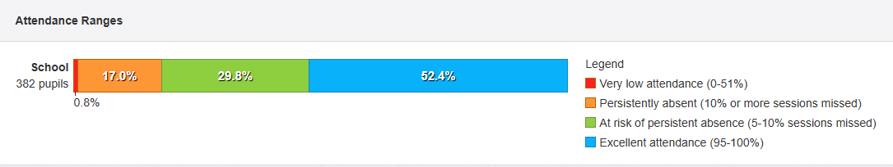

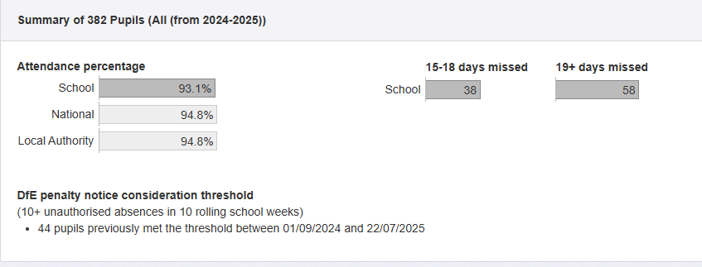

2024 – 2025 Gap between school and national – 1.7%

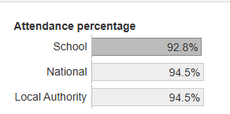

2023 – 2024 gap between school and national – 1.7%

The gap has not increased, however prior to this, the gap was 2.6% showing that we have maintained the decreasing gap.

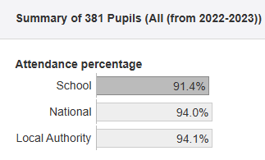

Further information (optional)

