Newsletter 2
Monday 30th September 2025
Dear Parents/Carers
Snacks and lunches 
We are lucky to be able to access the free fruit programme for our children. This means the children get a free piece of fruit or a vegetable every day. If your child brings in snacks instead of this please can they also be either a fruit or a vegetable. We hold a Bronze School Healthy award – so are keen to promote healthy eating – so no fizzy drinks please.
School lunches are planned to be nutritious, and many packed lunches are too.
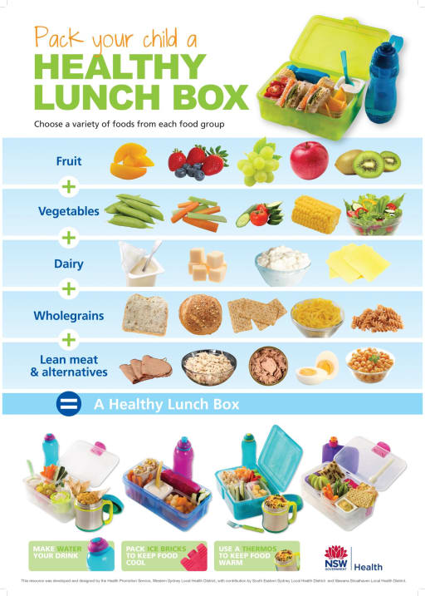
Please note too – we are a nut free school – with a number of children and adults who have nut allergies.

Communication
Thanks so much to all of you who have reconnected with Class Dojo - it’s a great way to have a chat with teachers and also see how your child is getting on and celebrate the number of points they have.
You will notice that we are using our new school information service Arbor , to email you . We are hoping to be able to rill out more services to you on this platform soon.
For any absence information please do not contact teachers on dojo – as this isn’t checked at all times. If your child is unable to attend school due to illness or unavoidable circumstances, please contact the school on each day of absence by:
Calling the Office – 01536 264540 – we have a message service out of hours.
Emailing admin@studfallinfantacademy.org
From 1st Nov Groupcall will no longer be used to report absence – so please use the methods above.
Please note that we do not authorise holidays during term times – taking holidays in term times would lead to a fine being issued by the Local Authority. Regular attendance is so important and is positive factor in making great progress at school.
Parking around school 
Please can you be very aware of where you park – we do not wish to upset our neighbours or have a dangerous environment around the school – so please park safely and responsibly. Neighbours in Clifton Square have reported their road being blocked – please park a bit further away and walk.
Please can we also ask that bikes and scooters are stored in the shelter near to our nursery rather than being brought onto the playground – it gets very busy, and we’d hate for there to be an accident – thank you.
Applying for a place at the Junior School and Reception Sept 26
We have emailed out information regarding how to apply for a place at the Junior School . This needs to be completed by Jan 15th 2026 – but the portal is open now .
http://www.northnorthants.gov.uk/school-admissions
This is the place to apply for a place for Year 3 at the Juniors and also for a place for Reception in 2026 – we’d love our nursery families to apply for a place with us .
APPLICATIONS FOR Pupil Premium
It’s really important for our school that all pupils who meet the criteria apply to get the support they need – applying for this funding can also really help our school too!
Even if your child is in Reception/Year 1 or Year 2 and therefore gets a free meal anyway, please do still apply if you think you meet the criteria outlined in this letter as this will generate pupil premium funding for your child and other extra funding into the school. We also want to make sure as many families as possible benefit from this additional support – which will continue in the Junior Academy. If you are eligible – we allocate £ 50 of support for uniforms ( ordered by us) , trips etc and also families will become eligible for vouchers for food support over the school holidays if you are able to claim this benefit.
To be eligible for free school meals you must be in receipt of the following benefits:
- Income support
- Income-based Job Seekers Allowance
- Child Tax Credit, with no Working Tax Credit, with an income below £16,190
- Universal Credit
- Universal Credit and employed – take home pay must be no more than £616.67 per month
Please do not apply if you are receiving:
- Working Tax Credit, if so you are not entitled to pupil premium no matter what your annual income is;
- Universal Credit and you or your partner you are living with are employed and your ‘take home pay’ is more than £616.67 a month
- Child Tax Credit with no Working Tax Credit, your annual income must be no more than £16,190 to receive free school meals.
If you feel you meet the eligibility criteria we would be most grateful if you could please fill in the application form which is located at the link below and submit it to the local authority – we are North Northamptonshire
https://forms.northnorthants.gov.uk/service/Pupil_premium_application

If you need any additional support with this – please do contact the school office.
Dates for your diary
- Wednesday 1st October Year 2 Trip to Rockingham Castle
- Thursday 9th October – Individual and sibling photos
- Parent consultations - 15th and 16th October – 3.30 – 5pm
- Tuesday 21st October Halloween Disco – Year 2 – 4-5pm
- Wednesday 22nd Halloween Disco – Reception – 4.- 4.45pm – Year 1 5 – 5.45pm
- Thursday 23rd October – Flu Inoculations
- Friday 24th October – Close for half term and Wear Red Day
- Monday 3rd November– School re opens
- Monday 10th November – Start of Anti Bullying and E safety week
- Thursday 4th December – Pantomime
- FRIDAY 5th DECEMBER – TRUST WIDE TRAINING DAY – SCHOOL SHUT TO CHILDREN
- Wednesday 17th December – Year 1 Christmas Production
- Friday 19th December – school closes for Christmas
- Monday 5th January 2026 – school opens (no training day)
Best wishes and thank you for all your continued support

Kim Kirchin

