Newsletter 6

Monday 5th Jan
Dear Parents/Carers

We hope that you all had a great Christmas and a fantastic new year. The weather looks changeable over the next few weeks. Can you make sure your child has their name in coats etc – as we will find it easier to return them. Please do take care with icy surfaces too – the playground and areas will be gritted overnight – but areas like the tyres will be slippy – so please stay off these.
We do have a good range of clothes at our main office – which are available to take – we are very keen to reuse these good quality clothes – so please look here before buying new ones .
Year 2 Admissions to Year 3 at Studfall Junior Academy and Nursery children for Reception in 25 / 26
Year 2 families will soon need to be making applications (if you haven’t already done so) for our fantastic Junior Academy. The application process closes on Jan 15^{th,} and you are notified of a place on April 16th. This is the website link that you need to use to complete an application. This is the same link for families applying for a place for children joining school in 25/26 in Reception – which includes children in our nursery - don’t forget to apply This is the link .
https://northnorthamptonshire.synergy.hsc.accessacloud.com/SynergyWeb/SchoolAdmissions.aspx
We would urge all families to complete this before January 15th. Please do talk to Year 2 teachers, Nursery Staff or the school office if you need any help.

Packed lunches 
Just a quick reminder to say no nuts in packed lunches please – we do have children in school with allergies and we share a hall to eat – so please do not put them in your child’s lunch. Some other classes may have specific requests for children with other allergies – thanks as always for your support with this .

Winnie the Pooh Day 
This is coming up on Friday January 16th – we complete activities in the class with children around the bear and use the stories to explore our feelings and emotions. If children wish to bring in any Winnie the Pooh items or wear connected items – that would be great.

Attendance 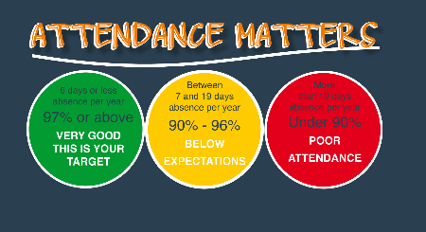
We know there are a number of bugs and infections around – but please ensure your child is at school as often as they can be. Guidance from the NHS – which we follow is available here –
https://www.nhs.uk/live-well/is-my-child-too-ill-for-school/
We do understand that if your child is ill – it is important for them to be at home to avoid spreading illness to others as well.
Please ensure you contact school every day of your child’s absence - please contact admin@studfallinfantacacdemy.org or call 01536 264540 before the start of the school day. Dojo messages may not be picked up before school. Holiday dates for the next year are on our website and have already been shared– please note that holidays outside of holiday times cannot be authorised.
Dates for your diaries
- Friday 16th January Winnie the Pooh day
- Feb 9th – 13th – Children’s Mental Health Week
- Friday Feb 13th Close for half term
- Monday 23rd February – open
- Wednesday 25th Feb and Thursday 26th Feb– Parents evening 3.30 – 5.30 . Book Fair will be here for this
- Thursday March 5th – World Book day – we’ll be dressing up for this
- Mon 9th – Fri 13th March – Science Week
- Tuesday 17th March – Rock Steady concert – 2.30pm
- Wednesday 25th March – Easter Fayre 3.30pm – 4.15 pm – Easter Bonnet competition!!
- Thursday 26th March - Reception Concert am and pm – times TBA
- Friday 27th March – close for Easter holidays
- Monday 13th April – Open for Summer term

Best wishes and thank you for all your continued support

Kim Kirchin

