Newsletter 7

Monday 19th Jan
Dear Parents/Carers
We are hoping that the next few weeks will be a little more seasonal for weather – but please do wrap the children up warm – names on all items is really helpful for us as lots gets left.
Big school bird watch 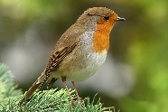
Next week - we shall be taking part in the Big School birdwatch – children will be able to identify birds with me on the playground one dinnertime. I’ll be talking to the children about recognising birds and why we are doing this – but if you are able to look at the birds around school with your children – that will be really helpful.
Parking 
I have had many conversations with lots of you about the awful parking outside and around our school. I really do urge you all to think carefully about where you park – don’t park on double yellows – keep the front of the school clear and please don’t park on or across our neighbours’ drives. We really want to ensure none of children are hurt. Please do not park close to the entrance to the school - it’s so busy and parking on the corner obstructs other cars moving past too.

Reading at home 
Thanks to all of you who read with your children at home – including their school reading book, reading this book at home 4 times a week makes all the difference to your child’s progress and is a key factor in all of their learning. We give children dojos for reading at home and would encourage you all to do this.
With this in mind we have a reading café on Wednesday 28th Jan at 2.30 pm . This is when you can pop into your child’s class and share a book together.

Medicine in School
If your child is prescribed or needs medicine and this is to be given in school – please make sure that you take this to the main school office where you can complete a form to tell us all the information we need. Please note that you should not send your child in with medication without letting us know. Where possible medication should be given at home – including antibiotics with three doses.

Attendance 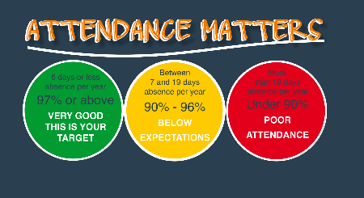
We know there are a number of bugs and infections around – but please ensure your child is at school as often as they can be. Guidance from the NHS – which we follow is available here –
https://www.nhs.uk/live-well/is-my-child-too-ill-for-school/
We do understand that if your child is ill – it is important for them to be at home to avoid spreading illness to others as well.
Please ensure you contact school every day of your child’s absence - please contact admin@studfallinfantacacdemy.org or call 01536 264540 before the start of the school day. Dojo messages may not be picked up before school. Holiday dates for the next year are on our website and have already been shared– please note that holidays outside of holiday times cannot be authorised.
Please remember that we do not authorise holidays during term time – unauthorised absence can incur a fine.
Pupil Premium 
Some of our families are entitled to pupil premium if you are in receipt of universal Credit – you may be eligible. Families who are eligible receive vouchers for food over some of the holidays, £50 support from us for uniforms and school trips. We also gain extra income as a school which is really helpful.
You can apply to see if you are eligible here
Free School Meals
Although the site is labelled a free school meals – this is confusing as all children for Reception – Year 2 are able to have free meals regardless of family income. This benefit is on top of this – although your child would still be eligible for free school meals at the Juniors if they qualify. Please do call the main office if you require any help with this.

I am including a link beneath to help one of our families – supporting a pet with cancer and a long road to recovery – you may wish to support this .
https://gofund.me/c2543ece8

Dates for your diaries
- Wednesday Jan 28th – 2.30 pm – Reading café
- Wednesday 4th Feb – Year 2 super hero day – Year 2 can dress as super heroes
- Feb 9th – 13th – Children’s Mental Health Week
- Friday Feb 13th Close for half term
- Monday 23rd February – open
- Wednesday 25th Feb and Thursday 26th Feb– Parents evening 3.30 – 5.30 . Book Fair will be here for this
- Thursday March 5th – World Book day – we’ll be dressing up for this
- Mon 9th – Fri 13th March – Science Week
- Tuesday 17th March – Rock Steady concert – 2.30pm
- Wednesday 25th March – Easter Fayre 3.30pm – 4.15 pm – Easter Bonnet competition!!
- Thursday 26th March - Reception Concert am and pm – times TBA
- Friday 27th March – close for Easter holidays
- Monday 13th April – Open for Summer term

Best wishes and thank you for all your continued support

Kim Kirchin

