STUDFALL INFANT AND NURSERY ACADEMY



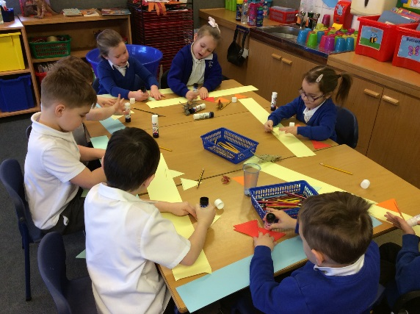

OFSTED SAYS:
Studfall Infant Academy is a warm and welcoming place. The school’s ethos of ‘nurture,
discovery, believe, achieve and shine’ runs through every part of school life. Leaders have
created a caring environment where all pupils feel secure and valued. As one pupil, typical
of many, said, ‘I feel so safe here because the grown-ups always help you.’

CONTENTS
2 About Our School
5 Parents in Partnership
6 Joining the School
8 Essential Information
12 Our Curriculum
22 Staffing
WELCOME
WELCOME TO STUDFALL INFANT AND NURSERY ACADEMY
This Prospectus has been put together by the children, staff and parents of the school. We hope it helps you gain an understanding of how our school is organised, and to appreciate the exciting opportunities on offer to the children in our care. All schools have their own distinctive ‘feel’ which makes each one unique. We believe that the ‘special feel’ at Studfall is to do with our caring, friendly atmosphere. Our school continues to develop in many exciting ways, providing an even more enriching experience for our children. We have been over-subscribed for the past few years and have increased our numbers to 116 in each year group. We have approx. 350 children in the infant building, plus a 78-place nursery.
In September 2012 Studfall Junior School and Studfall Infant and Nursery School hard federated, with one governing body and 2 headteachers. In June 2018 the school joined the Greenwood Academy Trust. The school was last inspected in November 2022 when we were judged to be a ‘good’ school in all key areas of the inspection. The full Ofsted report is available on the school’s website www.studfallinfantacademy.org
The school has a Designated Special Provision for up to 18 children who have education, health and care plans (EHCP), and who require additional teaching to help them with their learning and speech and language and communication. The children are mainly taught within the class groups with some withdrawal facilities available for specialist or small group teaching.
We are extremely proud to lead a team that is committed to achieving high standards and providing the best opportunities for the children in our care. Staff, supported by governors and parents, work hard to deliver a rich and challenging curriculum; to prepare children for future education and to help them acquire the skills and enthusiasm needed to pursue learning for the rest of their lives, to achieve their best!
We look forward to welcoming you and your child/children to our school and, to a happy and successful partnership.
Kim Kirchin
Principal

ABOUT OUR SCHOOL
OUR VISION
“Nurture – Believe – Discover – Achieve’
Our vision for Studfall Infant and Nursery Academy reflects a passionate commitment to learning and recognition of the uniqueness of individual learners. It is driven by our desire to offer the best possible education for our children in partnership with parents, carers and the local community.
In order to achieve this vision we will:
- include all children into the school community
- promote an ethos within school, which provides a happy and supportive environment for all
- aim for high standards of academic achievement
- create a positive learning environment in which good behaviour is rewarded
- offer a wide and enjoyable curriculum, which develops awareness of health issues, well-being and cultural differences
- take account of the diversity of learning styles
- celebrate achievement in any area and at any level
- share good practice amongst ourselves and with others
- keep abreast of current trends in education and adopt those which will be of value to the children we work with
- support parents in a variety of ways to enable them to help their own children
- work closely with our colleagues at Studfall Junior Academy to enable a positive transition for pupils and offer a supportive resource for the community
- work closely with other professionals to meet the needs of the individual child
- offer extended facilities to provide a range of support on the academy site
OUR VALUES  Values are fundamental expressions of what we think and believe. As a school we encourage the children to think about personal and social values, to become aware of and involved in the life and concerns of their community and society, and so develop their capacity to be active and effective future citizens.  AT STUDFALL, OUR CORE VALUES ARE:  FRIENDSHIP  We value friendship as fundamental to the development and fulfilment of ourselves and others, and the good of the community.  RESPECT  Develop self-respect and respect for others. Promote inclusion and appreciate the diversity of people’s backgrounds and circumstances.  RESPONSIBILITY  Take responsibility for the way we lead our lives, how we use our talents, rights and opportunities.  PERSEVERANCE  Maintain a ‘can do’ attitude and aspire to achieve your goals.  KINDNESS  Show care and concern and exercise goodwill towards others.  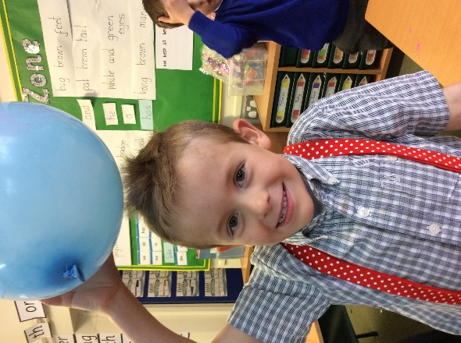  TO HAVE FUN  To demonstrate that learning is fun, for school to be a place that you want to be!  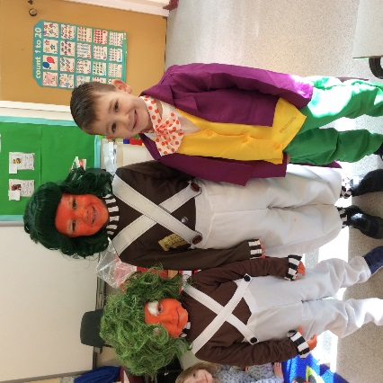  Book Week | OUR AIMS  Aims reflect our beliefs and values and represent our vision and what we want to achieve as a school community.  CELEBRATE SUCCESS  Nurture self-esteem through the celebration of children’s achievements.  VALUES CENTRED  Promote our core values and foster positive attitudes to all people, races, religions and ways of life.  HIGH EXPECTATIONS  Set high expectations to enable children to become effective, enthusiastic, independent learners.  DYNAMIC AND INNOVATIVE  Deliver a dynamic and innovative curriculum that challenges, excites and inspires children to achieve their best.  ACCOUNTABLE AT ALL LEVELS  Promote collective responsibility for raised standards and improved outcomes for children by ensuring that everyone understands their role in contributing to the success of the academy.  LEARNING CENTRED  Create an inclusive learning culture where children and others within the academy community are challenged in their thinking, strive for continuous improvement and are committed to life-long learning.  COMMUNITY ORIENTATED  Help children develop an understanding of citizenship and empower them to make valuable contributions locally and globally. Engage with the school and wider community to enrich and enhance children’s achievement and personal development.  CARING AND SUPPORTIVE  Create a happy, caring and supportive environment, through a strong partnership between our families, the community and the academy. Ensure the safety of every child and promote opportunities to adopt a healthy and active lifestyle.  INCLUSION  Treat children and others fairly, equitably and with dignity and respect, to maintain an inclusive culture.  WELL ORGANISED AND SYSTEMATIC  Establish good communication links, embed consistently applied policies and practices that ensure effective day-to-day running of the academy.

OFSTED SAYS:
Pupils like going to school and they enjoy learning. They are polite and cheerful. Pupils
concentrate in lessons and take pride in what they do.

PARENTS IN PARTNERSHIP 
At Studfall Academy we firmly believe that children will make the most progress when home and school work together. We are pleased to welcome all parents into the school. You will understand that during academy hours the teachers are busy with the children, but they will always be happy to talk with you before the start or at the end of the academy day.
There are many opportunities for parents and carers to become involved in the life of the school and to gain a greater understanding of its work. Parent’s support and expertise can be used in many ways and is greatly valued. DBS checks and safety checks are carried out on all adults working in school, including regular volunteers.
COMMUNICATION WITH PARENTS
We communicate with parents and carers in various ways, for example through our newsletters, questionnaires, social events, parent workshops e.g., how to help your child read, stay and play, family activities within the curriculum e.g. Science week and Book week.

There are a number of opportunities during the school year for you to visit the academy to talk about your child :
Autumn Term :
Just before the first break in October we have parent consultations throughout the school, when
you will hear how your child has settled into the new school year.
Spring Term:
There will be a second Parent consultation in February.
Summer Term :
At the beginning of July you will receive a written report which will tell you how your child is
progressing in each area of the curriculum. If your child is in Year 2, this report will also give you
information on the end of Key Stage 1 assessments in the core curriculum areas. We will also share phonics scores in the reports too.

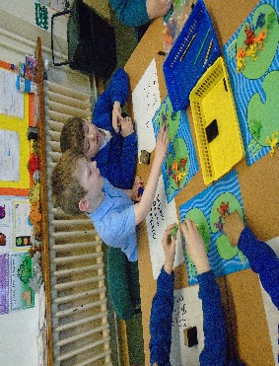
JOINING THE ACADEMY
Administration of admission arrangements to County schools is dealt centrally by Northamptonshire County Council – this is the email link for information https://www.northnorthants.gov.uk/school-admissions. Completed online admissions must be returned to the School Admission Team by the submission date in the January, prior to starting Reception.
Parents or carers of children seeking to join the academy in other years, should in the first instance contact the in-year Admissions Team of the County Council - https://www.northnorthants.gov.uk/school-admissions.

Nursery Admissions Policy
Nursery places are allocated on a waiting list basis. A Nursery place does not guarantee a place at the school.
Children may be registered for a Nursery place from the first day of September of the academic year in which the child is two years old. Parents will be emailed to confirm placement when the child is registered.
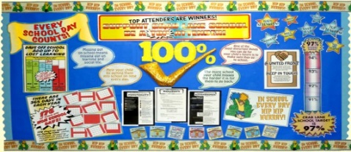
They will be asked if they still require the place in January before starting in September and informed if their application for a Nursery place has been successful around Easter of the year in which the child will start Nursery. Parents whose application for a place has not been successful will be informed by the beginning of July of that year.
If a family move into the area who had their child registered at another L.A. Nursery, then the family should bring their registration receipt to the school, and the child will be placed on our waiting list on the date of registration at the previous school.
Junior Admissions Policy
Currently families do have to apply for places to the junior academy during the autumn term of their Year 2. Priority placing is given to children from the infant academy, full details are on our website under key information.
SCHOOL TIMES AND ATTENDANCE

Morning session begins 8.55am
Afternoon session ends 3.15pm
Parents are asked to encourage children to arrive on time. Frequent lateness will be followed up by letter and by the academy Learning Mentor. We regularly remind children not to leave the premises at the end of the day unless an adult or older brother or sister (preferably over 14 years) has come to meet them. Parents who wish to make alternative arrangements, are asked to let us know of these in writing. Children are only handed over to adults who are named on the admission form unless parents notify the academy of alternative arrangements.
OFSTED SAYS:
Parents and carers are very happy with the school. They recognise the great efforts that
staff go to for every pupil.

Attendance Policy
It is important that children learn the right attitudes about school from the start of their education. Parents are asked to support the academy in this by encouraging prompt and regular attendance.
Parents are asked to give a reason for any absence which the child has from the academy. This may be done by letter or a telephone call to the academy. Unauthorised absences will be followed up by a letter asking parents to give a reason for the absence and any which continue to be unauthorised will be recorded on your child’s report at the end of the year. Frequent or unexplained absence or lateness will be followed up by daily telephone calls.
Each term children celebrate their attendance with an assembly and prizes are awarded.
Since September 2014, the Head teachers may not grant any leave of absence during term time unless there are exceptional circumstances. Family holidays are not deemed to be exceptional circumstances.
Jewellery and Toys
Jewellery should not be worn at the academy. Staff cannot take any responsibility for any valuable items which are brought to the academy by children.
We are responsible for ensuring that children participate in the full academy curriculum, including P.E., and children will therefore be required to take earrings out for P.E. lessons. Other jewellery will also be removed for P.E., and whilst every care will be taken, the academy cannot be responsible for any loss or damage to property which should not be in the academy.
Children are also discouraged from bringing toys to the academy as they are often lost and can lead to arguments between children. If teachers, ask children to bring items related to a particular topic e.g. “Teddies” or “Dinosaurs” then they will be carefully looked after in the classroom.
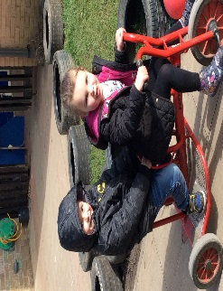

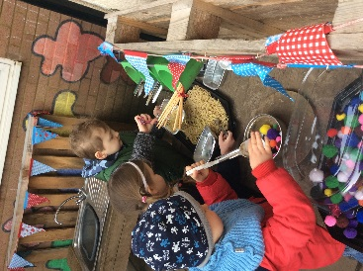

Medical and other issues

When your child starts the academy, you are asked to complete a form outlining any medical history including any allergies suffered, that we should be aware of. It is important that this record, including contact details is kept up-to-date.

First Aid
Basic first aid is given at the academy, when necessary, by qualified First Aiders. If an accident needs hospital attention, we will make every effort to contact parents and carers. We ask you to ensure all contact details are kept up-to-date so that we can contact you in an emergency. All injuries are recorded.

Health and Medical
Parents are notified of any medical or dental inspections which are to be held in school. . Children in reception have a visit to measure height and weight and may have a dentist survey.
A parent/carer may at any time request a special appointment e.g. for a hearing test with the school nurse team. Sometimes teachers may request such tests, but this would only be done in consultation with the parent and with their approval. The school may recommend referral to a Speech Therapist, but again, this would be done in consultation with the parent.
Head Lice - This is a recurring problem in school and can only be dealt with by vigilance on the part of parents and staff. Children should not be sent to the academy with untreated head-lice, and if we notice at the academy that a child has live head-lice then the parent will be asked to treat them. Where head-lice recur regularly with the same child we will ask the parent to make an appointment to see the school nurse.
Children who have been sick at home should not be sent to the academy for at least 48 hours, or until the sickness has stopped. This will help to prevent germs spreading at the academy, and also prevent the child becoming distressed if they are ill at the academy.
We have forms at the main office to complete if your child needs to take prescription medicine at school - we would ask where possible this is given at home – especially for 3 a day doses. We ask that no medication is sent into school with children or in their bags. All medicines must go to the main office – so we can record any information.
For more details about excluded illnesses, please contact the academy office.
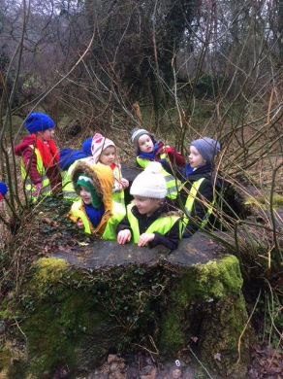
OFSTED SAYS
Everyone at Studfall Infants knows their role in keeping pupils safe from harm. Staff have
been well trained. They know the signs to look out for that might show that a someone is
in need of help.
Safeguarding
We have a Safeguarding Policy which explains how the school works to ensure that children are thriving and safe. Full policy is on our website. We take safeguarding and the protection of children very seriously. We offer support for all families in need and can help access other agencies if required. There are learning mentors and a school counsellor available.
If you would like any support please talk to the class teacher, a learning mentor or the safeguarding team.
Academy uniform
The academy uniform has proved very popular and children are encouraged to wear it to feel part of the school community. Uniform is ordered online at Price & Buckland www.pbparentsonline.co.uk/studfallacademy.
Families are also able to buy uniform from local supermarkets and other outlets – please keep with the school colour of purple – we do not insist on logo uniform.
Purple academy sweatshirt, cardigan or jumper
White or White with purple trim Polo Shirt, white shirt or blouse
Grey or Black trousers, skirt or pinafore
In summer:
Grey or black shorts or Purple/white dress
Grey or white socks or tights
Black or grey shoes
Uniform fleeces/ waterproof jackets are available and are popular all the year round.
N.B. shoes or sandals with high heels are not suitable for school.
PE KIT
Academy t-shirt with black shorts
Black jogging bottoms

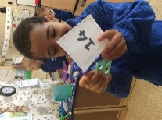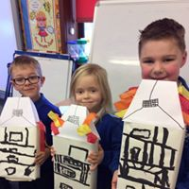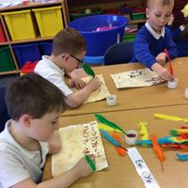
Sun Protection
During the summer months all children should have a named sun hat in school, which they will be encouraged to wear when playing outside.
Academy staff are not permitted to apply sun cream to children, but we would ask that you apply a long lasting sunscreen before school in sunny weather. Children may reapply their own sun cream which must be provided in a clearly named container
Academy Meals
All children in Reception, Year 1 and Year 2 are offered a free school meal – Kingswood Kitchens provides our hot meals, which are delivered daily. New government legislation means that all children in Reception, Year 1 and Year 2 are entitled to a free hot school meal. The caterer provides vegetarian meals and a packed lunch alternative. These need to be ordered by midnight the Wednesday the previous week. Alternatively, children may bring a packed lunch to school. See leaflet enclosed in pack for more details of meals provided by Kingswood Kitchens. This is the link to register with Kingswood kitchens https://www.kingswoodcatering.co.uk/register
Children who bring packed lunches bring their own non-fizzy drink, or water is freely available. Parents may send cartons of drink to school. Flasks, cans or bottles are not acceptable because of the dangers of breakage or leakage. We also ask that parents do not put nuts into lunchboxes.
One significant change in the new School Food Standards is that from January 2015, lower fat milk or lactose reduced milk must be available for drinking at least once a day during school hours. Milk will be offered free of charge to children entitled to free school meals.
Pupil Premium
Would you like to have a £50 voucher?
IF YOU THINK YOUR CHILD MAY BE ELIGIBLE TO FREE SCHOOL MEALS BASED ON YOUR FINANCIAL CIRCUMSTANCES, THEN PLEASE APPLY- THIS WILL HELP THE ACADEMY TO GET EXTRA FUNDING AND WILL SUPPORT YOU. (even if you do not want the actual meal)
All children at the infant academy are entitled to a free school meal but from nursery to year 6 you may also be eligible for pupil premium.
You may be aware that the government is currently allocating additional funding to schools in the form of ‘The Pupil Premium’. One of the criteria used to calculate this additional funding is the number of pupils at a school who are eligible to receive Pupil Premium Free School Meals (FSMs). In common with most schools it is likely that a number of parents/carers whose children attend Studfall fail to claim Pupil Premium FSMs, even though they are entitled to them.
As the academy will receive additional funding based on the number of children who are registered to receive Pupil Premium FSMs we are writing to all parents and carers to ask them, if they believe that they may be entitled to claim Pupil Premium FSMs for their children and do not already do so, to make a claim. It is simple to check if you are eligible. This can be done by simply sending a text message.
We are sure you will agree the children at our academy can only benefit if we are able to attract additional funding. Not only that, our catering team provides an excellent range of healthy lunch options that are enjoyed daily by a significant number of our children.
If you are eligible for and claim Pupil Premium FSMs, you may also be entitled to other services by the academy such as:
£50 voucher to spend on:
- Uniform
- Day Trips
- Books from the book fair
- Free milk daily
In addition if you register:
- Access to additional support for your child’s learning and/or well-being
- Possible financial support in other areas, in discussion with the principals and leadership team.
The more funding we access the better range of support we can offer.
How we spent last year’s pupil premium is available on the website.
In order to claim Pupil Premium FSMs a parent/carer must be claiming one of the following benefits:
- Income Support
- Income based Job Seekers Allowance
- Child Tax Credit, with no element of Working Tax Credit*, and a household income below £16,190 (as assessed by HM Revenue and Customs)
- National Asylum Seekers Support
- Guarantee Element of State Pension Credit
- Income Related Employment and Support Allowance
If you would like any help or advice on completing the forms please speak to the office staff or a learning mentor. This is the online link to register for pupil premium https://www.northnorthants.gov.uk/schools-and-education/free-school-meals-and-pupil-premium.
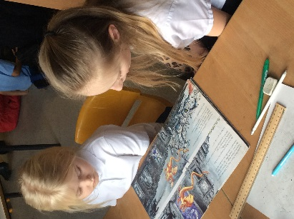

Smoking and Vaping
We operate a no-smoking or vaping policy – smoking is not permitted anywhere within the academy or grounds. This also includes vaping and e cigarettes.
Complaints
Any complaints about academy matters should first be discussed with class teachers or brought to the attention of the Principals . Our full complaints policy is available on our website in the About Us section – under Acacdemy policies – then Trust polices.

Charging Policy
At Studfall, we are constantly seeking to enrich the children’s learning experiences through trips, by inviting visitors and experts to talk to the children and by running activities and workshops. The children always feedback that these activities bring learning to life and are some of their most memorable experiences of primary school. Where possible, we look for free activities or apply for funding that will enable the academy to provide enrichment opportunities at no cost to families.
On occasions, activities are undertaken or visits made during the academy day for which parents are invited to contribute voluntarily towards the cost. No pupil will be refused a place on these activities if the parents are unable or unwilling to pay. Unfortunately, some activities or visits may not go ahead if insufficient funds are available.
Parents are asked to contribute to the cost of any reading books which may be lost or damaged at home.
The Charging Policy was updated in Spring 2018 and is reviewed regularly and is on the academy website.
Public Access to Documents
Principals are required to give access to documents under the Freedom of Information Act. For a copy of the policy relating to Freedom of Information please enquire at the school office.

Breakfast Club

This has been running successfully for many years and is organised by members of the school staff. Breakfast Club is £3.50 per day, £17.50 for the week.

Payment MUST be made via Parentpay the week before your booking is required. If you require further information – we have a separate breakfast club leaflet which the admin team will email to you.

Fund Raising Events
From time to time the academy will hold events to raise funds which will be used to enhance the environment for the children.


Foundation Stage
Nursery and Reception
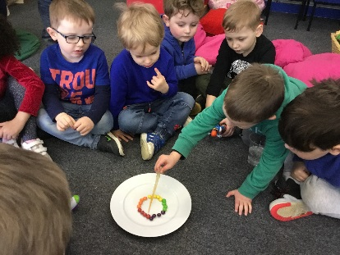
The Foundation Stage aims to provide an environment in which a child can develop social skills through interaction with other children and adults. From the start emphasis is placed on personal and social development and speaking and listening. We aim to develop the natural curiosity which children have in the world around them, and to give them first hand experiences using a variety of different materials. Children are encouraged to be independent, confident and caring towards living things. An interest in books is nurtured and the children are encouraged to listen carefully and respond appropriately. Challenging physical play activities are offered.
Children are well prepared for their move from Nursery into Reception and Nursery and Reception teachers plan closely together using the Early Years and Foundation Stage Curriculum to promote continuity. As the Reception year progresses, some more formal approaches are used to prepare children for the transition to the full National Curriculum in Year 1.


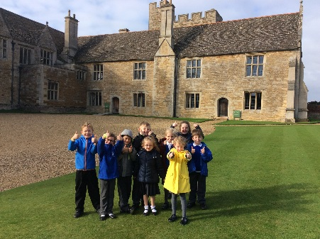

Key Stage 1
Years 1 and 2
The academy aims to deliver a broad, balanced, relevant and differentiated curriculum to all pupils. We work hard to ensure that work meets the individual child’s needs.
All curricular areas are taught in accordance with the updated National Curriculum or Foundation Stage requirements. The core subjects are English, Maths and Science and these are taught in conjunction with Design and Technology (D&T), Art, Music, Physical Education (P.E.), Geography and History. Religious Education (R.E.) is also taught on a weekly basis, and Information Technology (I.T.) is taught across all areas of the curriculum.
The academy uses a variety of teaching methods including whole class, paired work, individual and group work to ensure that children get the most from their lessons. From early in Year 1 and all of Year 2 children work in targeted groups for Literacy and Numeracy.
Teachers quickly identify exceptionally bright children and every effort is made to encourage these children to develop their potential. Links with Studfall Junior Academy are strong and their advice and loan of curricular material is sought if a child advances beyond the resources we have in the academy.
In addition to encouraging success in academic areas, we also endeavour through the curriculum to encourage children to be members of society by raising their awareness of such issues as citizenship, health and safety, the environment, personal and social education and economic and industrial understanding. Through teaching and example, we hope to pass on to each child the attitudes and values which will help them to be part of a helpful and caring society.

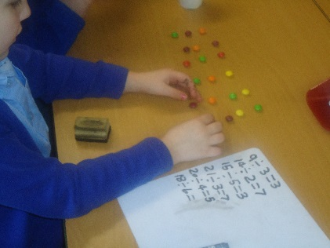
Maths

Mathematics is a core subject of the National Curriculum. We aim to foster a positive attitude to mathematics as an interesting and enjoyable subject, and to provide opportunities to undertake challenging investigations using number knowledge, and to practice number skills through mental, oral and practical work in number.
Whenever possible maths is used in a real and cross-curricular context to help solve a wide range of problems. We encourage children to use practical resources to help them to consolidate their understanding of number and other areas of maths.
We aim to enable children to effectively use mathematics as a tool in a wide range of activities within the academy and adult life.

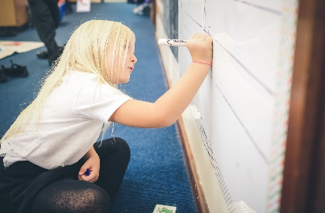
English
This is a core subject of the National Curriculum. Our aim is to enable all pupils to develop fully their abilities in the areas of speaking, listening, reading and writing. Opportunities to use and practise these skills occur in all areas of the curriculum. Children are encouraged to express their thoughts and ideas in a variety of ways to enable them to acquire the skills to express themselves clearly and purposefully.
In the area of reading and literature we aim to teach the children the skills to enable them to read with understanding. A variety of approaches to reading are used and the children learn letter sounds phonics, basic sight vocabulary and also learn to read for enjoyment. Children gain experience of reading in all areas of the curriculum. All classes have the opportunity to use the well-stocked academy library.
Children are given the skills and opportunities to present their ideas, information and impressions in a variety of written forms. We also focus on how sounds are linked to letter formations to develop good handwriting. Spelling rules are also taught and developed later as children become ready for this.
In all years of the school we use ELS phonics scheme – please see our website https://www.studfallinfantacademy.org/page/?title=Phonics&pid=151 – for further details and examples
Science
Young children are naturally curious about the world around them and so we aim to provide a science curriculum which extends this curiosity and gives our children every opportunity to observe at first hand, question, experiment, record and form conclusions. We believe that this should happen through practical activities where the children are encouraged to use a variety of materials and equipment suitable to their age and ability.
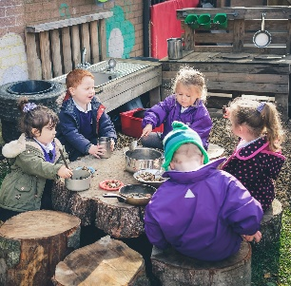
Our science work is organised through topic work based on investigative questions with cross-curricular links and complies with the requirements of the updated National Curriculum.
We aim to give the children ample opportunity to explore the immediate environment of the academy grounds. All pupils have the opportunity during the year to visit our forest site on our Academy Grounds and the local area.


History and Geography Our aim is to develop the children’s knowledge, skills and understanding by encouraging them to develop an awareness of the past and how it was different from the present Topics will have a ‘big question’ for the children to investigate. Children will have the opportunity to develop simple mapping skills, field-work techniques, and to gain knowledge of both their local environment and places on other continents.

Art
We aim to give children first-hand experiences using a variety of media, and to provide the opportunity to study the work of well-known artists and develop their skills of fine-art appreciation.

Design and Technology
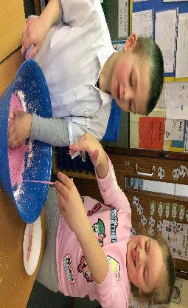
Work in this subject is based on the National Curriculum and is often linked with a topic the children are working on. Children are given a wide experience of different materials and techniques, and are taught basic skills and the correct use of tools. Through design and technology activities, we aim to develop the children’s creativity, resourcefulness and confidence. Children are introduced to the design process and are also encouraged to comment on the end product.

Information Communication Technology

Information Communication Technology is concerned with the storage, processing and presentation of material by electronic means. I.C.T. plays an increasingly large role in all areas of life - the home, the workplace, and the leisure pursuits - and so children need to be prepared to accept the challenge of a rapidly developing and changing technological world.
We aim for children to use I.C.T. to communicate and handle information; design, develop, explore and evaluate models of real or imaginary situations; measure and control physical variables and movement; and make informed judgements about the application of I.C.T. and its effect on the quality of life. We have recently updated our Internet network and have a bank of laptop trollies as well as banks of IPads. All classroom areas are now cabled so that the Internet can be used in the classroom. The school has a policy for internet access and no child is left unsupervised when the internet or World Wide Web is being accessed. Teachers have been trained in the use of interactive whiteboards, and we have increased the number of whiteboards and computers through the academy.

Music 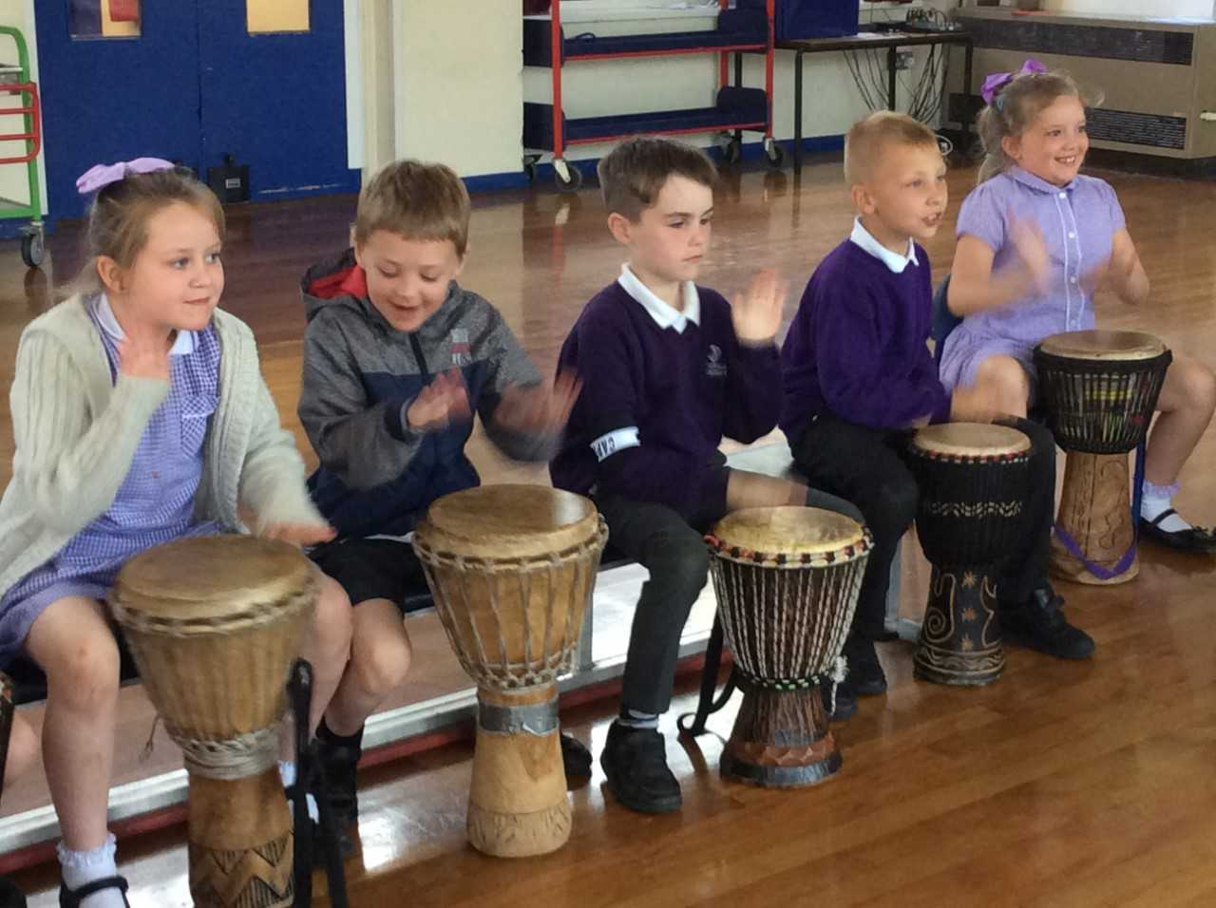

We aim to provide a curriculum, which encourages listening skills, singing, music making and an appreciation of a variety of forms and styles of music. We use an interactive programme called Charanga to help to develop children’s ability in music.
Children are encouraged to perform at other events in the school year such as Harvest Festival and Christmas. Children have the opportunity to play a variety of percussion instruments, and also to make and play their own instruments.

Physical Education
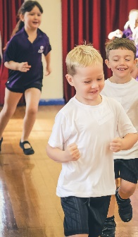
We aim in this subject to offer great opportunities for developing a healthy, active life-style through a variety of physical experiences - gymnastics, dance including country dancing, games, athletics, outdoor activities and team work. The children receive up to 2 hours of P.E. a week including both indoor and outdoor facilities, weather permitting, lunchtime play and Activate.

Children will have the opportunity to develop their potential for physical fitness and skill, in individual performance; and as a member of a group. Children will also be encouraged to contribute to the assessment of their performance. They enjoy competition particularly during our fun afternoons. Our Academy also takes teams of children to join in with Corby wide sporting competitions. We use a newly developed scheme of work to ensure continuity across the academy.
Religious Education and Assembly

Through our approaches to Religious Education and Assembly and Worship, we aim to enhance the spiritual, moral, and cultural development of each child. This forms part of the whole ethos of the academy, which emphasises care for each other and the environment, tolerance, understanding and discipline.
In keeping with the community of which the school is a part, our approach to religion is broadly Christian in nature and we have developed close links with St. Columba’s church in Studfall Avenue. However, reference is made to other cultures and religions by using festivals, celebrations and customs from other religions to raise the child’s awareness of other faiths.
Our academy has adopted the Northamptonshire Agreed Syllabus for R.E. Through this the children are introduced to the main concepts of Christianity. Their awareness of other cultures and religions is raised through festivals and celebrations - in particular those of Judaism. Links are formed with local churches for visits and services. Children are encouraged to discuss their own beliefs and the beliefs of others, being tolerant and understanding about differences.
Parents may request to withdraw their children from religious Education and from Assembly and worship on religious grounds.

Drama
Through Drama we aim to provide opportunities for the children to develop a range of practical skills which inter-relate within the working classroom. Drama focuses on confidence building and working together with their peers, which is always approached in a positive and non-threatening environment throughout the academy.

Personal, Social and Health Education
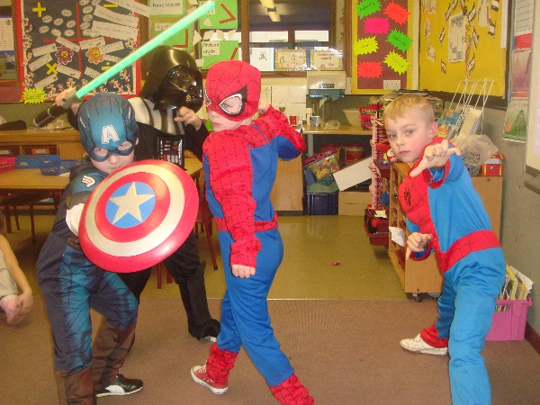
We aim to give the children an awareness of the need to care for their own bodies through health care, diet and cleanliness. We also aim to teach them to apply the knowledge and skills of safety education in the home, at play and on the roads as well as at academy.

As part of this programme, we frequently invite people from other professions to talk to the children, e.g., police, fire-fighters, dentist, school nurse etc. Once a year we have a “Keeping Safe” focus when all of the children in the academy are reminded in Assembly, lessons, and through visitors, about keeping themselves safe.

The academy has adopted the Circle Time model, which encourages all children to be aware of their role in promoting a happy healthy and safe community. During circle time classes discuss issues relating to PSHE and citizenship. This is linked to the academy Behaviour Policy. We also teach specific skills and develop ideas through our PSHE curriculum. This includes age appropriate relationships education. Children participate in academy and class councils which encourage them to discuss issues relating to the academy and the environment and to have their say.

