Newsletter 8

Monday 9th February
Dear Parents/Carers
We are now moving into the last week of this half term and what a busy half term it has been with our Big School Bird watch – the children and I saw 7 red kites!! It was also wonderful to see soo many of you at the reading café. We hope we might be able to get out a bit more this week – here’s hoping for a bit of sun ( or least not rain) . We hope you have lovely half term when it comes.

Attendance 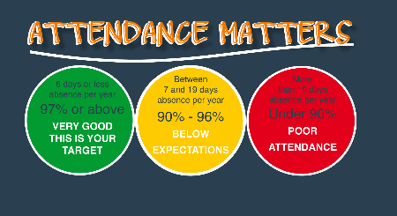
It is really important that children are in school as often as possible. We have updated our school policy in line with the Juniors and it can be found here on our website.
Studfall Infant Academy - Attendance
I am also including with this letter updated guidance for families – going through our procedures . One of the areas that we are looking to try to improve in is the number of children who arrive late to school. Children start their learning more or less as soon as they come in in the morning – so being here on time is so very important.
Please ensure you contact school every day of your child’s absence - please contact admin@studfallinfantacacdemy.org or call 01536 264540 before the start of the school day. Dojo messages may not be picked up before school. Holiday dates for the next year are on our website
Studfall Infant Academy - Term Dates
( 26/ 27 dates at bottom of page)
Please remember that we do not authorise holidays during term time – unauthorised absence can incur a fine.
Parent Questionnaire 
We will be publicising our annual parent survey at parents evenings. We welcome your responses – so am including an early preview here .
Parent Questionnaire 2026 – Fill out form
Medicine in School
If your child is prescribed or needs medicine and this is to be given in school – please make sure that you take this to the main school office where you can complete a form to tell us all the information we need. Please note that you should not send your child in with medication without letting us know. Where possible medication should be given at home – including antibiotics with three doses.
Pupil Premium 
Some of our families are entitled to pupil premium if you are in receipt of universal Credit – you may be eligible. Families who are eligible receive vouchers for food over some of the holidays, £50 support from us for uniforms and school trips. We also gain extra income as a school which is really helpful.
You can apply to see if you are eligible here
Free School Meals
Although the site is labelled a free school meals – this is confusing as all children for Reception – Year 2 are able to have free meals regardless of family income. This benefit is on top of this – although your child would still be eligible for free school meals at the Juniors if they qualify. Please do call the main office if you require any help with this.

Dates for your diaries
- Feb 9th – 13th – Children’s Mental Health Week
- Friday Feb 13th Close for half term - 3.15pm
- Monday 23rd February – open NO TRAINING DAY
- Wednesday 25th Feb and Thursday 26th Feb– Parents evening 3.30 – 5.30 . Book Fair will be here for this
- Thursday March 5th – World Book day – we’ll be dressing up for this
- Mon 9th – Fri 13th March – Science Week
- Tuesday 17th March – Rock Steady concert – 2.30pm
- Wednesday 25th March – Easter Fayre 3.30pm – 4.15 pm – Easter Bonnet competition!!
- Thursday 26th March - Reception Concert am and pm – times TBA
- Friday 27th March – close for Easter holidays
- Monday 13th April – Open for Summer term

Best wishes and thank you for all your continued support
Kim Kirchin

