Newsletter 9
Monday 2nd March
Dear Parents/Carers
As we may have some nicer weather this week (fingers crossed) can you please check that your child’s name is in their coats, jumpers etc as they often take them off at play and if they forget where they are we will get them back to them if they have their names in
World Book Day 
This is on Thursday March 5th and we hope you’ll join us in dressing up as book characters on this day or cosy night wear for a book at bedtime. We will be having a focus on books in school and a special assembly for the children.
Easter Fayre
We will be holding this after school Wednesday 25th March up until about 4.15pm. We are hoping to have stalls in the main hall – so do contact us on admin@studfallinfantacademy.org if you wish to find out more about this/ book one. Any donations of chocolate closer to the time would be greatly appreciated as we will be having a chocolate tombola. Part of the fayre will also be an Easter bonnet competition – with – weather permitting – and Easter parade on the playground. All entries will receive a certificate and a small prize – with bigger prizes for 1st, 2nd and 3rd.

Science Week 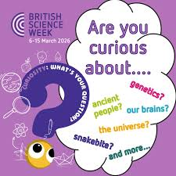
Next week will be Science Week (starting March 9th) . We are doing lots of great things in school and have a special event planned for all the children during the week. Children can dress up as scientists all week if they like 😊.

Reception Concert 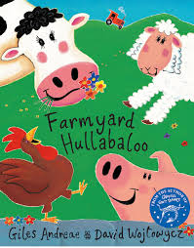
Just to confirm with you this is on Thursday 26th March and is at two showings – 9.20am and 2.15 pm. Can’t wait to see them all !! The theme of the show is a Farm Year Hullaballoo - very seasonal with the baby animals. I will send a link to register to come along there aren’t tickets – but we need to mindful of space and capacity in the hall.
Parking 
I met with the road safety team last week – and we were able to borrow the posters and parking buddies outside of the school. I hope this will help a little. We will also be looking to run special events to encourage paring further away from school and walking in (which I know a lot of you try to do). I am also looking to contact local venues etc to see if we would be able to allow parents to park in a safe car park then walk in. Please let me know if you have any contacts who might be able to help with this. The team will also look at safety measures – like a barrier for the Sherwood Close entrance and updating double yellows at the front of the school.
Please do also remember not to park close to corners – this is illegal parking and makes it very dangerous for all road users and pedestrians.

Parent Questionnaire 
We have received a number of responses from parents who attended parents evening . We welcome your responses – so am including the link here.
Parent Questionnaire 2026 – Fill out form
Medicine in School
If your child is prescribed or needs medicine and this is to be given in school – please make sure that you take this to the main school office where you can complete a form to tell us all the information we need. Please note that you should not send your child in with medication without letting us know. Where possible medication should be given at home – including antibiotics with three doses.
Pupil Premium 
Some of our families are entitled to pupil premium if you are in receipt of universal Credit – you may be eligible. Families who are eligible receive vouchers for food over some of the holidays, £50 support from us for uniforms and school trips. We also gain extra income as a school which is really helpful.
You can apply to see if you are eligible here
Free School Meals
Although the site is labelled a free school meals – this is confusing as all children for Reception – Year 2 are able to have free meals regardless of family income. This benefit is on top of this – although your child would still be eligible for free school meals at the Juniors if they qualify. Please do call the main office if you require any help with this.
Dates for your diaries
- Thursday March 5th – World Book day – we’ll be dressing up for this
- Mon 9th – Fri 13th March – Science Week- dress as a scientist all week if you like
- Tuesday 17th March – Rock Steady concert – 2.30pm
- Wednesday 25th March – Easter Fayre 3.30pm – 4.15 pm – Easter Bonnet competition!!
- Thursday 26th March - Reception Concert am and pm – 9.20am and 2.15pm
- Friday 27th March – close for Easter holidays
- Monday 13th April – Open for Summer term

Best wishes and thank you for all your continued support – Kim Kirchin

