NEWSLETTER 12
Thanks so much for your support with the Easter Fayre – we raised £473.40 and congratulations to Zac, Buddy and Myla for winning the Easter bonnet competition – all of the entries were amazing and it was so hard to choose.
Year 1 Phonics Workshop 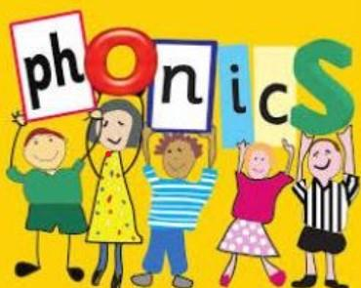
YEAR ONE PARENTS ONLY
We are holding a phonics meeting to provide information about a Year One Phonics Test. This is for all year one children and is a statutory requirement.
Date – 22.4.26
Time 2pm
What will happen?
* Information about the test
* Time to spend in classes
* Ideas to help
Please come and support us - it will be lovely to see you there!

Class Photos 
This Thursday 23rd April – children will be having class photographs taken – this is NOT individual photos. Can children be in their uniform please .

Well being week 
This is the week starting 5th May – we’ll have lots of great things happening and will be having a wear what makes you happy day on Friday 8th May – no donations needed.
Parking 
We must remind parents and carers that parking considerately is essential for the safety of our children, families and local residents. There have been ongoing issues with inappropriate parking, particularly on Sherwood Close. Please do not block driveways, pavements or access routes, and ensure your parking is safe and legal at all times. Failure to do so puts others at risk and causes disruption for our neighbours. Thank you for your cooperation.
Dates for your diaries
- Wednesday 22nd April – Year 1 phonics workshop for parents
- Thursday April 23rd – Class photos
- May 5th ( Orange and Silver) and 6th ( Gold and Rainbow ) – Year 1 trips
- Friday 8th May – wear what makes you happy
- Wednesday 20th May – Reading café 2.30pm
- Friday 22nd May – close for half term
- Open Monday June 1st ( NO TRAINING DAY)
- Thursday 4th June 2.15pm – Maths afternoon
- 2 weeks from 8th June – Phonics check
- Wed June 17th – Sports day
- Monday June 22nd – Training Day – school closed to children
- Wednesday 24th June – 9-10 am – MHST drop in – Year 2 transition
- Wednesday 8th July – End of Year reports come out
- Thursday 2nd July – Reception trip
- Monday 6th July – Year 2 to Woburn
- Friday 10th July - transfer afternoon
- Friday 17th July – school closes for summer
Best wishes and thank you for all your continued support
Kim Kirchin

