NEWSLETTER 13
5.5.26
Please don’t forget term dates for this year and next year can be found on our school website - https://www.studfallinfantacademy.org/page/?title=Term+Dates&pid=40
The weather looks like it will be nice for a little while – so you may wish to apply sunscreen – pop in cream for your children to apply. Hats are a great idea too. We’re enjoying being on the field – where we now have new sunshades – which make a big difference .
Well-being week 
This is the week starting 5th May – we’ll have lots of great things happening – to focus on well-being across the school and will be having a wear what makes you happy Mufti day on Friday 8th May – no donations needed.
Parking 
We must remind parents and carers that parking considerately is essential for the safety of our children, families and local residents. There have been ongoing issues with inappropriate parking, particularly on Sherwood Close. Please do not block driveways, pavements or access routes, and ensure your parking is safe and legal at all times. Failure to do so puts others at risk and causes disruption for our neighbours. Thank you for your cooperation.
Attendance 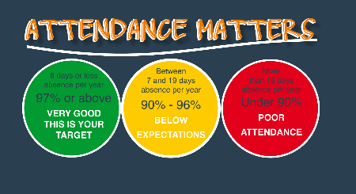
It is really important that children are in school as often as possible. We have updated our school policy in line with the Juniors and it can be found here on our website.
Studfall Infant Academy - Attendance
I am also including with this letter updated guidance for families – going through our procedures . One of the areas that we are looking to try to improve in is the number of children who arrive late to school. Children start their learning more or less as soon as they come in in the morning – so being here on time is so very important.
We are also starting to issue attendance plans for children/ families whose attendance is beneath 90% (persistent absence) and remains of concern. We are keen to help/ support families and children to improve attendance.
We are also enhancing the celebration of attendance – which includes whole class awards for the best attendance . We will be doing this especially for Mondays / Fridays after and before holidays where there is an increased level of absence .
Please ensure you contact school every day of your child’s absence - please contact admin@studfallinfantacacdemy.org or call 01536 264540 before the start of the school day. Dojo messages may not be picked up before school. Holiday dates for the next year are on our website
Studfall Infant Academy - Term Dates
( 26/ 27 dates at bottom of page)
Please remember that we do not authorise holidays during term time – unauthorised absence can incur a fine. Please do not book holidays during term time.

Dates for your diaries
- May 5th ( Orange and Silver) and 6th ( Gold and Rainbow ) – Year 1 trips
- Friday 8th May – wear what makes you happy
- Wednesday 20th May – Reading café 2.30pm
- Friday 22nd May – close for half term
- Open Monday June 1st ( NO TRAINING DAY)
- Thursday 4th June 2.15pm – Maths afternoon
- 2 weeks from 8th June – Phonics check
- Wed June 17th – Sports day
- Monday June 22nd – Training Day – school closed to children
- Wednesday 24th June – 9-10 am – MHST drop in – Year 2 transition
- Wednesday 8th July – End of Year reports come out
- Thursday 2nd July – Reception trip
- Monday 6th July – Year 2 to Woburn
- Friday 10th July - transfer afternoon
- Friday 17th July – school closes for summer
Best wishes and thank you for all your continued support
Kim Kirchin

