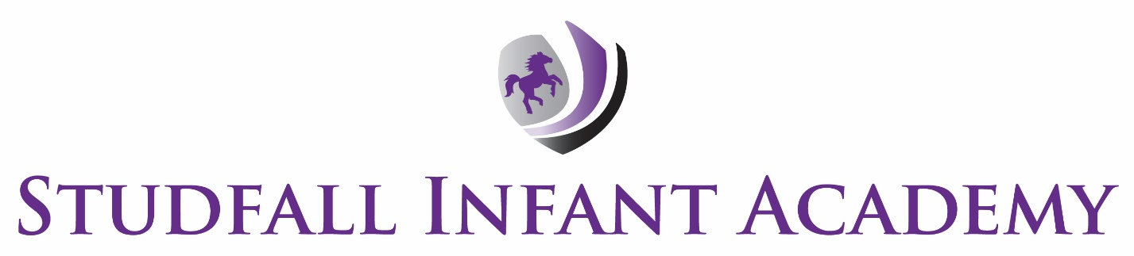

Marking Guidance
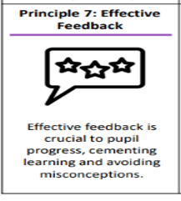

Date: January 26

To be reviewed: Jan 27
Introduction

Marking is an important part of ongoing assessment. Through this guidance, it is hoped to encourage the child to look at errors and misconceptions in a positive manner and be seen as part of the learning process. The marking guidance takes into account the school’s guidance on equality. The ownership and implementation of this guidance is the responsibility of all staff.

The Purpose of Marking in Studfall
Marking is an effective way to engage children in their own learning and aid progress and confidence. Marking can be the path through which the child makes sense of the curriculum and achieve their maximum potential. Marking is an essential part of the learning process and also encourages deeper thinking and a range of metacognition skills. Marking is an essential part of effective feedback – which is one of the principles of effective teaching and learning in GAT practice (Principle 7) Marking should be proportionate and not be over burdensome for teachers and other staff members – helping to support work life balance for our staff.

Implementation
Work should be marked in pink or green pen. For aspects where a child has achieved the learning objective or to acknowledge – this should be in pink pen. For areas to develop this should be in green wherever possible.
Marked work should generally be handed back quickly to encourage discussion of the work and maintain momentum.
All work completed by children should be assessed but may not always be commented on. There must however be a balance of detailed marking for work life balance for teachers. To provide accurate feedback to children work should have a more detailed mark on a regular basis – providing opportunities for remedying misconceptions and /or developing ideas.

Marking and feedback is best done with the child as ‘live marking’. This means that the amount of marking reduces – but its impact increases. Where work is live marked – there will be evidence of development in the work – which may be supported by teacher – dependant on age and ability.
Comments from teachers should relate to the objectives of the lesson and should where possible give examples or comments to enable children to make progress.
The teacher’s professional judgement is the key factor in all assessment, through marking and evaluation.
Supply teachers cover supervisors and teaching assistants should mark work according to this guidance.

Levels of support and comments
Where a child has worked with a teacher or teaching assistant this should be noted on the child’s work –work will be initialled to indicate who the children has worked with and a ratio where appropriate
S – child had been supported with work I – child has worked independently
Marking may not always involve writing on work – this assessment may also be orally with the children . Impact will be seen in work and in progress.
Teacher and TA comments must be accurate, constructive and always legible.
Comments should be written in language appropriate language for children and should be related to objectives for the lesson – to clarify or develop children’s learning.

Precise and positive praise
Dojos are awarded for good behaviour/work and the basis for this is as follows:
- Dojos are awarded for work done in and outside of the classroom.
- Dojos may be awarded for targets met.
- A maximum of 5 dojos per piece of work can be awarded.
- The children are clear in their understanding of the dojo system – which is also linked to our curriculum

Self assessment
Where possible, our children should be encouraged to mark their own work. Self-assessment is of vital importance. Year 2 start to use a purple pen to edit their work. Examples of work from children may be used to exemplify good practice.

Adaptions
Where children have learning plans – where it has been identified that they have met a target on these plans the code LPT ( Learning plan target ) will be used. For some children with SEN needs – work systems and rewards schedules may be used to show successful completion of work – with visual representations used – e.g. stars , smiley faces on a chart for successful completion. This code should be in pink as it showing a good example

Review
This guidance will be reviewed by June 2027 or when the need arises.

Kim Kirchin
Jan 26

Appendix – Guidance on Marking

Pinks and Greens Marking

- Key aspects of the work (learning objectives) that the children have completed very successfully will be neatly highlighted in pink.
- Aspects of the work related to the learning objectives (and other key learning areas where appropriate), where the children have not met the learning objective or need to further extend their learning will be highlighted in green.
- This highlighting can be completed with the child, during learning. This will give the child time to make immediate improvements if needed.
- Where aspects have been highlighted in green teachers or teaching assistants may set a question to support / develop understanding to remedy the misconception or error. This might be addressed immediately or in another lesson. It is really important that the children recognise that this is a positive part of their learning and that revisiting something is not a negative.
- Where aspects have been highlighted in pink teachers or teaching assistants may set a question to develop and extend understanding. This might be addressed immediately or in another lesson.
- In EYFS – next steps will be identified verbally. This will be shared verbally with children and followed up with children. Comments would be included on observations.
- This marking is to be completed with due regard to work life balance for staff and to ensure that all children get a good balance of marking from teachers and teaching assistants.

Based on an approach from Shirley Clarke

EYFS:
- Feedback in the EYFS is predominantly undertaken verbally, as and when progress or misconceptions arise, or during whole class teaching/review sessions.
- A focused, adult directed task is completed by the children weekly and recorded in literacy, maths or topic books. This is identified on the weekly plan, including resources/labels.
- Labels or headers are included to show learning objective(s) and success criteria.
- Marking of the focused task includes adult recording Teacher or TA assisted plus initials and date.
- Comments include use of apparatus/ word mat/ working wall/sentence reminders etc (Pupils are encouraged to use visual clues showing capital letters, full stops and finger spaces throughout the year).
- Different parts of the work may show an S (supported) or I (independent), e.g. individual words/numbers
- Live marking - green work is usually practised straight away (after verbal feedback) e.g. written again with finger spaces; letter and number formation practise is ongoing.
- Correct letters in words are ticked (with pink).
- Ratios are not currently recorded but focus group size increases over the year.
- Tasks completed in the Provision that shows clear learning and progress, will be stuck in books and marked with the date and a circled I (independent) and P (provision) scribed by an adult, with initials.
- Focus or provision tasks may also be marked with a circled ‘LPT’ (Learning Plan Target) to indicate where pupils have practised/achieved their targets.
- Adults may also use stickers/stamps in books to show praise or a comment identifying a positive aspect, e.g. ‘Super letter formation!’
- Dojos will be given for strengths e.g. ‘Wonderful Writing’ or ‘Fantastic Phonics’. Teachers are encouraged to create dojo awards for key areas of focus for their classes/ year groups.

