NEWSLETTER 15
8.6.26

Please don’t forget term dates for this year and next year can be found on our school website - https://www.studfallinfantacademy.org/page/?title=Term+Dates&pid=40
Wear Yellow Day 
For the second year, we are holding a fundraiser to support this charity. It is close to our hearts as we have a pupil (and past pupils) with CF and we want to support as much as we can.
Please support Wear Yellow Day, you will be helping to fund life-changing research and support the 11,000+ people in the UK living with CF.
To donate follow the link
https://www.cysticfibrosis.org.uk/donate
Come to school in something yellow, something small or bigger- choice is yours. Wearing yellow will raise awareness and hopefully raise some money for this charity to continue the good work they do.
Sports Day 
This will be on Wed 17th June. There will be a carousel of activities for the children to join in with and you can come in and watch the children take part = this will be on the main field . The times are –
Reception 9.15 - 10.15am - Year 1 10.30 - 11.30am and Year 2 - 1.30 – 2.30pm.
Hopefully the weather will be kind to us .

Training Day
Please note school will be closed to children on Monday 22nd June for our training day – this is the case for the Juniors School too.
Phonics checks 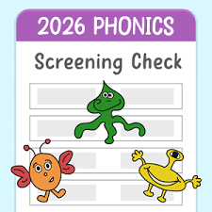
Children in Year 1 will be undertaking their phonics check the week starting 8th June (over 2 weeks if needed) . Thanks to all families who came along to the session on the check led by Mrs Parris – it was so great that so many of you could join us. Year 1 have been sending lots of helpful information to support children in the check and practise their phonics. Children in Year 2 that didn’t pass the test last year will also be re assessed again in a non-pressured way.
Here is a link to information about the checks
https://www.gov.uk/government/publications/phonics-screening-check-information-for-parents/phonics-screening-check-2024-information-for-parents-text-only-version
New Classes for September 26
Thanks for your input into the new classes – we are looking at these soon. Thanks for the suggestions you gave us – we can’t guarantee your child will get all of their options – as there so many possible combinations – as I’m sure you’ll understand. We will be arranging some dates for the children to spend some time in their new classes (e.g. a story time / playtime) before the transfer day in July and will let you know when this is as soon as possible. This move will help the children to develop resilience and have the chance to develop new friendships too.
Attendance 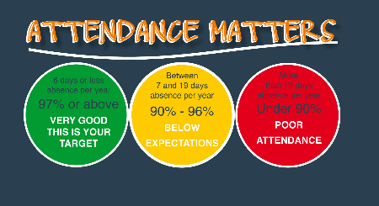
Holiday dates for the next year are on our website and have already been shared– please note that holidays outside of holiday times cannot be authorised and are likely to result in fines issued by the local authority.
We know there are a number of bugs and infections around – but please ensure your child is at school as often as they can be. Guidance from the NHS – which we follow is available here –
https://www.nhs.uk/live-well/is-my-child-too-ill-for-school/
Please ensure you contact school every day of your child’s absence - please contact admin@studfallinfantacacdemy.org or call 01536 264540 before the start of the school day. Dojo messages may not be picked up before school – please don’t dojo the teacher directly – do use the telephone number or email.
Dates for your diaries
- 2 weeks from 8th June – Phonics check
- Friday 12th June – Wear Yellow Mufti Day
- Wed June 17th – Sports day
- Monday June 22nd – Training Day – school closed to children
- Wednesday 24th June – 9-10 am – MHST drop in- main hall – Year 2 transition
- Wednesday 8th July – End of Year reports come out
- Thursday 2nd July – Reception trip
- Monday 6th July – Year 2 to Woburn
- Friday 10th July - transfer afternoon
- Monday 13th – after school discos Reception – 4 – 4.45pm Year 1 – 5- 5.45
Year 2 – 6-7 pm.
- Friday 17th July – Year 2 leavers assembly 1:30pm
- Friday 17th July – school closes for summer
All my very best as always
Kim Kirchin

