Equality Objectives Statement
Studfall Infant and Nursery
Academy

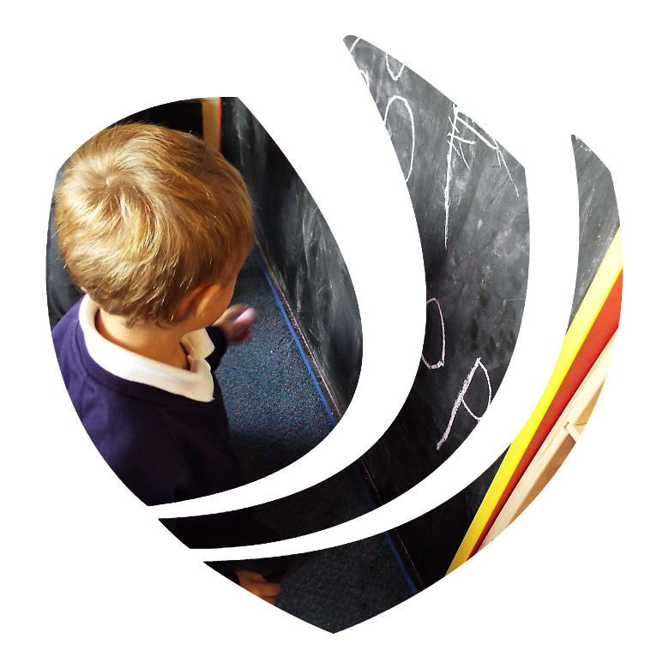

Skegness Academy

Greenwood Academies Trust

Date: 21.5.22
Author: Kim Kirchin

Background
(1) A public authority must, in the exercise of its functions, have due regard to the need to—
(a) eliminate discrimination, harassment, victimisation, and any other conduct that is prohibited by or under this Act.
(b) advance equality of opportunity between persons who share a relevant protected characteristic and persons who do not share it.
(c) foster good relations between persons who share a relevant protected characteristic and persons who do not share it.

(2) A person who is not a public authority but who exercises public functions must, in the exercise of those functions, have due regard to the matters mentioned in subsection (1).

(3) Having due regard to the need to advance equality of opportunity between persons who share a relevant protected characteristic and persons who do not share it involves having due regard, in particular, to the need to—
(a) remove or minimise disadvantages suffered by persons who share a relevant protected characteristic that are connected to that characteristic;
(b) take steps to meet the needs of persons who share a relevant protected characteristic that are different from the needs of persons who do not share it;
(c) encourage persons who share a relevant protected characteristic to participate in public life or in any other activity in which participation by such persons is disproportionately low.

(4) The steps involved in meeting the needs of disabled persons that are different from the needs of persons who are not disabled include, in particular, steps to take account of disabled persons' disabilities.

(5) Having due regard to the need to foster good relations between persons who share a relevant protected characteristic and persons who do not share it involves having due regard, in particular, to the need to—

(a) tackle prejudice, and
(b)promote understanding.

(6) Compliance with the duties in this section may involve treating some persons more favourably than others; but that is not to be taken as permitting conduct that would otherwise be prohibited by or under this Act.

(7) The relevant protected characteristics are—
- age;
- disability;
- gender reassignment;
- pregnancy and maternity;
- race;
- religion or belief;
- sex;
- sexual orientation.

Schools must publish information relating to persons who share a relevant protected characteristic who are affected by their policies and practices. However, data about employees will not need to be published where a public authority has fewer than 150 employees. This means that for the great majority of schools, only pupil-related data will need to be published. Schools are not required to collect any statistical data which they do not already collect routinely.

Part A- Information which demonstrates how we are complying with the Public Sector Equality Duty for our Pupils and our People (Annual review of information)
- Date last reviewed:21.5.22
Age
- In EYFS (aged 4 and 5) there has been a focussed programme on addressing their social and emotional needs to prepare for year 1 curriculum – this is our nurture group (aged 5 and 6)
- We are flexible with our working pattern for people – for example – recently two members of staff reduced hours to help with maintaining their ability to work as long as possible before retirement.
Disability
- We have an inclusive DSP provision – with individual arrangements regarding inclusion . EYFS is fully inclusive – Special Provision in Year 1 and 2.
- Visual communication systems used
- Sensory areas in place
- Learning Mentor has training has been undertaken with elective mutism- and masking ASD in girls
- We have a hearing loop installed in our Reception Area.
Gender re-assignment
- Children are taught as part of the PSE curriculum that whoever they – is great.
- All children on special days can wear whatever they like.
- Whilst our children would be too young to have gender reassignment work - we would support and welcome families that are dealing with this.
Marriage and Civil Partnership
- Children are taught about different family types – Oak academy and Twinkl- ‘The Circle of Love ‘and how there are different types of families.
Pregnancy & Maternity
- We are supportive of women’s rights to return to work part time after having children. We have adjusted days for 8 members of staff to support this.
- All pregnant staff have carefully thought our risk assessments – which includes careful monitoring of infectious disease.

Race
- For KS1 we have used the GAT Equity, Diversity & Inclusion guidance (EDI) to increase the diversity of text used across the curriculum, with a particular focus on learning about persons who are African.
- We ensure that our programme of assemblies have a diverse focus – celebrating the achievements of a range of people from different culture. This is not just in black history month.
- We ask families to share their cultures with us – for example children brining in their home language books on Book Week.
Religion or Belief
- We have close connections with our Christian Church – children visit, and we have visits from the Vicar.
- We celebrate and discuss the celebrations of other cultures - for example – Chinese New Year – immersing in culture and celebration, creations of divas for Diwali and we study Judaism in depth.
Sex
- We have a shared whole school view that sexual discrimination is not acceptable. This is reflected in our assemblies and PSHE curriculum. This includes teaching stereotypes – which directly addresses the expectations of what males and females can be.

Sexual Orientation
- We have a well-developed RSE policy – which links closely with our junior Academy which shows our commitment as an academy to valuing and celebration staff, children, and families with a range of sexual orientations.

Part B- Statistical data (annual review of data)
- Date last reviewed: 21.5.22
- This information below should be based upon information readily available in your academy. For achievement in GAT (national performance measures, where appropriate) this is usually for end of EYFS (GLD), end of Key Stage 1, 2, 4 and 5
- For attendance and exclusions in GAT this is usually broken down by year group
Cohort profile (as included in GAT outcomes reports)
*%Boys *%Girls *%SEND overall *%SEND SENK **SEND EHCP *%Disadvantage *%Non-disadvantage *% White British *% Non-white British/other
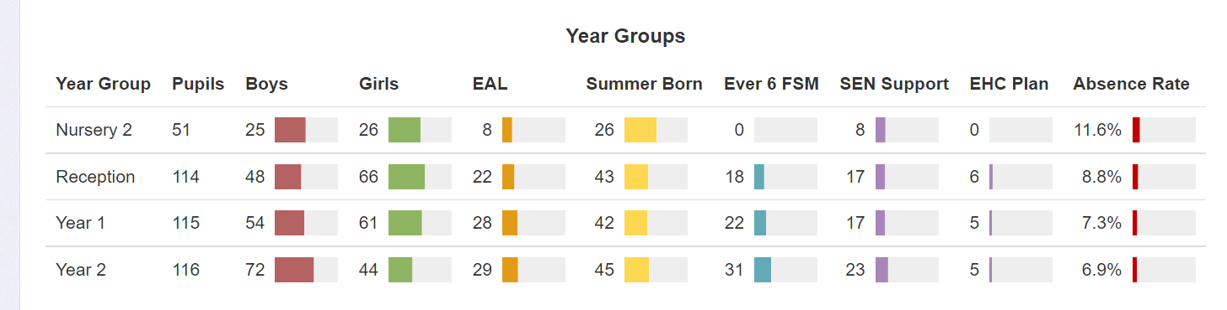
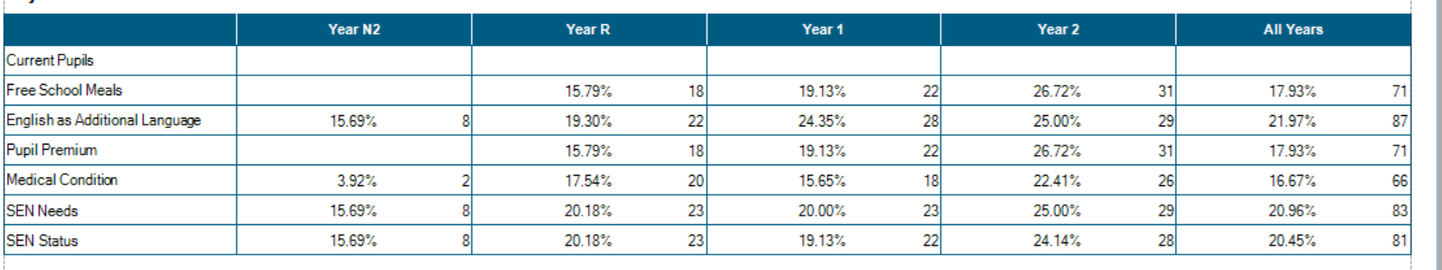

SEND and non-SEND information
*achievement *attendance *exclusions
We only have 1 fixed term exclusion – this was a boy in Year 1 with SEND needs

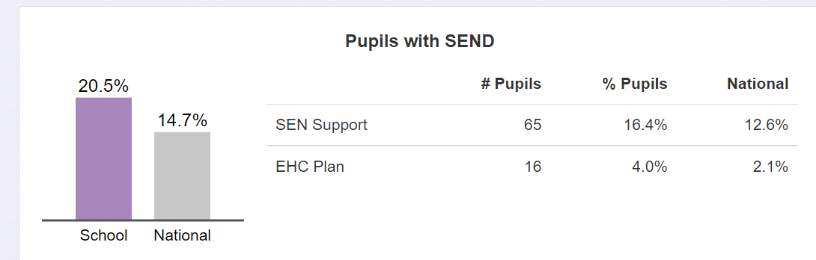

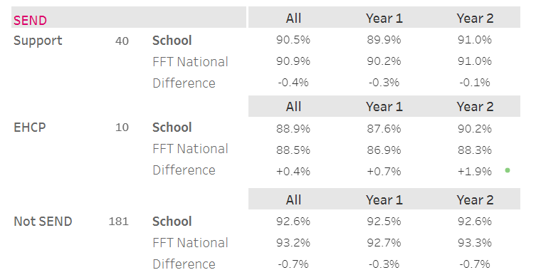
Attendance

Attainment
Reception
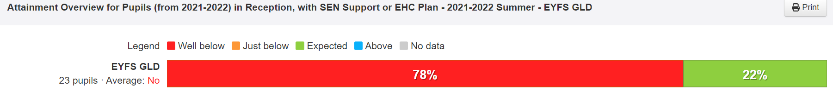
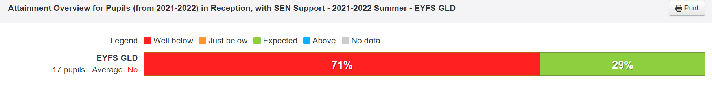
Year 1
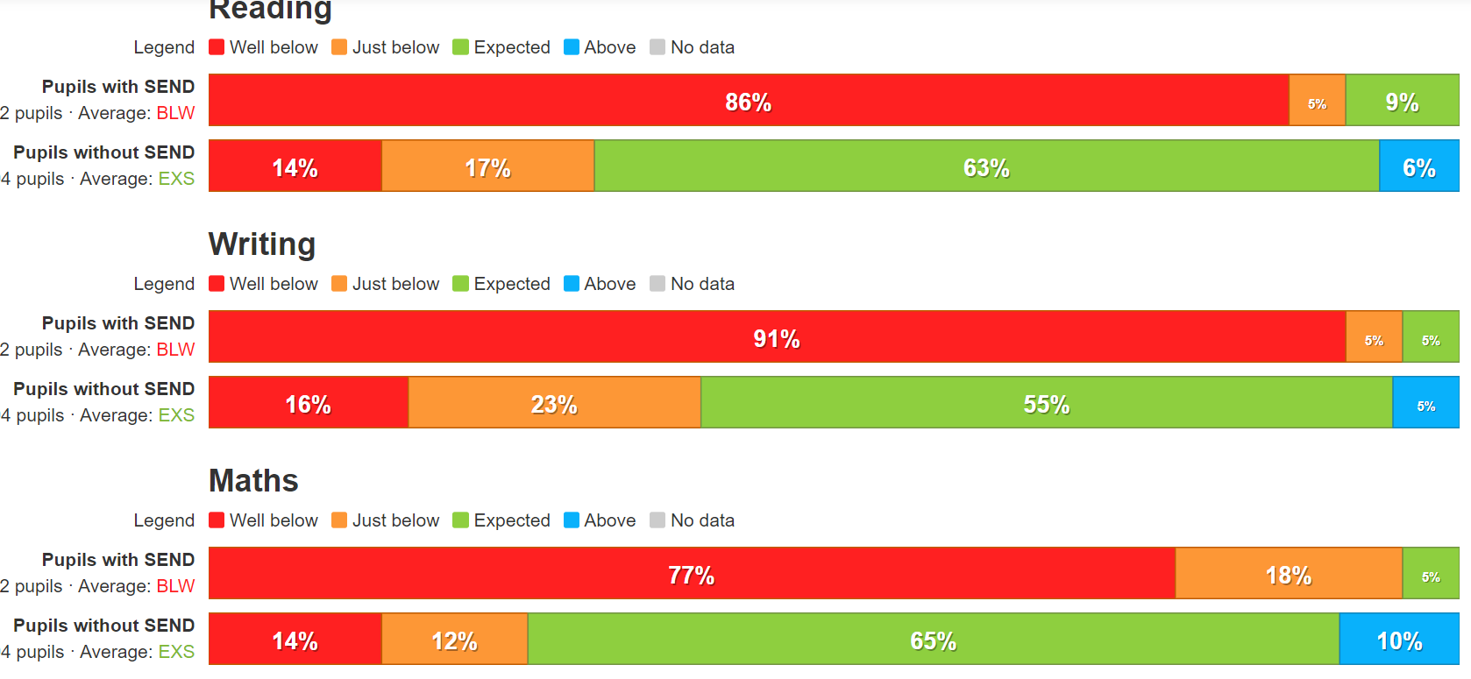

Year 2

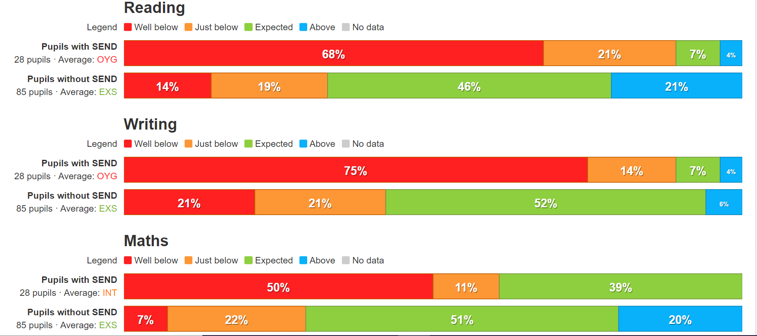

Boys and Girls
*achievement *attendance *exclusions
Attendance
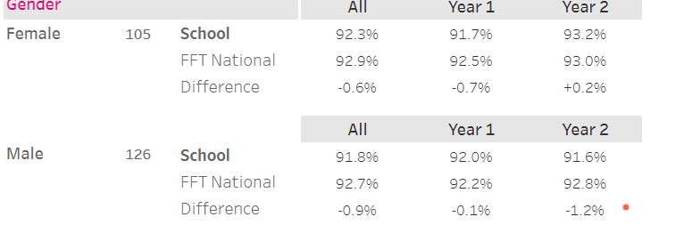
1 boy exclusion

Reception 21 - 22
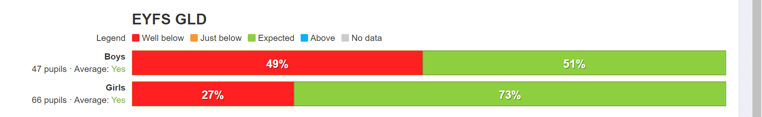

Year 1
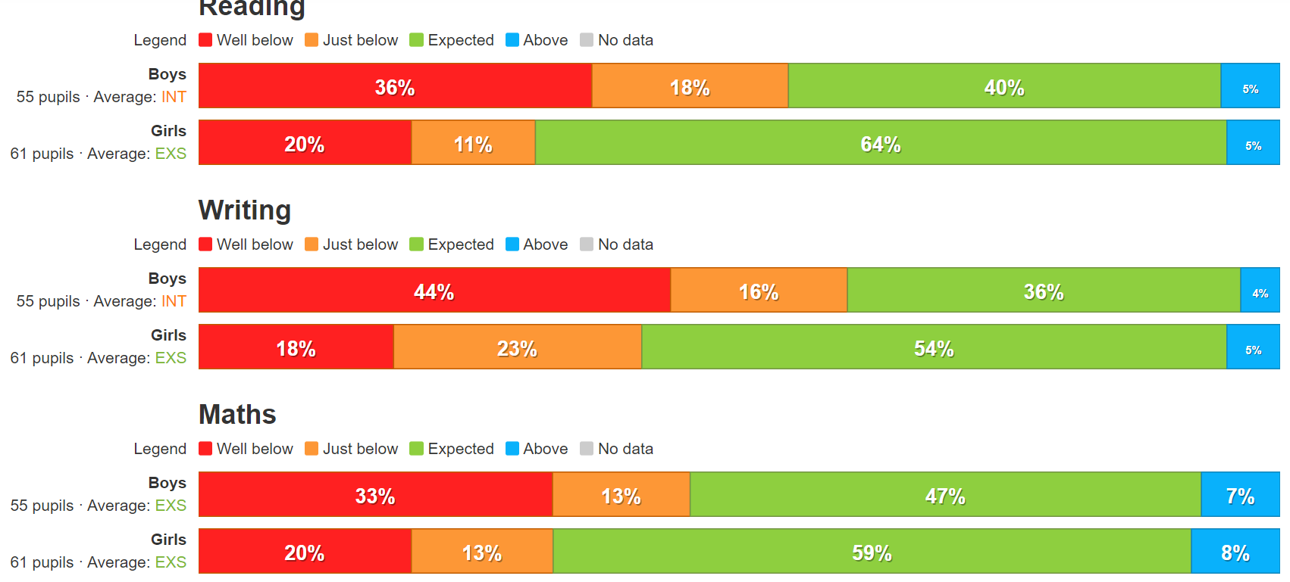

Year 2

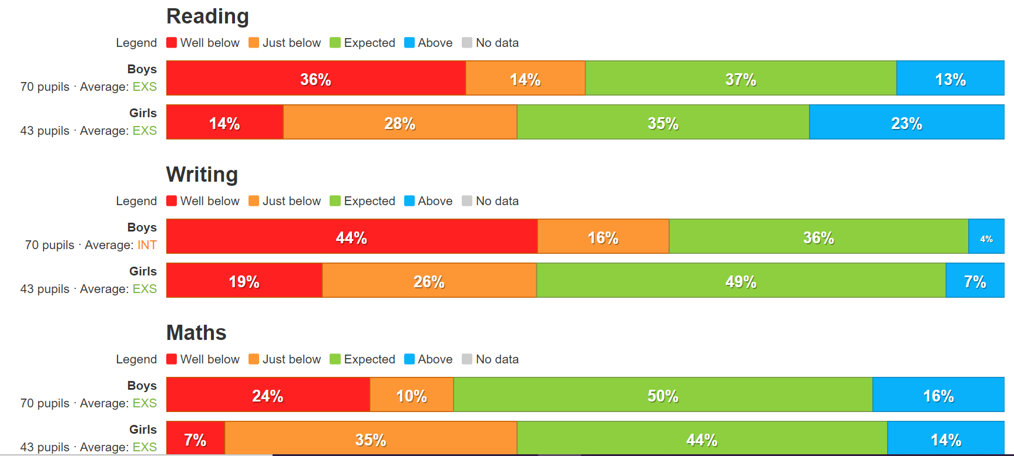
Disadvantaged and non-disadvantaged
*achievement *attendance *exclusions
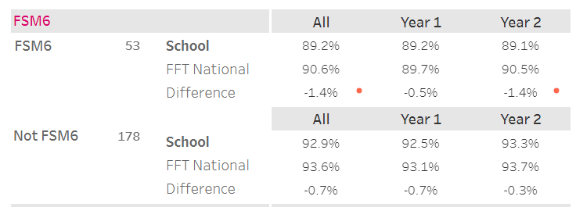

Attainment – Reception
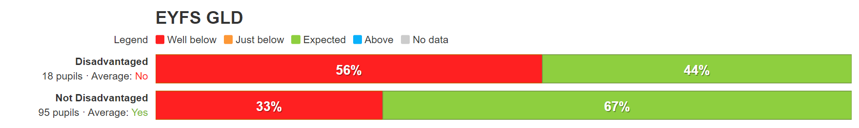
Year 1
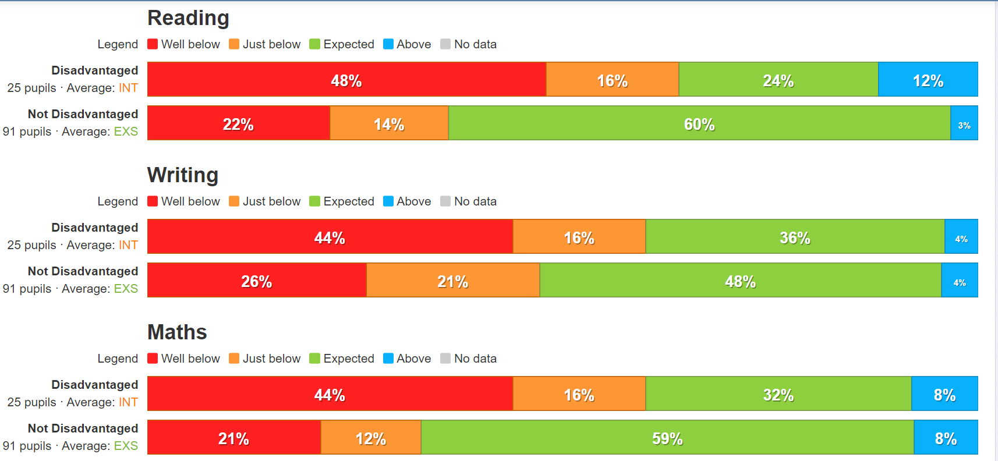

Year 2
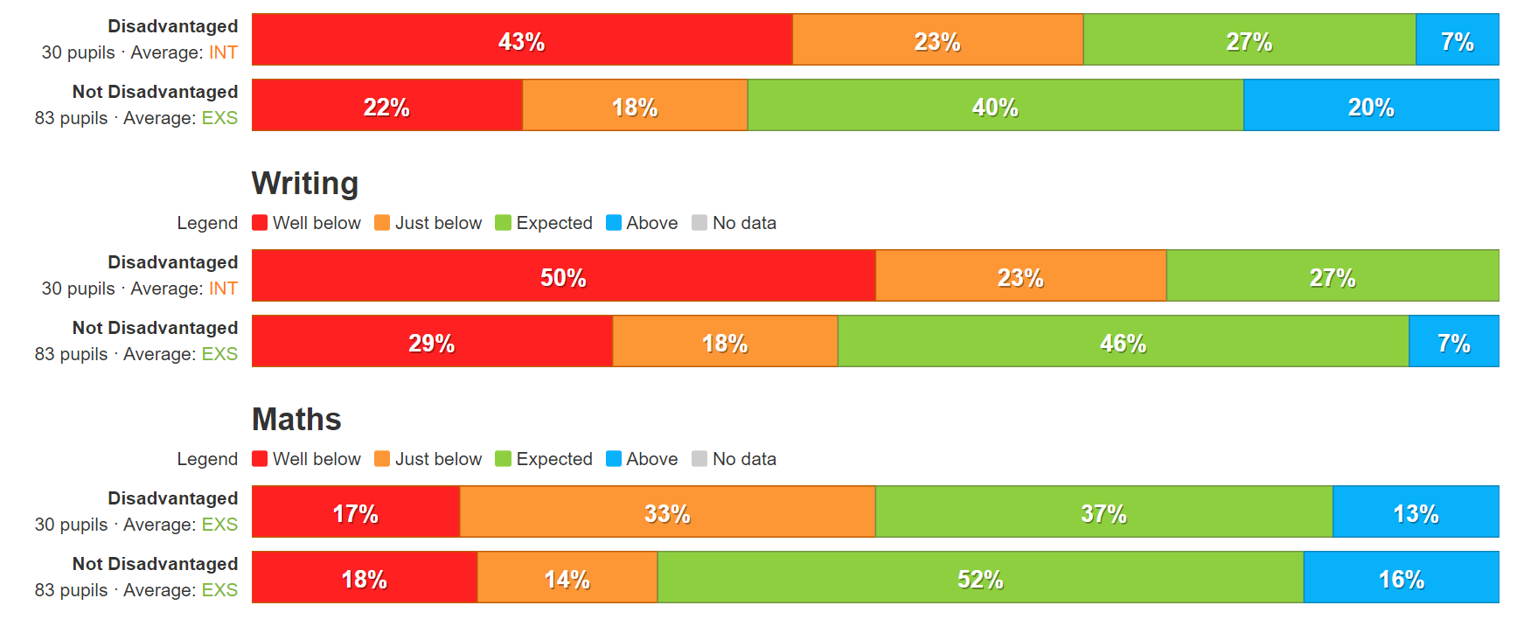
White British and other groups
*achievement *attendance *exclusions
1 White British Boy exclusion
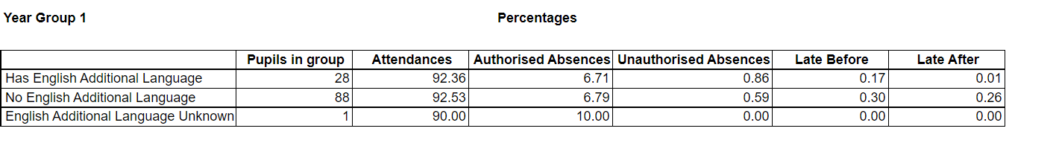

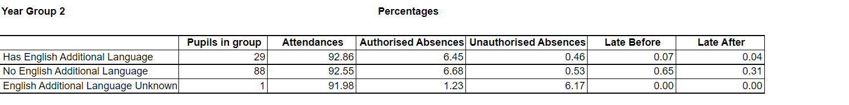

Attainment – Reception
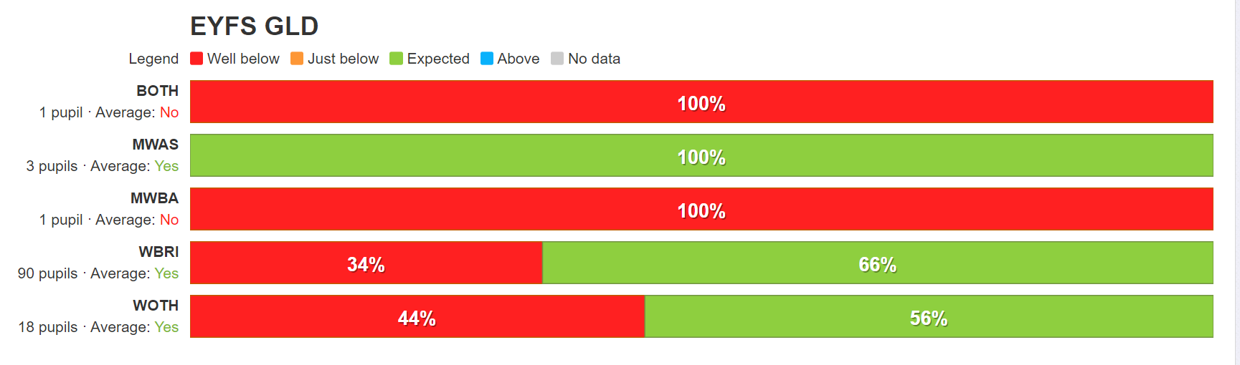

Year 1
Ethnic groups combined
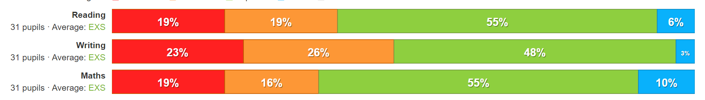
WBRI – Year 1
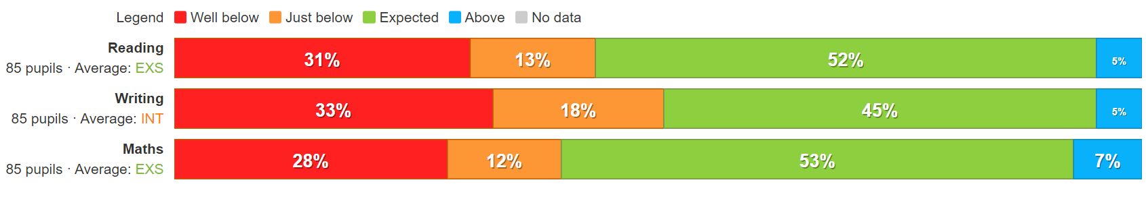

Year 2 – WBRI
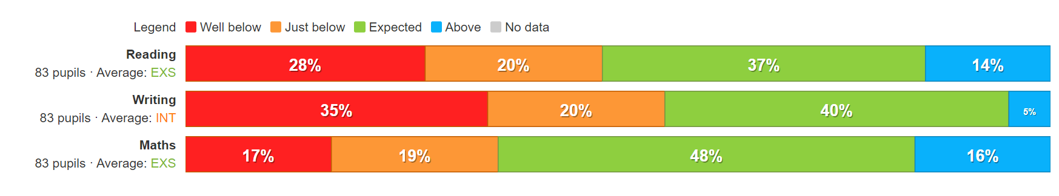
Year 2 – other ethnicities
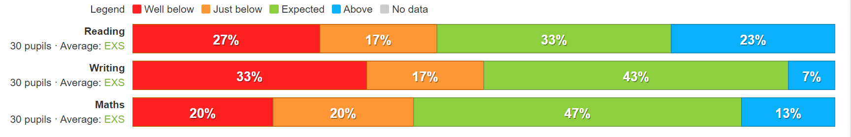

Part C- Equality Objectives (4-yearly priorities)
- Readily available data/information within your academy should be used to help shape these
- Date objectives set: 21.5.22
Objective | Actions | Who | By when | Commentary of progress  (yearly)
Leadership of our pupil’s & people
To provide an enhanced offer of CPD for staff at all levels to help to support mental well being and behaviours of staff, children and our community. | Seek external support to facilitate training for all levels of staff.  Explore mental health teaching assistant course – 5 days of training.  For PDR of staff – ensure this aspect is part of the target setting for next year.  Plan and develop a programme of activities and session for all children across the school to have the opportunity to explore well being and seek to involve parents in this too. | Kim Kirchin  Karen Parris  SLT  PSHE lead - Janine | Sept 23 | End of year 1 progress summary  End of year 2 progress summary  End of year 3 progress summary  End of year 4 progress summary
Quality of Education for our pupils & people
To review the texts used in the EYFS and KS1 curriculum, to secure appropriate breadth and depth of different race, and cultures and sexual orientation. | Examine the RSE and PSHE scheme – what books and themes do we need to supplement? Year 2 have a possible focus area for a term and can develop class readers  Re look again at history and geography topics to ensure they represent the protected characteristics. | SLT – Janine and Kerry S | Sept 22 (but ongoing as new books are published) | End of year 1 progress summary  End of year 2 progress summary  End of year 3 progress summary  End of year 4 progress summary
Personal Development of our pupils & people
Complete Bronze Healthy Eating Award ( this is more then healthy eating and crucially includes well being ) – focussing on well being , safety and resilience of pupils and staff | Continue to link with SFJ and the LA to complete the Bronze award.  Gather staff and pupil voice- which will help to identify aspects where we need to develop | SLT – Kim Kirchin and Joy McKenzie | May 23 | End of year 1 progress summary  End of year 2 progress summary  End of year 3 progress summary  End of year 4 progress summary
Behaviour & Attitudes of our pupils & people
To reduce further the number of recorded behaviour incidents for KS1 boys – they form the vast majority of the incidents. | Move behaviour recording system to CPOMS to enable quicker analysis of incidents and patterns  Include behviour training in CPD termly for staff – seek external support for this (Ed psych team ?) .  Revisit the golden rules – do the children and families know and support this?  Leadership monitoring of behviour in classes enhanced. | SLT – Kim Kirchin and Joy McKenzie | Sept 23 | End of year 1 progress summary  End of year 2 progress summary  End of year 3 progress summary  End of year 4 progress summary

