If you are bullied:
You could:
- Ask them to STOP if you can
- Use eye contact and tell them to go away
- Ignore them
- Walk away
- Don’t be a bystander
But always:
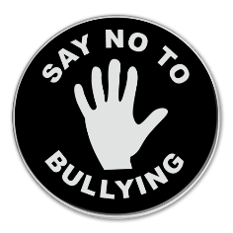
- TELL SOMEONE

DON’T:
- Do what they say
- Hit them
- Think it’s your fault
- Hide it
What should I do if I see someone is being bullied?
- Don’t walk away and ignore the bullying
- Tell the bully to stop if it is safe to do so
- Don’t stay silent or the bullying will keep happening
- Tell an adult what you have seen

All the staff will work together to:
- Make our school a place where everyone can feel safe and happy. That means no bullying allowed
- We will help everyone to get on with each other and we believe that everyone has the right to be who they a

Studfall Junior, Infant & Nursery Academy

Child Friendly Anti-Bullying Policy

What is Bullying?
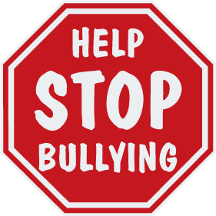
In our school a bully is someone who hurts someone several times, by using behaviour which is meant to hurt, frighten or upset another person.

Bullying can be……
Emotional: Hurting people’s feelings, leaving you out.
Physical: Punching, kicking, spitting hitting, pushing.
Verbal: Being teased, name calling.
Racist: Calling you racist names.
Cyber: saying unkind things by text, e-mail and social networking.
When is it bullying?
Several Start
Times Telling
On Other
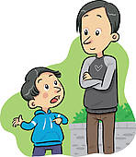
Purpose People
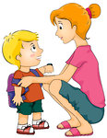
At Studfall we promise to always do something about bullying
Who can I tell?
A Friend Mum/Dad
Teachers Learning Mentors
Lunchtime helpers
Any grown-ups that work in school
Child Line: 0800 11 11
MOST IMPORTANTLY:-
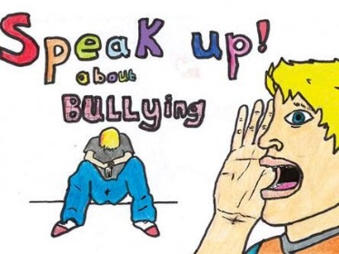
If you are being bullied:

Start Telling Other People

