Studfall Infant and Junior Academy - Special Educational Needs Information Report

Studfall Infant and Junior Academy 2022-2023

At Studfall we aim to deliver a broad, balanced, relevant and differentiated curriculum to all pupils. We work hard to ensure that work meets the individual child’s needs.
Our vision reflects a passionate commitment to learning and recognition of the uniqueness of individual learners. It is driven by our desire to offer the best possible education for our children in partnership with parents, carers and the local community.
We strive to meet the needs of all children at Studfall and recognise that some children require additional support in order to catch up with other children of the same age. Our approach is flexible according to individual needs. Support may be provided on an individual or small group work basis or within larger classes, depending on the needs of the child. We aim to identify and meet the needs of all children as early as possible.

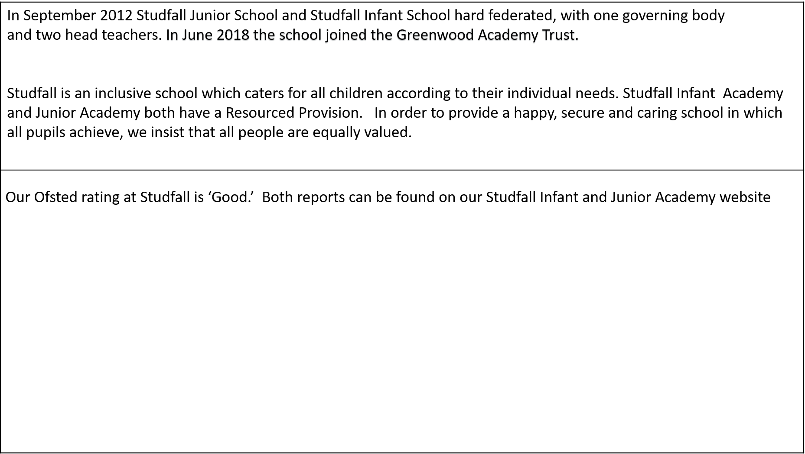

Infant Ofsted November 2017
Staff go ‘above and beyond’ when vulnerable pupils need extra adjustments.
This is clear in the personally tailored support for pupils in the designated specialist provision.

Junior Ofsted 2017
The support for pupils who have special educational needs and/or disabilities in the
designated specialist provision is good. Pupils receive an inclusive, broad and rich
curriculum.

How does the Academy ensure that children who need extra help are identified early?
We aim to identify and meet the needs of all children as early as possible through:
- The analysis of data including baseline assessments against the Early Years Foundation Goals, speech and language assessments, phonics data and other whole-school pupil progress data.
- Pupil progress data is monitored and scrutinized by the Principals and the subject teacher at Pupil Progress Meetings each November, March and June.
- We follow up any parental concerns
- Tracking individual children’s progress over time, including progress in EAL.
- Liaising with feeder schools and nurseries.
- Gathering information from previous schools/academies and other services
- Undertaking, when necessary, a more in-depth individual assessment - this may include a range of commercially available assessments.
- Involving an external agency where it is suspected that a special educational need is significant.

What should a parent do if they think their child may have special educational needs?

Talk to us – in the first instance, contact your child’s class teacher; if you still have concerns you can contact one of the Vice Principals or SENDCo’s
We pride ourselves on building positive relationships with parents. We are open and honest with parents and hope that they are able to do the same with us.

Who will explain my child’s needs and progress to me?

- The class teacher will meet parents to discuss your child’s needs, support and progress.
- For further information the Inclusion team are available to discuss support in more detail.

Special Educational Needs and Disabilities Coordinators:
Studfall Junior Academy:
Erin Stark, responsibility for Inclusion, Resourced Provision and SEN support
estark@studfalljunioracademy.org
Studfall Infant Academy:
Karen Parris (Vice Principal) responsibility for Inclusion, Resourced Provision and SEN support
kparris@studfallinfantacademy.org

How will the Academy support my child?

The SENDCo oversees all the support and progress of any child requiring additional help across the school.
- Class teachers will oversee, plan and work with each child with special educational needs or disabilities in their class to ensure that progress in every area is made.
- Progress is tracked on a whole school provision map to set out the support your child is receiving and evaluate the success of any interventions.
- Most children are given an Individual Education Plan (IEP) with specific targets so that it is easy to track progress.

There may be a Learning Support Assistant or Teaching Assistant working with your child either individually or as part of a group for some parts of the day.

The regularity of these sessions will be explained to parents when the support starts and set out in an Individual Education plan (IEP)

The range of specialist training that staff have received includes:
Autism (TEACCH approach)
Dyslexia
Play Therapy
Theraplay
Growing Optimism
Nurture Group
Mentoring
De-escalation techniques (Team Teach)
Lego Therapy
Kinetic letters
Colourful Semantics
Cued Articulation

Your child may benefit from specific intervention programmes. We carefully plan interventions based around staff expertise.

Studfall Junior and Infant Academy has a Resourced Provision for children with significant to severe learning difficulties, serving Corby and the surrounding villages. Pupils at the Studfall Academies' resourced provision will have:

• Cognition and Learning Needs - Severe Learning Disabilities (SLD)
• Communication and Interaction Needs - Autistic Spectrum Disorder (ASD)

Pupils are admitted to the resourced provision if their EHC Plan identifies SLD and/or ASD, but they are deemed capable of integrating with a large school community. Pupils may have communication difficulties, social difficulties, and/or cognitive difficulties.

The Sunshine Room (SIA) and Developmental/Community Room (SJA) is used to support children in individual or small teaching groups for some parts of the day.

All admissions will be determined by the Local Authority in accordance with the ‘SEN and Disability Code of Practice’, July 2014, if the pupil has an EHC plan or in accordance with the ‘SEN Code of Practice’. Consultation with the school will be in accordance with these documents, before the Local Authority makes a decision about placement.

What adaptations have been made to the learning environment for children with SEN?

Both Academies are a single-story site, which have been modified to allow for wheel chair access with ramps. Accessibility plans for both sites can be found on the school website.

Other facilities and adaptations include:

- disabled toilets
- specially adapted showers
- specially adapted sound proof rooms available for Hearing Impaired children
- a number of rooms allocated specifically for small group teaching including one for physiotherapy and occupational therapy
- a small room available for ‘time out’
- a Nurture Room (SJA)
- mentoring rooms
- sensory rooms
- ball pool (SIA)
- Outdoor areas designated for smaller group playtimes which are
accessible via a ramp.

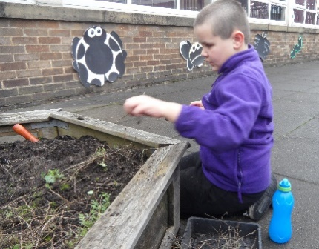

How is the Academy Council involved and what are their responsibilities?

The Academy Council is an external body of external, independent advisors who will have an overview of the provision of SEN within the Academy. Their role is to
- Work closely with the Principal to advise and act as a critical friend
- To advise the Board of Directors of the Greenwood Academies Trust about local issues that they may need to consider about local issues.
- To represent the Academy community and the Academy in its community
- To support the Principal should in the event of a complaint

How do teachers match the curriculum to an individual child’s needs?

The needs of the children will be first and foremost met in the classroom. Teachers will ensure that all children are fully involved in the life of the class. Some children will spend time in smaller groups or be withdrawn for specific activities related to their needs.

Some children who access our resourced provision receive an enhanced curriculum which incorporates early literacy and numeracy skills as well as topic related activities. Children may receive a nurture based curriculum to support social interaction and communication as well as time spent working towards individual targets.

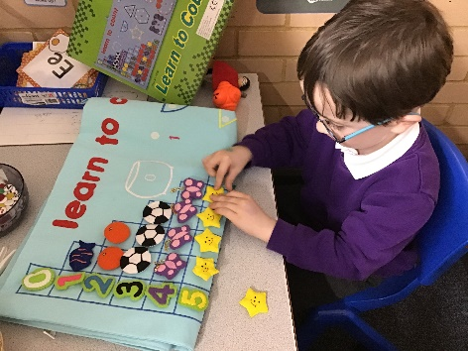

It is the Class Teacher’s responsibility to secure good provision and good outcomes for all groups of children.
At Studfall we endeavor to provide:
- Differentiated teaching and learning opportunities
- Opportunities for pupils with special educational needs to work on agreed targets
- Learning opportunities to be maximised by effectively deploying resources, including teaching assistant support.

How are the Academy resources allocated and matched to children’s special educational needs?

We work hard to use the funding allocated effectively.

- It may be decided that a very small number of the pupils on the SEND list will require additional High Needs funding, for which an application needs to be made to the Local Authority, to ensure their underlying special educational need is being addressed.

- Where a pupil has a significant, severe and sustained need, it may be necessary to enter a multi-disciplinary assessment process with health and social care in order to consider the need for an Education, Health and Care Plan (EHCP)

How is the decision made about what type and how much support my child will receive?

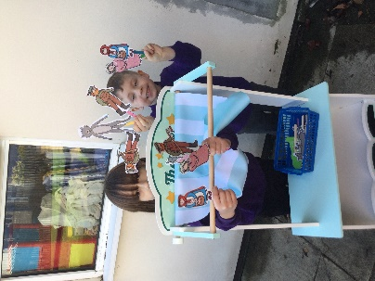
The Class Teacher will liaise with the SENDCo, depending on the level of need, to decide what support would be appropriate. Different children will require different levels of support in order to help them make progress and achieve their potential.

How does the school judge whether the support has had an impact?

Depending upon the stage of support, the progress of our pupils will be assessed and reviewed through:

- Pupil progress meetings used for tracking the progress of all pupils
- Termly evaluation of the effectiveness of interventions on the provision map
- At least termly evaluation of whether pupils in receipt of High Needs Funding and/or with
Education, Health and Care Plans are meeting their individual targets which have been written
to address their underlying special educational need.
- Annual review of Education, Health and Care Plans

As part of the process, ‘progress’ will be defined as that which;

Closes the attainment gap between the child and their peers
- Prevents the attainment gap growing wider
- Is similar to that of peers starting from the same attainment baseline, but less than that of the majority of peers
- Matches or betters the pupil’s previous rate of progress
- Ensures access to the full curriculum

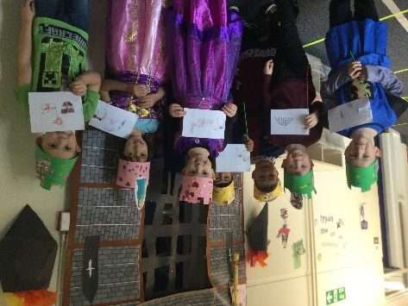

What opportunities will there be for me to discuss my child’s progress?

The Academy recognises the importance of close relationships between staff and parents and carers and in making all feel welcome. Emphasis is given to the need for partnership with parents in meeting the pupil’s needs.

There are regular opportunities for all parents to discuss your child’s progress in school through regular consultation evenings.
Parents are also welcome to make an appointment at any time to discuss progress with the Class Teacher
and/or SENDCo.
Class Teacher and/or SENDCo can be contacted through ClassDojo.
Dates of reviews etc. are given early as possible to enable parents to attend.

The class teacher or SENDCo can offer advice and practical ways that you can help your child at home.

• The class teacher can provide a home / school communication book which your child will bring home daily
so that comments from parents and teacher can be shared.
• If your child is on the special needs register, they may have an Individual Education Plan (IEP) which
will have individual / group targets. This will be discussed with you on a termly basis.
The targets set are SMART (specific, measurable, achievable, realistic, time scaled) targets,
with the expectation that the child will achieve the target by the time it is reviewed.
• If your child has complex special educational needs or a disability, they may an Education, Health Care Plan (EHCP),
which means that a formal meeting will take place annually to review your child’s progress.
How will the Academy help me to support my child’s learning?

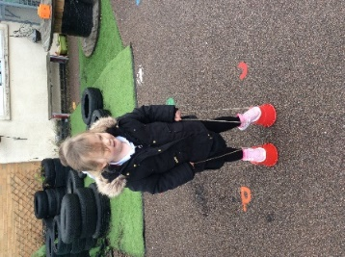
Recommendations from external agencies
e.g. a speech and language therapist,
will be shared with you so that strategies
can be implemented at home and school.

How does the school measure my child’s progress?

We measure children’s progress in learning against national age-related expectations.

• The class teacher continually assesses each child and notes areas where they are improving and where
further support is needed. We track children’s progress from their admission through to Year 6
using a variety of different methods, including National Curriculum levels, P-scales and some standardised tests.

• Children who are not making expected progress are identified through the termly progress meetings.
In this meeting a discussion takes place about those pupils experiencing difficulties and what further
support can be given to aid their progress.

• When a child’s IEP is reviewed, comments are made against each
target to show what progress has been made. If the child has not met
the target, the reasons for this will be discussed, then the target
may be adapted into smaller steps or a different approach may be
tried to ensure the child does make progress.

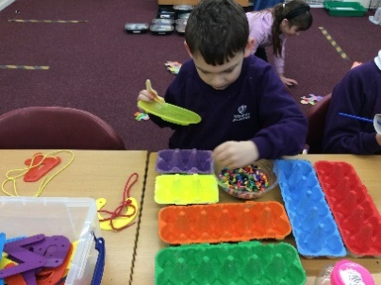

What is the pastoral, medical and social support available in the Academy to ensure my child’s overall well-being?

Values are fundamental expressions of what we think and believe. As a school we encourage the children to
think about personal and social values, to become aware of and involved in the life and concerns of
their community and society, and so develop their capacity to be active and effective future citizens.

- On arrival, there are members of staff who greet and welcome pupils and their families each morning.

This ensures a smooth transition between home and school each day.
- The class teacher has overall responsibility for the pastoral, medical and social care of every child in their class, therefore this should be your first point of contact.
- Studfall Infant and Junior Academy has a team of Learning Mentors, who work with children who need emotional support.

How does the school manage the administration of medicines and personal care?

We have a policy regarding the administration and management of medicines on the school web site.
• Parents need to contact the academy office if medication is recommended by Health Professionals to be taken
during the school day. Parents will need to complete a medication form with details of the medication and how it should be administered.

• An individual care plan will be written up by the school, in consultation with the medical care team for the administration of more complex medicines, eg insulin or epi- pens. The appropriate training will be set up for a small number of identified staff.

• Staff have regular training regarding conditions and medication affecting individual
children so that all staff can manage medical situations if the need arises.

• If a child requires personal hygiene care this will be managed through an
individual care plan.

What support is there for behaviour, avoiding exclusion and increasing attendance?

- We have a positive approach to behaviour management with a clear Behaviour for Learning policy that
is followed by all staff and pupils. We are an inclusive school and we make every effort to include all pupils
in learning sessions with their class. We also take every opportunity to include pupils socially at break and
lunch times.

- For anything other than minor incidents it is our policy to inform parents / guardians at an early stage.
In this way, we can seek their help and support to resolve problems quickly. In the rare event a child becomes at
risk of exclusion a Pastoral Support Plan is put in place to support the child staying in school. This plan would
be written with the parent/carers and all adults involved.

- The attendance of every child is monitored on a daily basis. Lateness and absence
are recorded and reported to the Principal and is regularly reviewed by the attendance committee.

The children receive attendance booklets every term stating their level of attendance. We also celebrate good attendance in whole school assemblies, where individual prizes and class prizes are awarded for good attendance.

How will my child be able to contribute their views?

At Studfall, we recognise that all pupils have the right to be involved in making decisions and exercising choice.
To participate in decision making, children need information and support so that they can work towards:
- understanding the importance of the information
- expressing their views and feelings
- identifying their own needs and learn about learning
- sharing in individual target setting, so that they know what their targets are and why they have them
- self-review their progress and set new targets
- participating in discussions
- indicating choices
The children contribute to reviews in different ways. At the Infant Academy, pupil feedback is sought through One Page Profiles, pictures and at the Junior Academy, children complete a Have Your Say booklet which they share at the annual review meeting.
discussion. At the Junior Academy, children may contribute more to annual reviews by attending part of the review themselves to contribute
to discussion.

What specialist services and expertise are accessed by the school?

The involvement of outside professionals is considered when pupils make little or no progress over time despite
all our best efforts. It involves external experts providing specialist assessment and advice on strategies and support.

These may include:
  - a specialist teacher
  - an educational psychologist
  - a paediatrician
  - speech therapist
  - physiotherapist
  - occupational therapist

We seek to respond quickly to emerging need and work closely with other agencies including:

Education, Health and Care Team, Children, Families and
Early Help Assessment team (EHA)
Educational Psychology Service
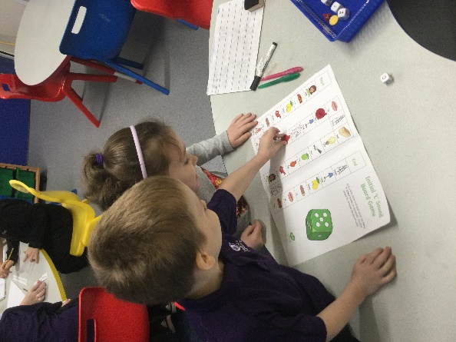
Information, Advice and Support Service for SEND in Northamptonshire
Referral Management Centre (RMC )
Speech and Language Therapy (SALT)
Occupational therapy and physiotherapy
Community pediatricians and psychiatrist
Child and Adolescent Mental Health Services (CAMHS)
The Sun Flower Centre
The Virtual School for Looked After Children-NCC Sensory Impairment team
Autism Outreach Team
ADHD Information Advice & Guidance Service
Targeted Prevention Team
Education Entitlement Team
Pen Green Children’s Centre
Early Years SEN support service
Special Support Service (SSS)

How will my child be included in activities outside the classroom including day and residential trips?

- We aim for all children to be included on school day trips and residential stays.
We will provide the necessary adaptations, having consulted with you, to ensure
that this is successful.

- A risk assessment is carried out prior to any off-site activity to ensure
everyone’s health & safety will not be compromised. In the unlikely event
that it is considered unsafe for a child to take part in an activity, then alternative
activities, which will cover the same curriculum areas will be provided in school.

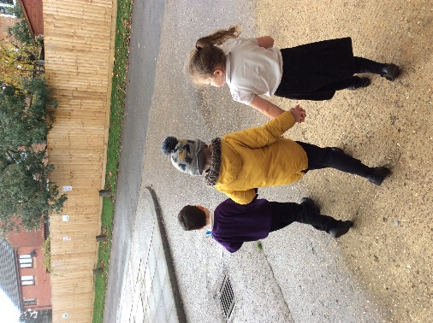

How will you prepare and support my child when joining the Academy or transferring to a new school?

Transfer from Year 2 to Year 3
Liaison is undertaken with receiving and sending schools prior to transfer. Contact is coordinated by the head teachers,
teacher responsible for transition from Infants to Juniors, SENDCo or learning mentors as appropriate.
The links between the Infant and Junior Academies are well established.
All children in Year 2 have the opportunity to visit Studfall Juniors for at least 2 or 3 visits. Additional transition is planned in for those children who need additional transition. Transition booklets are made for the children for use over the summer holidays in preparation for a new term in September.
Both Academies work closely together to raise the awareness of those children who have been identified as vulnerable learners.

For children with an EHC plan there is close liaison. Both SENDCOs attend the transfer meetings and annual reviews of all the Year 2 children who will be transferring to the Junior School. During the Summer term an enhanced transition programme is put in place to meet the needs of those specific children. This normally includes 6/7 different visits to the Junior School. In addition, the Year 3 teachers and support staff visit the children in their own environment. A buddy system with Year 4 children is well established and begins during the transition period.

Transfer to and from other schools and nurseries:
The SENDCo liaises with the other schools, visits the child/children and attends the annual
review meetings or transition meetings where possible. Parents are fully involved in the process and an induction
programme appropriate to each child is planned and implemented.

Within School
When transferring from one year group to the next, children with an EHC plan and
other children with special needs follow individually tailored induction programmes with the aim of building up
relationships with the receiving staff members and familiarising themselves with their new classrooms.

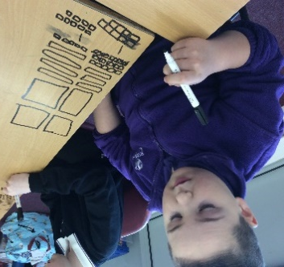

Transfer to Secondary
All children at Studfall Junior Academy follow a carefully planned induction programme to ensure a
smooth transfer. Links with secondary schools and Learning Support Departments are well established.

During the Summer Term members of Learning Support Departments visit the children at Studfall.

In June, Year 6 class teachers meet with Year 7 teachers from all secondary schools to discuss individual needs.

Children with autism or similar needs have an individual induction programme designed and implemented by our learning mentors.

Where a child has an Education Health and Care Plan the SENDCo (or equivalent) from the chosen secondary school will be invited to the Annual Review and/or Transfer meeting.
These children will all have accompanied additional visits to their secondary school prior to ‘transfer day’.
These visits are arranged by our learning mentors.

How are parents involved in school life?

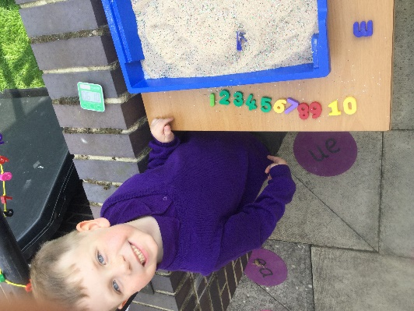
We recognise the importance of close relationships between staff
and parents and carers and in making all feel welcome.

We communicate with parents and carers in various ways, for example through
our newsletters, questionnaires, social events, parent workshops e.g. how to
help your child read, stay and play, family activities within the curriculum
e.g. Science Week, Phonics workshops for parents and Book Week

Parents are also welcome to help out as volunteers, for example, listening to readers.

Parents are also invited to regular class assemblies and concerts.

There are regular opportunities for all parents to discuss their child’s progress in school
through parent consultations and open afternoons/evenings.

Teachers are contactable through Class Dojo. This platform is also used to reinforce whole school or class stories
which helps keep parents updated and informed about current events and learning.

What do I do if I feel my child has special educational needs?

• The first point of contact would be your child’s class teacher to share your concerns.
• Any member of the inclusion team would be happy to help.
• Look at our Special Educational Needs policy on our website.

Who should I contact if I am considering whether my child should join the school?

• Contact the school office to arrange a meeting and tour of the school.
• If your child has a special educational need or a disability speak to the SENDCo
at either site who will discuss how the school could meet your child’s needs.

Teaching assistants provide good support for pupils who have special educational needs and/or disabilities. They take the time to understand their specific needs and support their learning through careful questioning.
SJS Ofsted 2017
Pupils are proud of their school and said that they
Enjoy learning every day……..pupils are particularly
respectful of diversity and all feel included.
SIS Ofsted 2017

